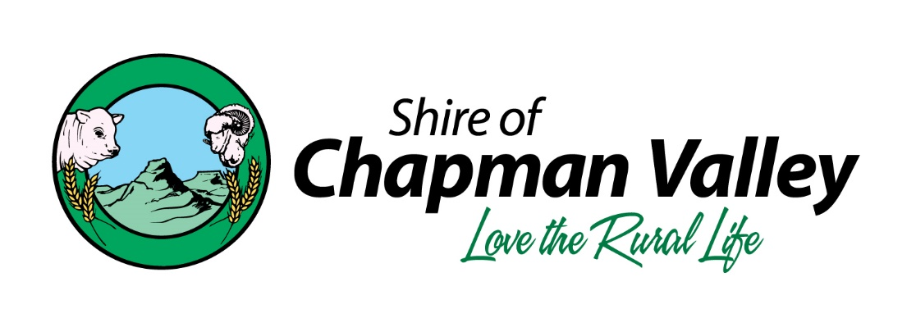

DISCONTINUED VEHICLE INSPECTION SERVICE

The Department of Transport (DoT) has advised Council of the minimum qualification for staff to provide vehicle inspection services as an Authorised Vehicle Examiner (AVE) on their behalf being as follows:
- An Australian standard motor mechanical trade qualification, or overseas equivalent as approved by the DoT CEO, to the following minimum qualifications:

- Certificate III in Automotive (Mechanical – Light Vehicle) for light vehicle, and/or
- Certificate III in Automotive (Mechanical – Heavy Vehicle) for heavy vehicles;

- A current Western Australian Driver’s Licence relevant to each class of vehicle the AVE is authorised to inspection (for example, classes ‘R’ and ‘C’ if authorised to inspect all light vehicles including motorcycles; and

- Be of good character.

As Shire staff do not have all the minimum qualifications as stipulated to DoT to perform the task as an AVE on their behalf Council has resolved to discontinue this service, effective from the 30 June 2017,o earlier if the existing AVE shire staff member requests so.
Shire constituents will now need to arrange vehicle inspections through the nearest DoT agency in Geraldton. Location of these service providers in Geraldton can be obtained by following this link to the DoT website.
http://www.transport.wa.gov.au/licensing/regional-vehicle-examinations.asp

