MAKE: | SM Multipac Multi Tyred Roller
MODEL: | VP2400
PLANT AVAILABLE FROM: | Shire of Chapman Valley Depot, Nabawa WA 6530
CURRENT OWNER: | Shire of Chapman Valley
ORIGINAL DELIVERY DATE OR YEAR OF MANUFACTURE: | 1999
VIN NUMBER: | 010
ENGINE NUMBER: | 45846081
REGISTRATION NUMBER: | CV2658
REGISTRATION EXPIRY: | 30th June 2019
ODOMETER / HOUR METER READING: | 13,470
COLOUR: | Yellow
TYRE CONDITION: | Fair
ENGINE SIZE: | 3.9L
HORSEPOWER RATING: | 99
FUEL TYPE: | Diesel
TARE: | 24,000
INCLUDED ADDED OPTIONS: | As is
ANTICIPATED AVAILABILITY DATE : | Determined on supplier of new item of Plant
OTHER DETAILS: | As is

Important Information:
- To arrange an inspection or ask any questions relating to the plant item, please contact:
Esky Kelly, Works Supervisor
Telephone: (08) 99205011 or Mobile 0429 109 816
Email: works@chapmanvalley.wa.gov.au
- The trade vehicles include all fitted “add on” (non OEM) devices, toolboxes and bracketing etc. This
does not include non-fitted, loose equipment carried in the Plant at the time of inspection.
- It is the Tenderer’s responsibility to satisfy themselves as to the condition and the value of the Plant.

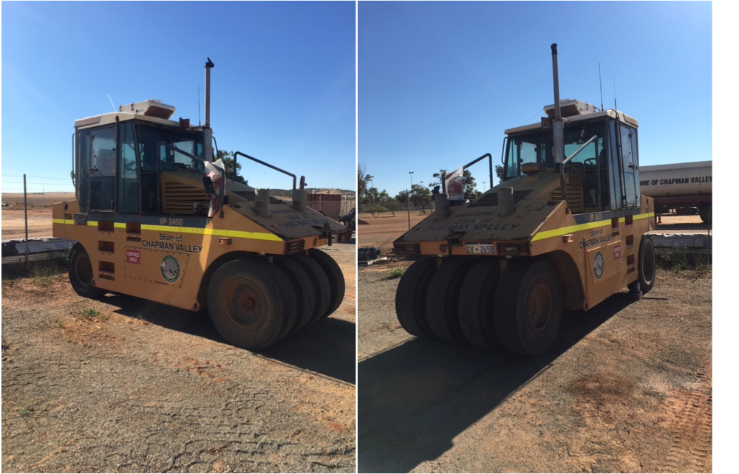

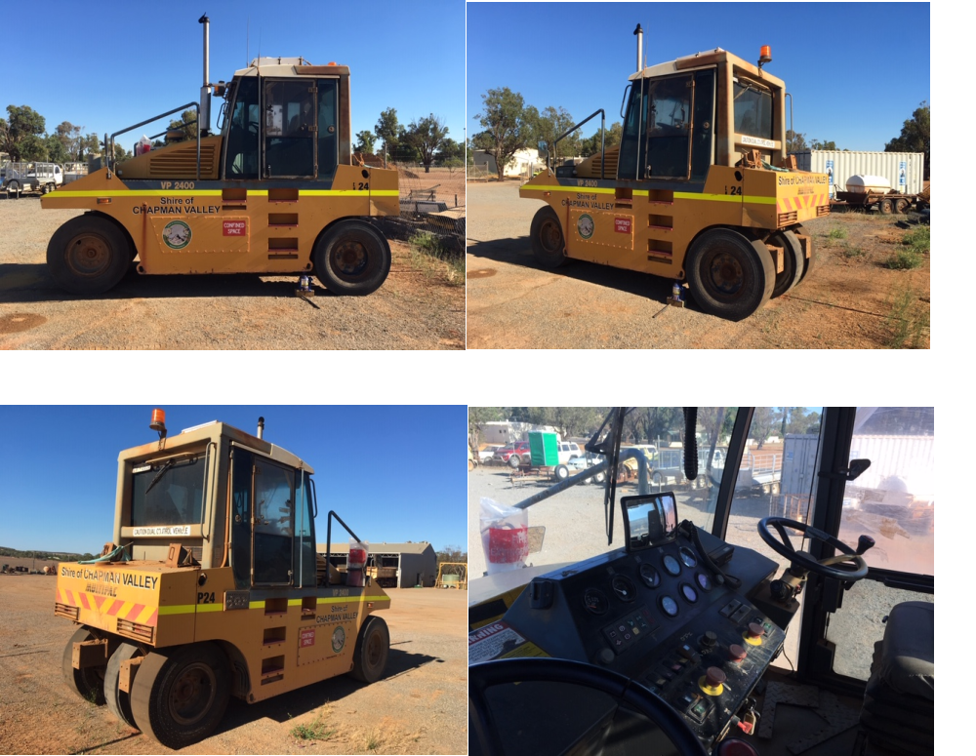

..

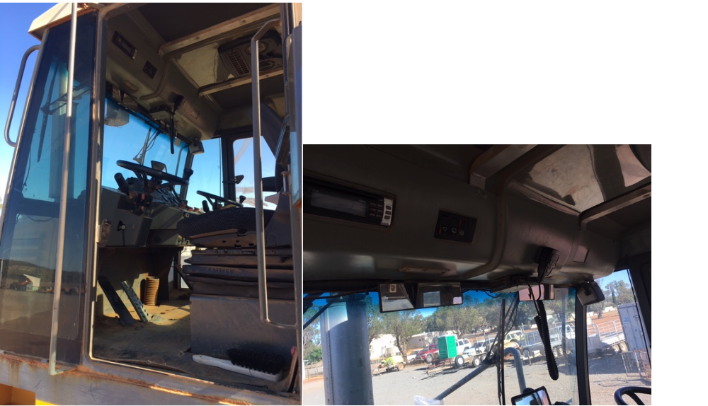

CHAPMAN VALLEY SHIRE COUNCIL

OUTRIGHT PURCHASE

RFQ 5-18/19

1999 SM Multipac VP2400 Multi Tyred Roller

I, ..................................................................of........................................................................

offer $ ................................................(GST Inclusive) in words.................................................

................................................................................................................................................

FOR THE OUTRIGHT PURCHASE OF THE ABOVE VEHICLE

I agree to the conditions attached

Signed ..................................................... Witness ..........................................................

Date ......................................................... Date ...............................................................

Name of Quote...................................................................................................................

Representative .......................................................................................................................

Signature ...............................................................................................................................

Postal Address .......................................................................................................................

Telephone Number ....................................... Facsimile Number ..........................................

OUTRIGHT PURCHASE OF TRADE ITEM(S)

Service | Cost (Excl. GST)
1999 SM Multipac VP2400 Multi Tyred Roller | $............................

