

ORDINARY COUNCIL MEETING

Notice is hereby given that an Ordinary Meeting
of Council will be held on Wednesday 13 December 2017
at the Shire Chambers Nabawa, commencing at 9:00am.

Maurice Battilana
CHIEF EXECUTIVE OFFICER

CONFIRMED MINUTES

DECEMBER 2017

DISCLAIMER

No responsibility whatsoever is implied or accepted by the Shire of Chapman Valley for any act, omission or statement or intimation occurring during Council Meeting. The Shire of Chapman Valley disclaims any liability for any loss whatsoever and howsoever caused arising out of reliance by any person or legal entity on any such act, omission or statement or intimation occurring during Council or Committee Meetings.

Any person or legal entity who acts or fails to act in reliance upon any statement, act or omission made in a Council Meeting does so at that person’s or legal entity’s own risk.

The Shire of Chapman Valley warns that anyone who has any application or request with the Shire of Chapman Valley must obtain and should rely on WRITTEN CONFIRMATION of the outcome of the application or request of the decision made by the Shire of Chapman Valley.
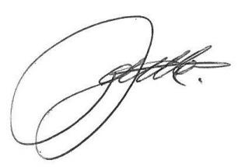

Maurice Battilana
CHIEF EXECUTIVE OFFICER
INDEX

1.0 DECLARATION OF OPENING/ANNOUNCEMENTS OF VISITORS

2.0 ANNOUNCEMENTS FROM THE PRESIDING MEMBER

3.0 RECORD OF ATTENDANCE / APOLOGIES / LEAVE OF ABSENCE (PREVIOUSLY APPROVED)

3.1 APOLOGIES

3.2 PREVIOUSLY APPROVED LEAVE OF ABSENCE

4.0 PUBLIC QUESTION TIME

4.1 RESPONSE TO PREVIOUS PUBLIC QUESTIONS TAKEN ON NOTICE

4.2 PUBLIC QUESTION TIME

5.0 APPLICATIONS FOR LEAVE OF ABSENCE

6.0 DISCLOSURE OF INTEREST

Members should fill in Disclosure of Interest forms for items in which they have a financial, proximity or impartiality interest and forward these to the Presiding Member before the meeting commences.

Section 5.60A:
“a person has a financial interest in a matter if it is reasonable to expect that the matter will, if dealt with by the local government, or an employee or committee of the local government or member of the council of the local government, in a particular way, result in a financial gain, loss, benefit or detriment for the person.”

Section 5.60B:
“a person has a proximity interest in a matter if the matter concerns –
(a) a proposed change to a planning scheme affecting land that adjoins the person’s land; or
(b) a proposed change to the zoning or use of land that adjoins the person’s land; or
(c) a proposed development (as defined in section 5.63(5)) of land that adjoins the person’s land.”

Regulation 34C (Impartiality):
“interest means an interest that could, or could reasonably be perceived to, adversely affect the impartiality of the person having the interest and includes an interest arising from kinship, friendship or membership of an association.”

Item No. | Member/Officers | Type of Interest | Nature of Interest

- PETITIONS/DEPUTATIONS/PRESENTATIONS

  - PETITIONS
  - PRESENTATIONS
  - DEPUTATIONS

- CONFIRMATION OF MINUTES FROM PREVIOUS MEETINGS

8.1 Ordinary Meeting of Council – 15 November 2017
(Previously provided under separate cover)

9.0 ITEMS TO BE DEALT WITH EN BLOC

10.0 OFFICERS REPORTS PAGE NO.

10.1 MANAGER OF PLANNING 6
10.1.1 Proposed Outbuilding – 52 (Lot 31) Dolbys Drive Waggrakine
10.1.2 Rural Industry (Olive Press)
10.1.3 Dongara to Northampton Corridor Alignment Selection Study
10.1.4 Bill Hemsley Park
10.1.5 Proposed Rezoning – L1455 Chapman Valley Road Waggrakine
10.1.6 Proposed Rezoning – 337 (L7550) Hickety Road Howatharra

10.2 FINANCE 73
10.2.1 Financial Reports for November 2017
10.2.2 Write Off Outstanding Debt – A1398

10.3 CHIEF EXECUTIVE OFFICER 78

10.3.1 2016/2017 Annual Report
10.3.2 M Ramshaw – Waiver of Fees/Charges
10.3.3 Tourism & Events Working Group – Australia Day Awards
10.3.4 Budget Variation

11.0 ELECTED MEMBERS MOTIONS OF WHICH PREVIOUS NOTICE HAS BEEN GIVEN

Nil

12.0 NEW BUSINESS OF AN URGENT NATURE INTRODUCED BY DECISION OF THE MEETING

13.0 DELEGATES REPORTS

14.0 ANNOUNCEMENTS BY PRESIDING MEMBER WITHOUT DISCUSSION

15.0 MATTERS FOR WHICH MEETING TO BE CLOSED TO MEMBERS OF THE PUBLIC

16.0 CLOSURE

ORDER OF BUSINESS:

1.0 DECLARATION OF OPENING/ANNOUNCEMENTS OF VISITORS

The President, Cr Farrell welcomed Elected Members and Staff and declared the meeting open at 9.00am.

2.0 ANNOUNCEMENTS FROM THE PRESIDING MEMBER

Nil

3.0 RECORD OF ATTENDANCE/APOLOGIES/LEAVE OF ABSENCE (PREVIOUSLY APPROVED)

3.1 Present

a. Councillors
Member
Cr Anthony Farrell (President)
Cr Kirrilee Warr (Deputy President)
Cr Nicole Batten
Cr Pauline Forrester
Cr Darrell Forth
Cr Peter Humphrey
Cr Ian Maluish
Cr Trevor Royce

b. Staff
Officer | Position
Mr Maurice Battilana | Chief Executive Officer
Simon Lancaster | Deputy Chief Executive Officer
Mrs Karen McKay | Executive Services Administrator (Minute Taker)

c. Visitors
Name
Louise Gilbert | Item 1.1

Apologies

Name
Mrs Dianne Raymond – Manager of Finance & Corporate Services

3.2 Previously Approved Leave of Absence

Name
Nil

4.0 PUBLIC QUESTION TIME

4.1 Response to Previous Public Questions On Notice

Nil
4.2 Public Question Time

Nil

5.0 APPLICATIONS FOR LEAVE OF ABSENCE

Cr Batten requested Leave of Absence of the February 2018 Ordinary Meeting of Council.

6.0 DISCLOSURE OF INTEREST

Item No. | Member/Officers | Type of Interest | Nature of Interest
10.1.3 | Cr Warr | Impartiality | Board Member of the Mid West Development Commission
10.1.3 | Cr Royce | Financial | Owns land in the area
10.1.4 | Cr Maluish | Impartiality | Member of the Parkfalls Residents Association

7.0 PETITIONS/DEPUTATIONS/PRESENTATIONS

7.1 Petitions

Nil

7.2 Presentations

Nil

7.3 Deputations

Nil

8.0 CONFIRMATION OF MINUTES FROM PREVIOUS MEETINGS

COUNCIL RESOLUTION

MOVED: CR FORTH SECONDED: CR BATTEN

  - Ordinary Meeting of Council held on Wednesday 15 November 2017

That the minutes of the Ordinary Meeting of Council held Wednesday 15 November 2017 be confirmed as a true and accurate record.
Voting 8/0
CARRIED
Minute Reference:12/17-1

9.0 ITEMS TO BE DEALT WITH EN BLOC

COUNCIL RESOLUTION

MOVED: CR WARR SECONDED: CR BATTEN

That items 10.1.2, 10.1.5, 10.1.6, 10.2.2, 10.3.3 and 10.3.4 be moved en-bloc
Voting 7/1
CARRIED
Minute Reference:12/17-2

10.0 OFFICERS REPORTS

10.1
ATTACHMENT 1
Attachment 1
Manager of Planning
December 2017

Contents

10.1 AGENDA ITEMS

10.1.1 Proposed Outbuilding – 52 (Lot 31) Dolbys Drive Waggrakine

10.1.2 Rural Industry (Olive Press)

10.1.3 Dongara to Northampton Corridor Alignment Selection Study

10.1.4 Bill Hemsley Park

10.1.5 Proposed Rezoning – L1455 Chapman Valley Road Waggrakine

10.1.6 Proposed Rezoning – 337 (L7550) Hickety Road Howatharra

ATTACHMENT 1
AGENDA ITEM: | 10.1.1
SUBJECT: | PROPOSED OUTBUILDING
PROPONENT: | G. TAFFE & L. GILBERT
SITE: | 52 (LOT 31) DOLBYS DRIVE, WAGGRAKINE
FILE REFERENCE: | A1220
PREVIOUS REFERENCE: | 8/13-2, 04/14-2 & 05/14-2
DATE: | 5 DECEMBER 2017
AUTHOR: | SIMON LANCASTER

SUPPORTING DOCUMENT:

Ref | Title | Attached  to  Report | Under Separate Cover
10.1.1(a) | Applicant’s submitted plans | √
10.1.1(b) | Outbuildings Local Planning Policy | √
10.1.1(c) | Received submissions | √

DISCLOSURE OF INTEREST

Nil.

BACKGROUND
Council is in receipt of an application to construct an outbuilding upon 52 (Lot 31) Dolbys Drive. The application has been placed before Council as it exceeds the delegation limits of the Shire’s ‘Outbuildings’ Local Planning Policy. This report recommends approval of the application, subject to the prior demolition of an existing outbuilding. An alternative recommendation is provided in the event that Council consider that the application should be refused.

COMMENT
52 (Lot 31) Dolbys Drive, Waggrakine is a 3.3657ha property located on the northern side of Dolbys Drive.

Figure 10.1.1(a) – Location Plan for 52 (Lot 31) Dolbys Drive, Waggrakine
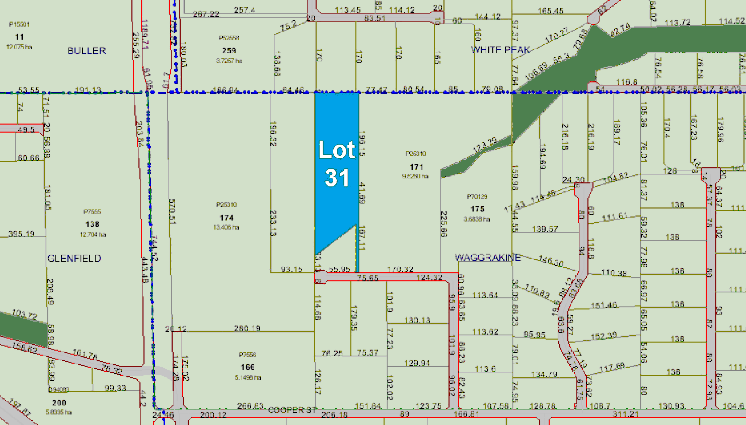

The applicant is seeking approval to construct a 160m² (16m x 10m) colorbond outbuilding, the outbuilding would have a skillion roof with a 3.45m rear wall height rising to 4.5m at the front.

The proposed outbuilding would be setback approximately 330m from Dolbys Drive, 15m from the nearest side (eastern) property boundary and 30m from the residence. A copy of the applicant’s submitted plans have been included as Attachment 10.1.1(a) for Council’s information.

In support of their application the landowner has advised as follows:

“The proposed building is a 16m x 10m skillion shed designed for use as storage of boats, camper, tractor and used as a hobby shed.

The intended location is forseen to have no negative impacts on the surrounding properties in terms of views and visual aspects. It will be of the same colour and materials as the existing buildings.

The shed is required as the existing structures consist of open stables, tack room and a granny flat.

This is the only addition required to finish the property, providing properly sealed storage. No earthworks required on the selected site.

Thank you for taking the time to consider our request.”

Figure 10.1.1(b) – Aerial Photograph of 52 (Lot 31) Dolbys Drive, Waggrakine
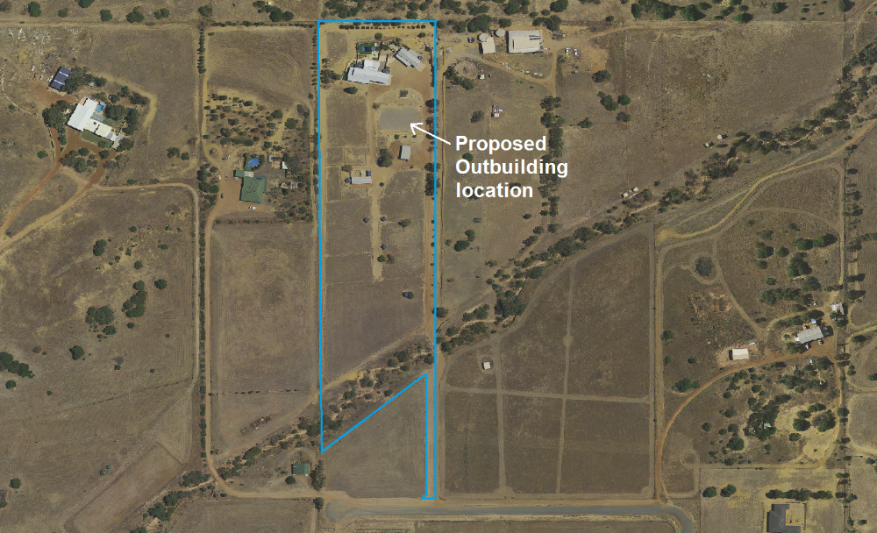

The development history for Lot 31 is as follows:

27 October 2004 98m² Outbuilding approved;
1 May 2007 96m² Outbuilding approved (aerial photographs confirm that a 66m² open sided horse equipment outbuilding also upon property was constructed prior to 2006 although no approval for this is on Shire records);
3 June 2008 259m² Residence approved;
21 September 2012 Swimming Pool approved;
23 August 2013 Council approves trial period for keeping of 4 horses and 2 sheep;
16 April 2014 Council approves keeping of stock at Scheme stocking rate (i.e. 1 horse per 2ha) with additional foals pending their sale;
21 May 2014 Council supports subdivision of Lot 172 to create Lot 30 & 31 (all buildings contained within Lot 31);
11 September 2015 Ancillary Accommodation (conversion of existing 98m² outbuilding in immediate proximity to residence) approved;
18 August 2016 WAPC approve DP406596 that creates Lots 30 & 31;
24 February 2017 Applicant purchases Lot 31.

Figure 10.1.2(c) – View of existing building area and proposed outbuilding location
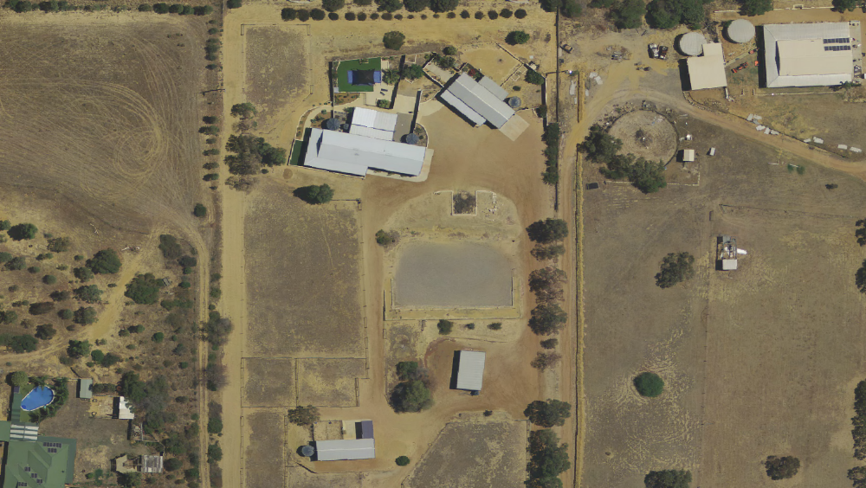

The applicant is proposing a 160m² outbuilding, and given that Lot 31 already contains 3 outbuildings that total 260m² in area, this application exceeds the 200m² total outbuilding area that Shire staff may approve under delegated authority and is therefore required to be placed before Council for its deliberation.

It is noted that the outbuilding closest to the residence has been converted to ancillary accommodation and now contains many external features that could be considered to more in keeping with a habitable building, including patios, verandahs, windows and doors. On this basis it may be considered reasonable to exclude this building from the total outbuilding area calculation which is intended for shed structures.

The revised existing total outbuilding area would therefore be calculated at 162m², and the proposed 160m² outbuilding would take the total outbuilding area to 322m², which remains in excess of the delegated authority of staff and hence the presentation of this application to Council for its consideration.

Figure 10.1.1(d) – View looking north-west at residence and ancillary accommodation
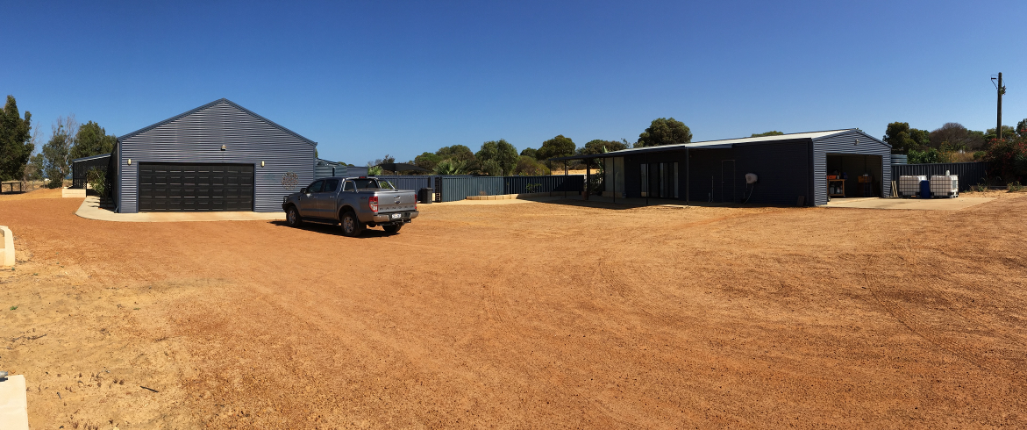

Figure 10.1.1(e) – View looking south over proposed outbuilding location
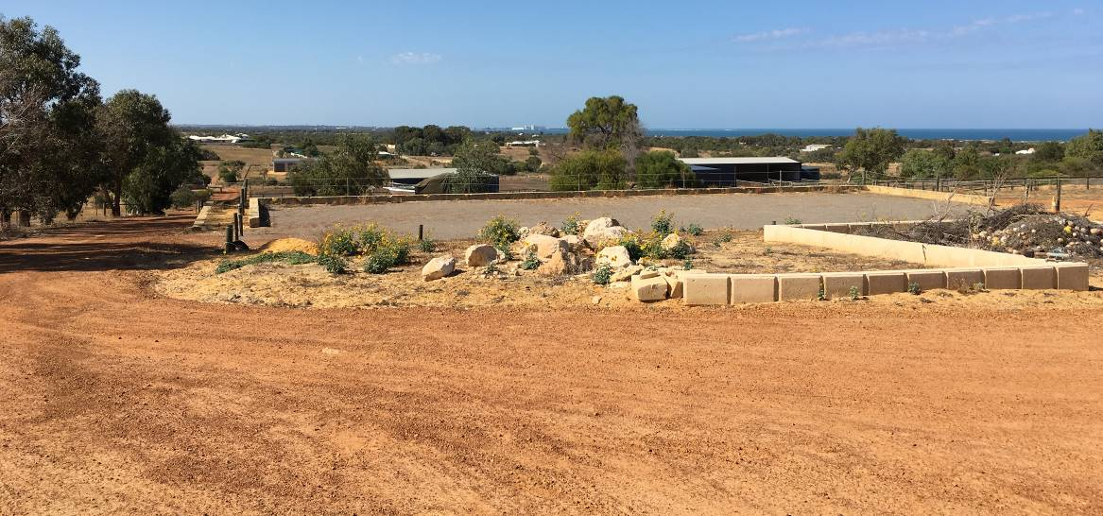

Figure 10.1.1(f) – View looking east over proposed outbuilding location
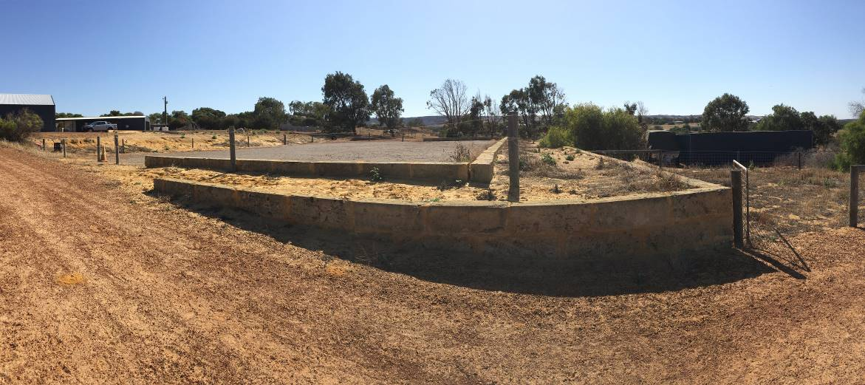

Figure 10.1.1(g) – View of Lot 31 from Dolbys Drive looking north along battleaxe access
(shed to left is on neighbouring Lot 31, buildings upon Lot 31 are in distance)
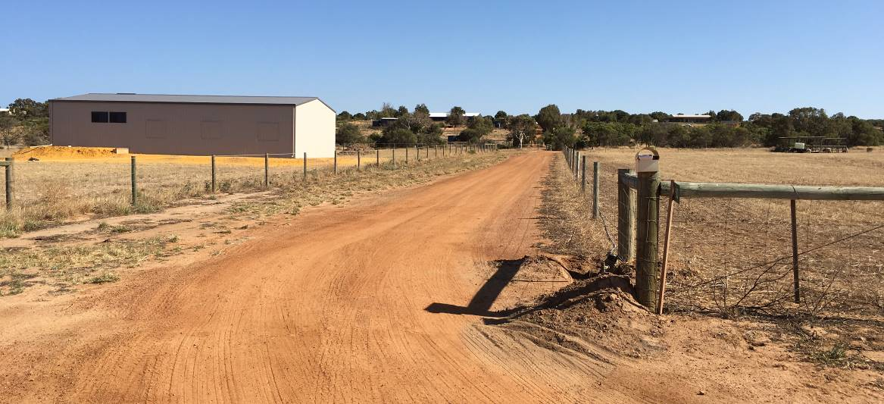

It is considered that in this particular instance the proposed development could be supported based on the following:

• the outbuilding would be setback 330m from Dolbys Drive and there is existing landscaping upon Lot 31 to assist in reducing its visual impact as viewed from the road and neighbouring properties;
• the outbuilding would be located in an area of cut and fill earthworks and possess a relatively low-slung skillion roofline to reduce the potential for impacting on neighbouring views;
• the outbuilding would be located between existing structures upon the property to create a clustered development pattern rather than be spread across the lot;
• the outbuilding would be clad in matching colours to the existing residence, ancillary accommodation and outbuildings;
• the subject property is 3.3657ha in area and the proposed outbuilding when combined with the other buildings upon the property would create a plot ratio of approximately 2% which is considered a low density of built form appropriate for a rural residential amenity;
• the proposed location for the outbuilding would not prejudice the future subdivision of Lot 31 as outlined by the Dolbys Drive Structure Plan, and it is noted that the structure plan only proposes that the lot be subdivided into 2 lots (pending the creation of a crossing over Dolbys Drive) and on this basis the subdivided lots would still be larger than the majority of those in the Parkfalls Estate to the north, or Dolby Creek Estate to the east;
• the comments of the neighbouring landowners upon the application have been sought and no objections were received.

The staff recommendation is for conditional approval of this application. However, Council should note that the recommendation includes requirement that the 66m² outbuilding upon Lot 31 that does not have approval (i.e. the south-eastern outbuilding) should be demolished prior to the construction of the proposed outbuilding. The demolition of this outbuilding would reduce the total outbuilding area upon Lot 61 to 256m² (inclusive of the proposed outbuilding) which is closer to the 200m² policy requirement and the 56m² variation is suggested as being acceptable given the 3.3657ha size of the property.

Alternatively Council may consider that condition 1 of the staff recommendation is not required and remove it from a resolution.

However, in the event that Council considers that the application should be refused, it may consider the following alternative wording appropriate in its determination on the application:

“That Council refuse planning approval for the proposed outbuilding upon 52 (Lot 31) Dolbys Drive, Waggrakine for the following reasons:

1 The development proposes an outbuilding in excess of the 200m² total aggregate area as specified under the Shire of Chapman Valley Local Planning Policy ‘Outbuildings’ for the ‘Rural Residential’ zone.

2 The proposed development is not considered consistent with the objectives of the Shire of Chapman Valley Local Planning Policy ‘Outbuildings’;

3 The proposed development is not considered consistent with Section 5.8 ‘Appearance of Land and Buildings’ of the Shire of Chapman Valley Local Planning Scheme No.2 or Section 67 of the Planning and Development (Local Planning Schemes) Regulations 2015;

4 Council is not satisfied that sufficient justification has been provided to warrant a concession being granted in this instance; &

5 Approval of this application may well set an undesirable precedent for continued variation to the Shire’s statutory and policy requirements, which in time could prove to be detrimental to the rural residential amenity and lifestyle opportunities of the locality.

Advice Note:

(i) If the applicant is aggrieved by this determination there is a right pursuant to the Planning and Development Act 2005 to have the decision reviewed by the State Administrative Tribunal. Such application must be lodged within 28 days from the date of determination.”

STATUTORY ENVIRONMENT
52 (Lot 31) Dolbys Drive, Waggrakine is zoned ‘Rural Residential 1’ under Shire of Chapman Valley Local Planning Scheme No.2 (‘the Scheme’).

Section 4.2.4 of the Scheme lists the objectives of the ‘Rural Residential’ zone as being:

“(a) Provide for residential development within a low-density environment;
(b) Provide for other land-uses compatible with a high level of residential amenity;
(c) Prevent the establishment of land-uses more appropriately undertaken in commercial and/or industrial areas; and
(d) Protect the environmental and landscape values of the land.”

Part 4 of Schedule 11 of the Scheme notes the following for the ‘Rural Residential 1’ zone:

“All buildings constructed on the land shall be sympathetic to existing landscape elements, namely landform, vegetation and amenity, in terms of their design, height, location, materials and cladding colours.”

Section 5.8 of the Scheme states:

“5.8 Appearance of Land and Buildings

5.8.1 Unless otherwise approved, no person shall erect any building or other structure which by reason of colour or type of materials, architectural style, height or bulk, ornament or general appearance, has an exterior appearance which is out of harmony with existing buildings or the landscape character of the area.

5.8.2 All buildings and land on which they are located within the Scheme area shall be maintained in a manner, which preserves the amenity of the surrounding locality to the satisfaction of the Local Government.

5.8.3 Where in the opinion of the Local Government an activity is being undertaken that results in the appearance of the property having a deleterious effect on the amenity of the area in which it is located, the Local Government shall require the owner or occupier to restore or upgrade the conditions of that property to a standard commensurate with those generally prevailing in the vicinity.”

Section 10.2 of the Scheme lists the following relevant matters to be considered by Council in considering a development application:

“(f) any Local Planning Policy adopted by the Local Government under clause 2.4, any heritage policy statement for a designated heritage area adopted under clause 7.2.2, and any other plan or guideline adopted by the Local Government under the Scheme;...
...(i) the compatibility of a use or development with its setting;…
…(n) the preservation of the amenity of the locality;
(o) the relationship of the proposal to development on adjoining land or on other land in the locality including but not limited to, the likely effect of the height, bulk, scale, orientation, and appearance of the proposal;...
... (v) whether adequate provision has been made for the landscaping of the land to which the application relates and whether any trees or other vegetation on the land should be preserved;...
…(y) any relevant submissions received on the application…
(za) any other planning consideration the Local Government considers relevant.”

POLICY IMPLICATIONS
Section 2.2 of the Scheme provides for the Council to prepare a Local Planning Policy in respect of any matter related to the planning and development of the Scheme area.

The Shire ‘Outbuildings’ Local Planning Policy has been provided as Attachment 10.1.1(b).

The proposed outbuilding upon Lot 61 would increase the total outbuilding area from 162m² to 322m². Shire of Chapman Valley Local Planning Policy ‘Outbuildings’ lists the maximum total aggregate area for Lot 61 as being 200m². Given the proposed development exceeds this policy requirement by 122m² the application cannot be determined under delegated authority and is required to be presented to Council for its consideration.

A Local Planning Policy does not bind the local government in respect of any application for planning approval but the local government is to have due regard to the provisions of the policy and the objectives which the policy is designed to achieve before making its determination.

In most circumstances the Council will adhere to the standards prescribed in a Local Planning Policy, however, the Council is not bound by the policy provisions and has the right to vary the standards and approve development where it is satisfied that sufficient justification warrants a concession and the variation granted will not set an undesirable precedent for future development.

FINANCIAL IMPLICATIONS
- Long Term Financial Plan:

The Shire of Chapman Valley Long Term Financial Plan was endorsed by Council at its 19 July 2017 meeting. It is not considered that the determination of this application by Council would have impact in relation to the Long Term Financial Plan.

STRATEGIC IMPLICATIONS
- Strategic Community Plan:

The Shire of Chapman Valley Strategic Community Plan was endorsed by Council at its 15 November 2017 meeting. It is not considered that the determination of this application by Council would have impact in relation to the Strategic Community Plan.

CONSULTATION
Section 4.11 of the ‘Outbuildings’ Local Planning Policy and Section 5.5 of the Scheme states that when considering an application for planning approval, where, in the opinion of the local government, the variation is likely to affect any owner occupiers in the general locality or adjoining the site which is the subject of consideration for the variation, the local government may consult with the affected parties, and have regard to any expressed views prior to making its determination.

The Shire wrote to the 10 landowners surrounding Lot 61 on 10 November 2017 providing details of the application and inviting comment upon the proposal prior to 1 December 2017, a sign was also erected on-site to advise of the received application and the opportunity for comment, and details of the application were placed upon the Shire website.

At the conclusion of the advertising period 3 submissions had been received, 2 in support of the application, and 1 expressing indifference, no objections were received.

A copy of the received submissions have been included as Attachment 10.1.1(c).

RISK ASSESMENT

Rating 1 (Insignificant) Measures of Consequence – Risk Assessment and Acceptance Criteria

VOTING REQUIREMENTS
Simple majority required.

COUNCIL RESOLUTION / STAFF RECOMMENDATION

MOVED: CR FORRESTER SECONDED: CR HUMPHREY

That Council grant formal planning approval for a 160m² (4.5m height) Outbuilding upon 52 (Lot 31) Dolbys Drive, Waggrakine subject to compliance with the following conditions:

- The existing outbuilding that is located immediately south of the proposed outbuilding location shall be demolished prior to the construction of the proposed outbuilding.

2 Development shall be in accordance with the approved plans dated 13 December 2017 and subject to any modifications required as a consequence of any conditions of this approval. The endorsed plans shall not be modified or altered without the prior written approval of the local government.

3 Any additions to or change of use of any part of the building or land (not the subject of this consent/approval) considered by the Chief Executive Officer to represent significant variation from the approved development plan requires further application and planning approval for that use/addition.

4 The proposed outbuilding is required to be externally clad in a complementary colour to the existing structures upon the lot to the approval of the local government.

5 The outbuilding is only to be used for general storage purposes associated with the predominant use of the land and must not be used for habitation, commercial or industrial purposes.

6 Landscaping is required to be maintained between the outbuilding and the eastern side property boundary and Dolbys Drive for the purpose of softening the visual impact of the structure to the approval of the local government.

7 The use hereby permitted shall not cause injury to or prejudicially affect the amenity of the locality by reason of the emission of smoke, dust, fumes, odour, noise, vibration, waste product or otherwise.

Advice Notes

- The applicant is advised that this planning approval does not negate the requirement for any additional approvals which may be required under separate legislation. It is the applicant’s responsibility to obtain any additional approvals required before the development/use lawfully commences.

(b) Council notes in its determination on this application that it would create a 56m² variation to the total outbuilding area specified by its Outbuildings Local Planning Policy. This variation has been considered with regard to the subject property being 3.3657ha in area, the front boundary setback being 330m, and the development having a skillion (rather than gable) roof profile and being sited in an area of cut and fill earthworks. Council further notes on this basis that this decision should not be viewed as a precedent for applications seeking relaxation of the outbuilding area requirements under the Shire’s Outbuildings Local Planning Policy.

(c) If an applicant is aggrieved by this determination there is a right pursuant to the Planning and Development Act 2005 to have the decision reviewed by the State Administrative Tribunal. Such application must be lodged within 28 days from the date of determination.

Voting 8/0
CARRIED
Minute Reference 12/17-3

Ms Gilbert left Chambers at 9.13am

ATTACHMENT 10.1.1(a)

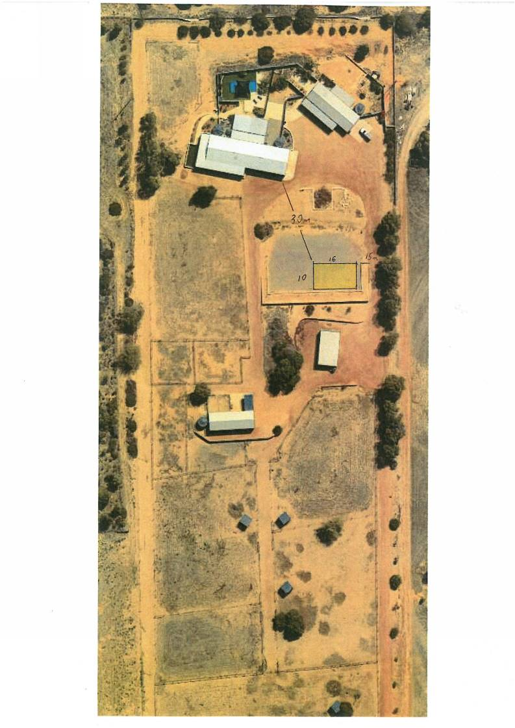

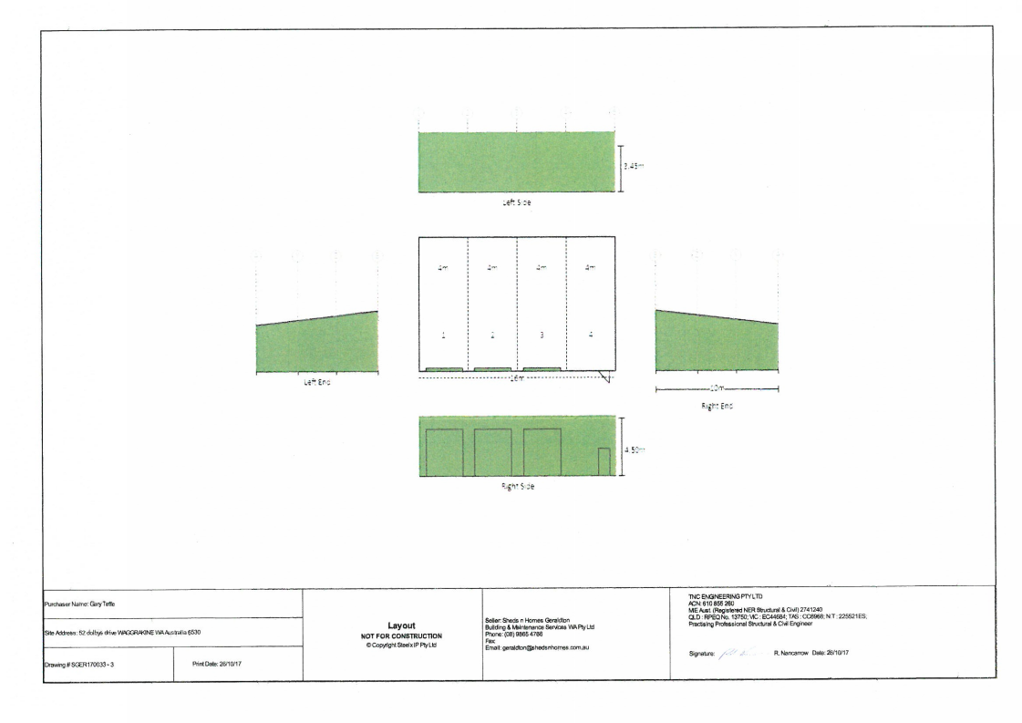

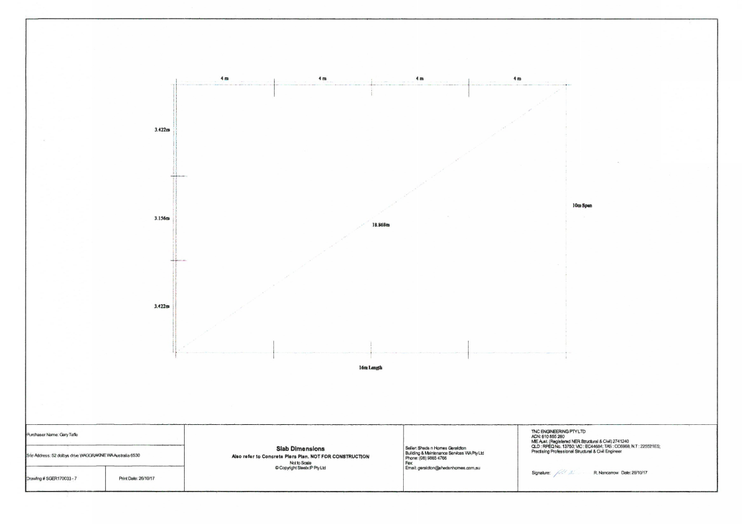

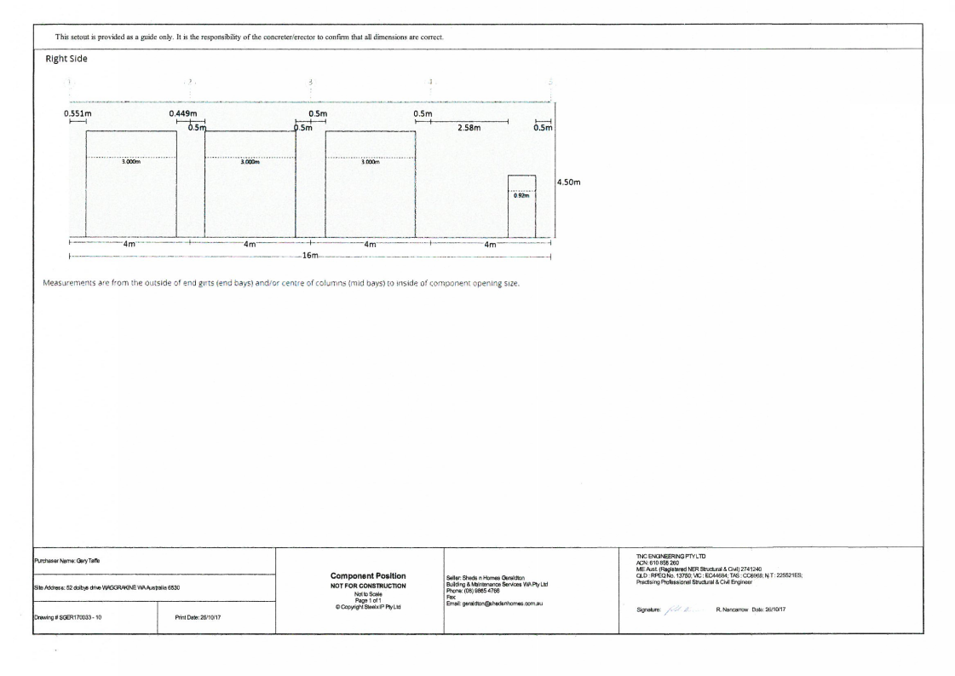
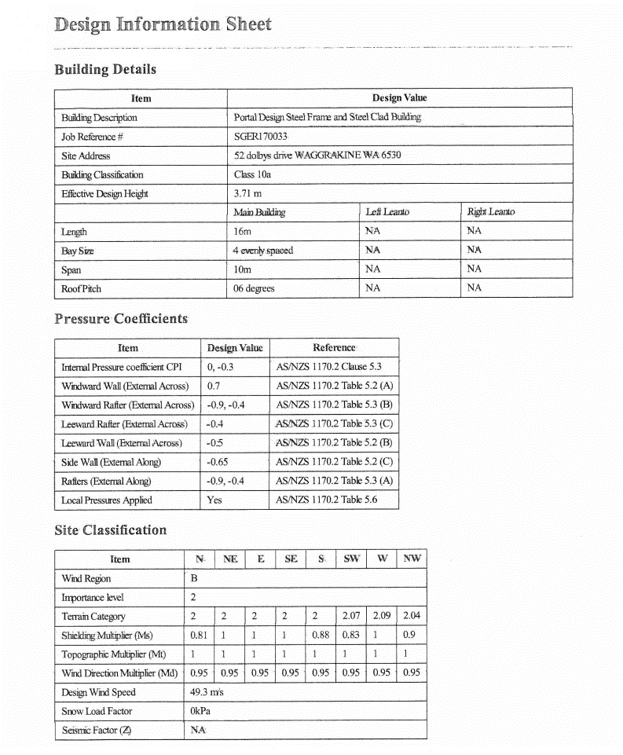

ATTACHMENT 10.1.1(b)

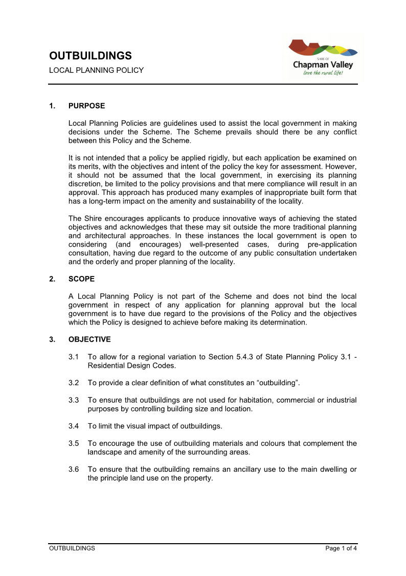

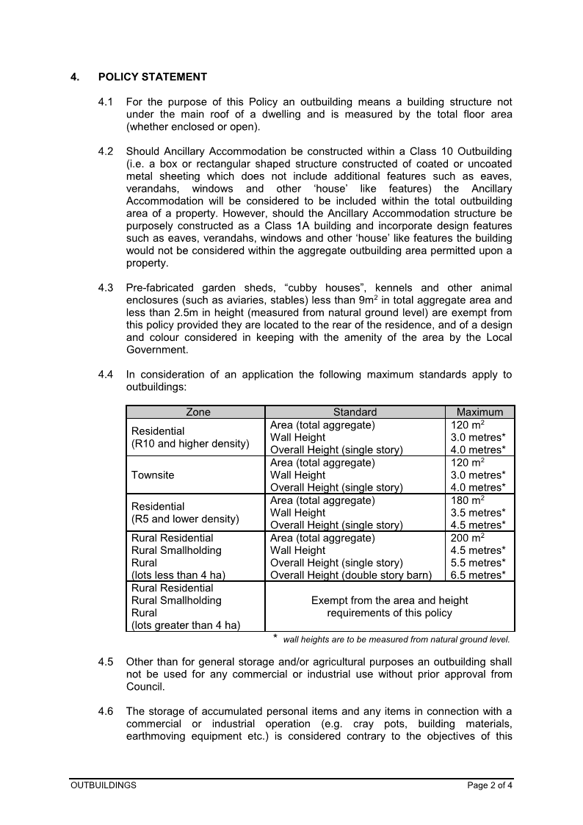

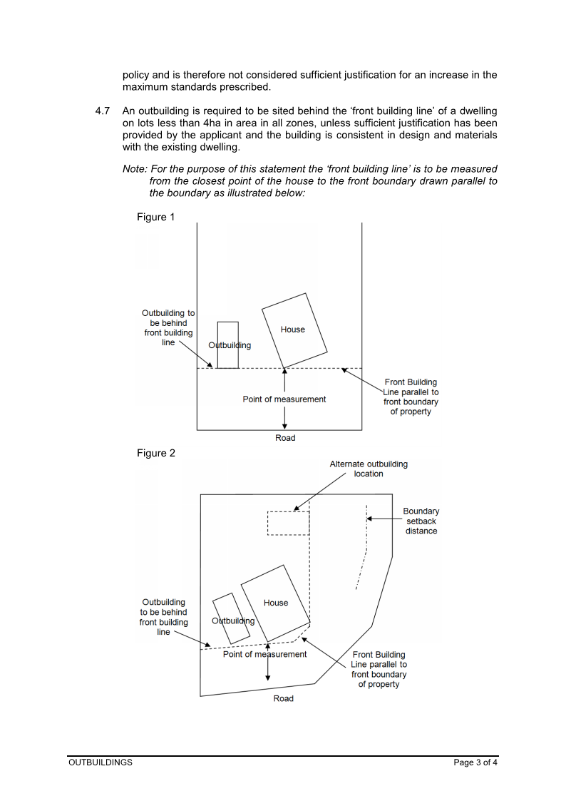

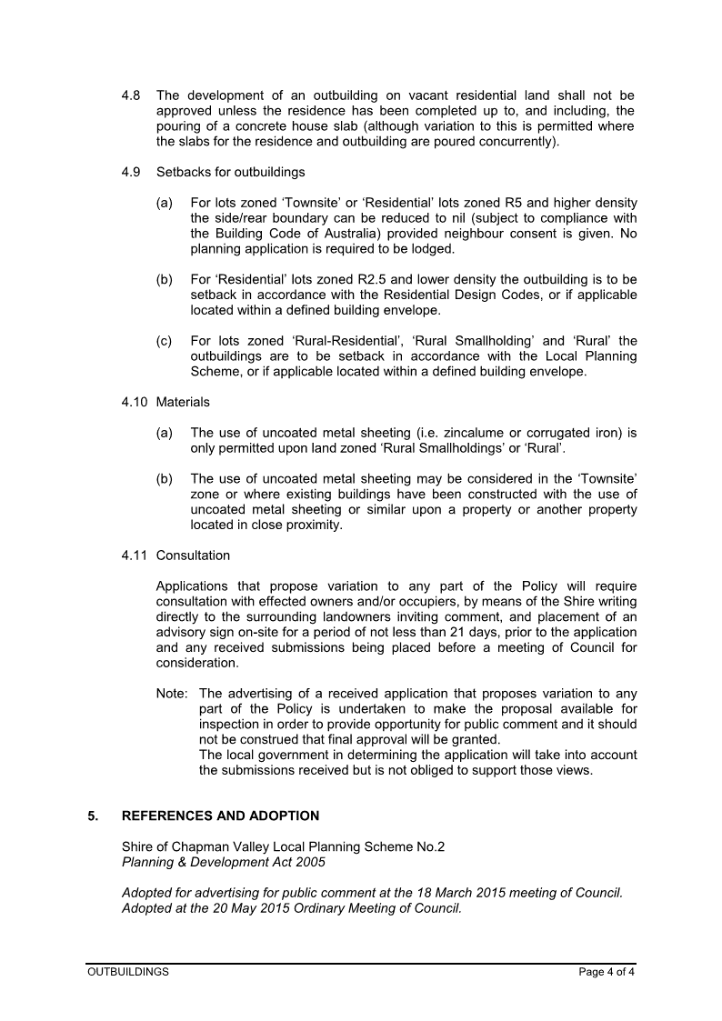

ATTACHMENT 10.1.1(c)

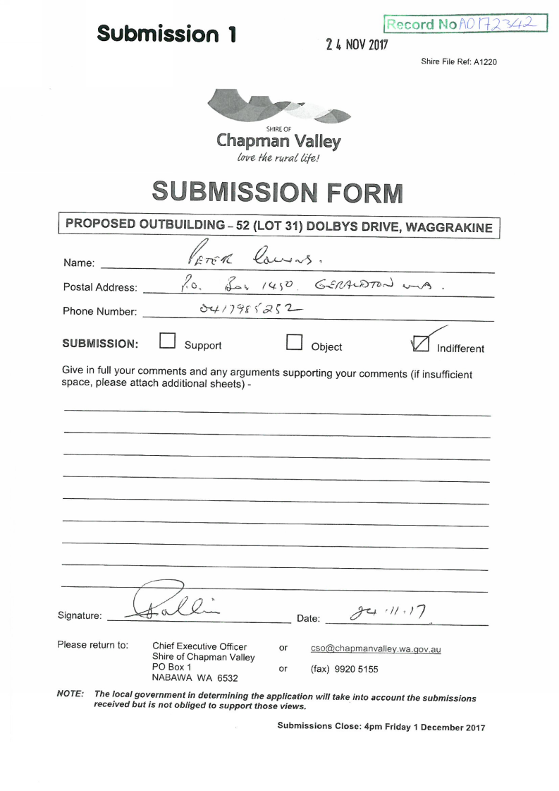

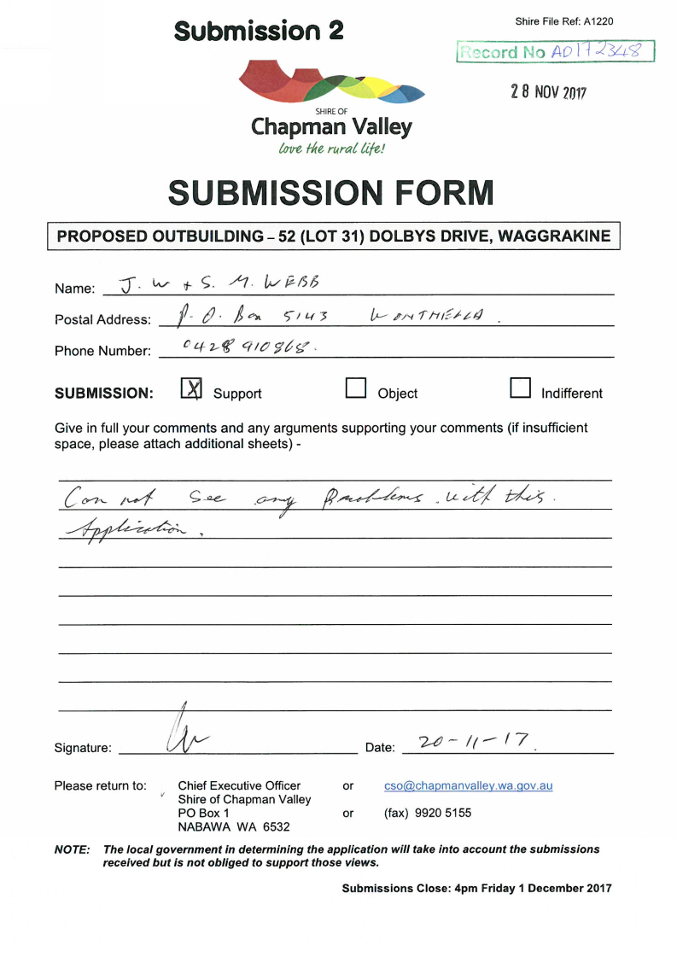

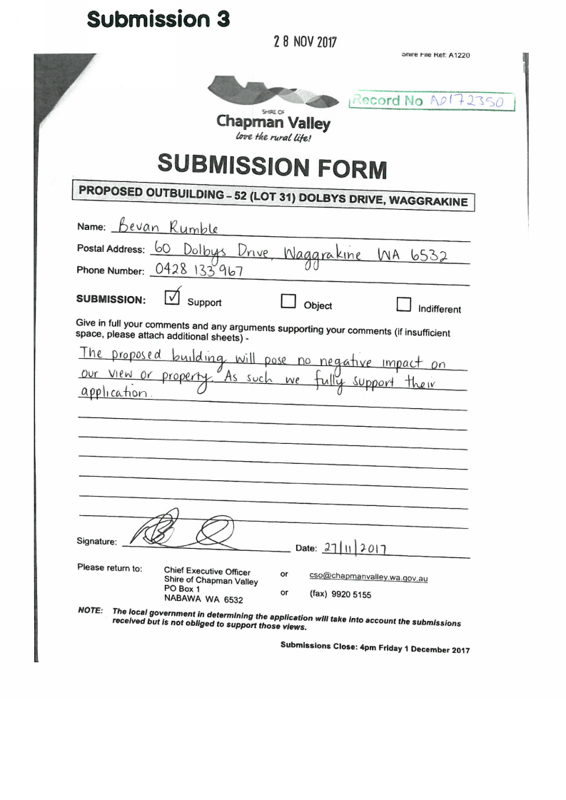

ATTACHMENT 1
AGENDA ITEM: | 10.1.2
SUBJECT: | RURAL INDUSTRY (OLIVE PRESS)
PROPONENT: | ARDLUI HOLDINGS PTY LTD
SITE: | 1957 (LOT 107) CHAPMAN VALLEY ROAD, YETNA
FILE REFERENCE: | A3
PREVIOUS REFERENCE: | 07/06-9
DATE: | 29 NOVEMBER 2017
AUTHOR: | SIMON LANCASTER

SUPPORTING DOCUMENT:

Ref | Title | Attached  to  Report | Under Separate Cover
10.1.2 | Applicant’s submitted plans | √

DISCLOSURE OF INTEREST

Nil.

BACKGROUND
Council is in receipt of an application to construct an outbuilding upon 1957 (Lot 107) Chapman Valley Road, Yetna for the purposes of operating an olive press and cool storage. This report recommends conditional approval of the application.

COMMENT
1957 (Lot 107) Chapman Valley Road, Yetna is a 80.778ha property located on the western side of Chapman Valley Road approximately 19km (by road) from the North West Coastal Highway/Chapman Valley Road turnoff. The proposed outbuilding would be sited approximately 60m from the applicant’s residence upon Lot 107, and setback approximately 200m from the front boundary and 20m from the closest (northern) side boundary.

Figure 10.1.2(a) – Location Plan for 1957 (Lot 107) Chapman Valley Road, Yetna
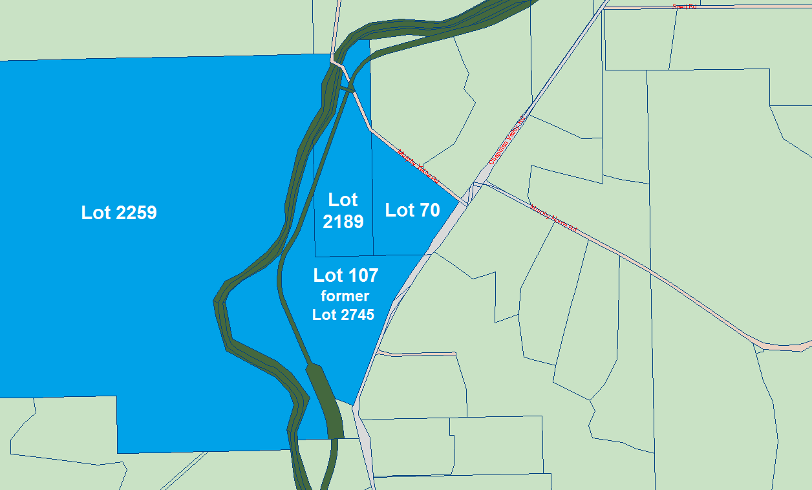

The applicant owns the adjoining 27.022ha Lot 70 and 37.4ha Lot 2189 to the north of Lot 107, and the 523.71ha Lot 2559 to the west. These properties contain an olive grove previously approved by Council, and the applicant is now seeking to operate an olive press to process their produce.

The landowner is seeking approval for a 216m² (12m x 18m) zincalume outbuilding with a 4m wall height and 5.28 apex height. A copy of the applicant’s submitted plans have been included as Attachment 10.1.2 for Council’s information.

The applicant proposes to use the outbuilding to store an olive press, that would be operated by the residents of the nearby house, and for cool storage of produce. The press would be used to process olives grown on the property, and produce would be delivered off-site i.e. there would be no ‘door sale’ retail conducted on-site.

Access to the site would be by means of the existing crossover and gravel driveway network.

It is proposed that solid waste from the pressing process would be disposed of as compost material in the olive grove.

The applicant has estimated that the hours of operation would be 150 hours per annum through May-June, the applicant has advised they may need to operate the press at night. The operations would involve a generator, hammermill and decanter.

The closest existing 3rd party residence is approximately 850m to the east of the proposed outbuilding, on the other side of Chapman Valley Road. There is potential for a residence to be developed upon a vacant lot, again on the other side of Chapman Valley Road, however, this lot contains a building envelope that would mean that a future residence would be sited approximately 500m south-east of the outbuilding. There is potential for further residences to be developed closer on the 2 lots immediately north of the outbuilding, however, it is noted that the applicant also owns these lots.

Figure 10.1.2(b) – Aerial Photograph of 1957 (Lot 107) Chapman Valley Road, Yetna
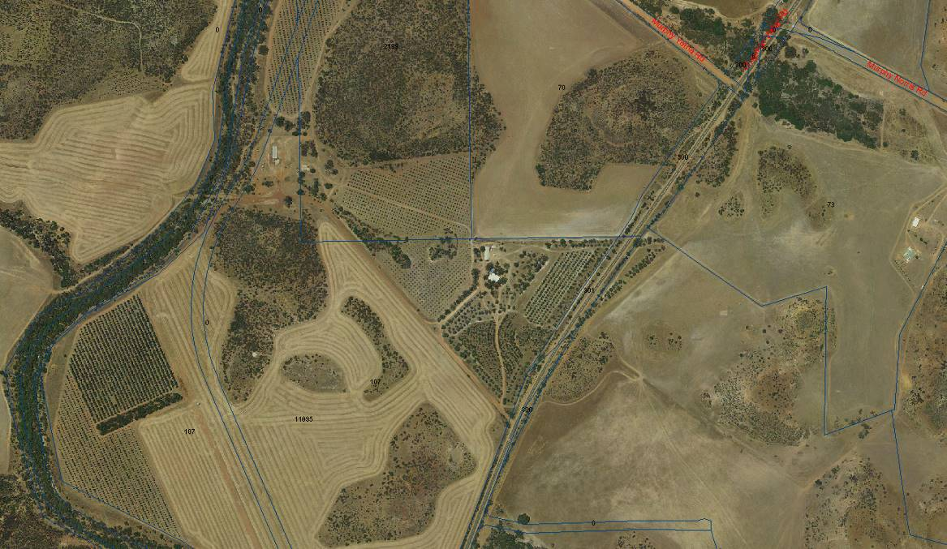

Council resolved at its 19 July 2006 meeting to approve the Chapman River Olive Grove as follows:

“That Council resolve to grant Planning Consent for the proposed intensive agricultural pursuit (olives grove) on Victoria Location 2559, 2745 and 2189 Chapman Valley Road Yetna, subject to the following conditions and advice:

Conditions

(a) This approval applies to the planting of a total of 40ha of olive trees (12.8ha established and 23.2ha proposed) to be undertaken in accordance with the approved site plan dated 19 July 2006 that forms part of this approval. Any further planting beyond this area is not permitted, unless otherwise approved by local government.

(b) The existing and further planting of 23.2ha of olive trees is directly linked to the approved allocation of groundwater issued by the Department of Water based on the required 6–8 megalitres of water per hectare per year. The planting of these trees shall not commence until written proof of water allocation has been provided to the local government.

(c) A 5m wide tree planting program, consisting of appropriate ‘wind break‘ trees capable of growing to a minimum height of 5m, shall be established around the 40ha olive grove within 12 months from the date of this approval to the satisfaction of the local government.

(d) Any polluted/waste waters arising from the horticultural activities shall not be discharged into the Chapman River or any existing soaks/dams on the property.

(e) The disposal/dumping of wastes arising from the horticultural activities shall be to the specifications and requirements of the Council’s Environmental Health Services and the Health Department of WA.

(f) The on-site processing and/or retailing of produce from the property is not permitted, unless otherwise approved by Council.

(g) Any noise generated from the horticultural activities on the property, including machinery motors, vehicles and bird scaring devices shall not exceed the levels set under the Environmental Protection Act and Regulations.

(h) The planting of olive trees and activities associated with the olive grove shall not in any interfere with the heritage values of the disused Yetna Railway Siding on Location 2745, which includes the clearing of the site and removal of any of the mature trees associated with this site.

Advice

• The proponents are advised that the use of chemicals is regulated by the Australia Pesticides and Veterinary Medicines Authority (APVMA). In this regard reference should be made to the ‘Code of Practice for the use of agricultural and veterinary chemicals in Western Australia’, February 2005 issued by the Department for Agriculture and Food.

• This approval is specifically linked to the approved allocation of groundwater granted by the Department of Water. If the proposed planting of tree has not commenced within a 2 year period from the date of this approval, a new approval must be obtained before commencing or continuing development/activity.

• The applicant is advised that a right of appeal against Council’s decision exists in accordance with the provisions of the Planning and Development Act, 2005. In this regard contact should be made with the State Administrative Tribunal on 9219 3111 or via website www.sat.justice.wa.gov.au”

Figure 10.1.2(c) – View of proposed outbuilding location
looking south-west towards existing outbuilding and residence
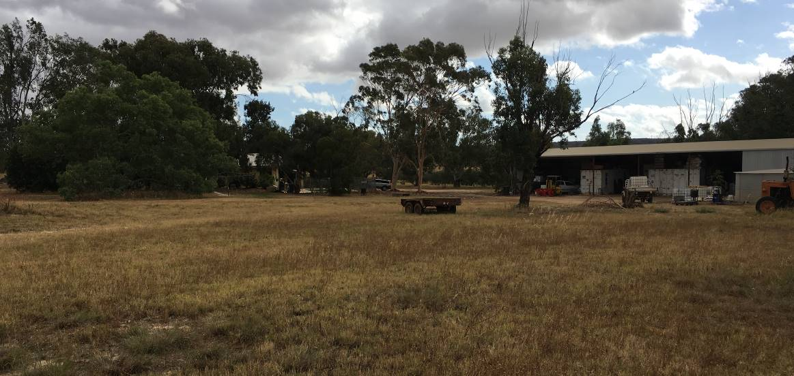

Figure 10.1.2(d) – View of proposed outbuilding location
looking north-east towards Chapman Valley Road
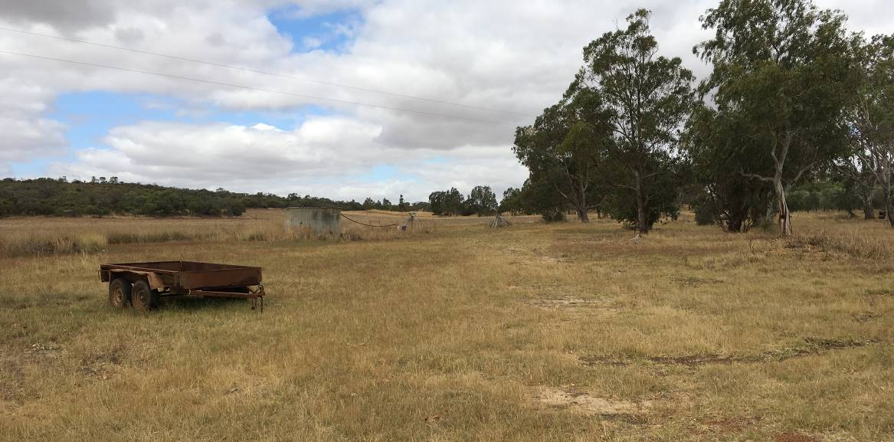

Figure 10.1.2(e) – Views north/south along Chapman Valley Road from Lot 107 entrance
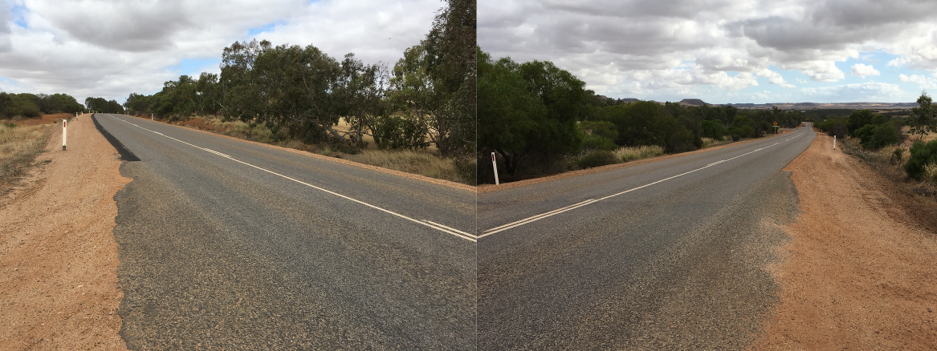

STATUTORY ENVIRONMENT
1957 (Lot 107) Chapman Valley Road, Yetna is zoned ‘Rural’ under Shire of Chapman Valley Local Planning Scheme No.2 (‘the Scheme’).

Section 4.2.5 of the Scheme lists the objectives of the ‘Rural’ zone as being:

“(a) Provide for a variety of agricultural/rural activities;
(b) Provide for other land-uses compatible with the predominant use of the land;
(c) Prevent the establishment of land-uses more appropriately undertaken in commercial and/or industrial areas;
(d) Provide appropriate protection from incompatible development for existing land uses; and
(e) Protect the environmental and landscape values of the land.”

The use of an outbuilding to process and store olives can be deemed to meet the definition of a ‘Industry-Rural’ which is defined under Schedule 1 of the Scheme as meaning:

“(a) an industry handling, treating, processing or packing rural products; or
(b) a workshop servicing plant or equipment used for rural purposes”.

‘Rural Industry’ is listed as a ‘D’ use within the ‘Rural’ zone meaning that it is not permitted unless the local government has exercised its discretion by granting planning approval.

POLICY IMPLICATIONS
The Shire’s ‘Rural Industry’ Local Planning Policy has the stated objective of specifying the minimum development standards to be applied to ‘Rural Industry’ applications.

Section 4.2 of the ‘Rural Industry’ Policy requires that:

“An application for planning consent is required to be submitted with the following criteria and minimum development standards to be met:

Criteria | Minimum Standard
General Location | Buildings are to be sited in a clustered format well away from hills, mesa tops, and ridge-lines
Setbacks * | 40m from all boundaries;  200m from neighbouring residences;  100m from any water course or water body.
Effluent & Waste Disposal | As determined by Shire Environmental Health Officer.
Building Materials & Colours | Non reflective building materials and colours complementary to the surrounding landscape to be used in areas of high visual amenity such as the Moresby Ranges and the Chapman Valley area.
Property Access | Property access is to be via a 12m form/8m gravel paved road.
On-site Carparking and Service Areas ** | Carparking and service areas to be constructed to a delineated, drained and compacted gravel standard. The number of parking bays to be calculated at 1 bay for every 50m² gross area.
Landscaping | Landscaping is to be provided around all associated buildings, parking, storage and loading areas.

* Depending on the nature of the proposed rural industry, local wind, topography and vegetation conditions, setbacks may need to be greater than those specified above. When determining such setbacks Council shall consider existing and potential land-uses on adjoining and nearby properties.

** Where a rural industry has direct access to a sealed road and car parking for ten or more staff is required (as determined by Council) and/or the projected number of vehicle movements from the site would justify such a requirement, Council may require crossover, vehicle access, loading and car parking areas to be constructed with a stable, impervious surface, with stormwater runoff being controlled. Construction of a crossover shall be in accordance with Council Policy 15.10.”

In relation to each of the policy criteria the following consideration is given:

• General Location – the development would operate from an outbuilding that would be clustered with the existing residence, swimming pool and outbuilding;
• Setbacks – the development would be located 200m west of the lot’s Chapman Valley Road frontage, 750m east of the Chapman River, and 850m west of the nearest neighbouring residence, the development would be located 20m from the nearest property boundary although it is noted that the adjoining lot to the north is also owned by the applicant, and the applicant has previously applied to realign this boundary to increase the outbuilding’s setback to the proposed new boundary to 150m;
• Effluent & Waste Disposal – not part of this application, however, were the landowner to later make application for installation of a toilet or sink in the outbuilding this would be subject to standard Shire health requirements;
• Building Materials & Colours - it is common for Council to require cladding to be coloured to match natural landscape features, however, in this instance the applicant proposes that the outbuilding be clad in zincalume to match the adjacent existing outbuilding, it is also accepted that zincalume is a commonly used rural building material;
• Property Access – the applicant proposes to use the existing driveway/crossover and there would be no additional traffic movements or general public/visitor access to the development;
• On-site Car Parking and Service Areas – there is sufficient available area to ensure vehicle manoeuvring and parking is conducted on-site;
• Landscaping – the development site is obscured from the tourist route of Chapman Valley Road by an intervening hill and vegetation, and it is recommended that the installation and maintenance of landscaping along the northern boundary in the event of the adjoining lot being sold by the applicant be made a condition of any approval.

A Local Planning Policy does not bind the local government in respect of any application for planning approval but the local government is to have due regard to the provisions of the policy and the objectives which the policy is designed to achieve before making its determination.

In most circumstances the Council will adhere to the standards prescribed in a Local Planning Policy, however, the Council is not bound by the policy provisions and has the right to vary the standards and approve development where it is satisfied that sufficient justification warrants a concession and the variation granted will not set an undesirable precedent for future development.

FINANCIAL IMPLICATIONS
On determination of this application (refusal/approval) should the applicant be aggrieved by the determination or conditions of approval they have a right of appeal to the State Administrative Tribunal with a cost likely to be imposed on the Shire through its involvement in the appeal process.

- Long Term Financial Plan:

The Shire of Chapman Valley Long Term Financial Plan was endorsed by Council at its 19 July 2017 meeting. It is not considered that the determination of this application by Council would have impact in relation to the Long Term Financial Plan.

STRATEGIC IMPLICATIONS
The Shire of Chapman Valley Local Planning Strategy (2008) identifies Lot 107 as being located within ‘Precinct 3 – Chapman Valley’ the vision for which is:

“A diverse range of rural pursuits and incidental tourist developments that complement the sustainable use of agricultural resources.

The Strategy lists ‘Rural Industry’ as an appropriate land use for Precinct No.3.

The operation of this ‘Rural Industry’ is considered to align with the following Precinct No.3 economic objectives:

“3.2.1 Facilitate agricultural diversification in appropriate areas where there will be no detrimental impact to the surrounding land.”

3.2.2 Encourage the experimentation and growth of newer crops and animal varieties through farm diversification and support value adding to this diversified farm produce. This could include links to tourism in accordance with Council Policy.

3.2.3 Promote opportunities for processing and value adding to agricultural produce.”

The operation of the ‘Rural Industry’ would need to satisfy the following Precinct No.3 environmental objectives:

“3.3.3 Ensure development does not adversely impact on river systems, associated catchment areas and groundwater resources through the provision/submission of detailed/supporting research, information and analysis.

3.3.4 Ensure that land use conflicts (i.e. noise, dust, odour, spray drift, vermin etc.) are avoided through appropriate environmental and planning controls.

3.3.5 Protect the rural amenity and character of the area from incompatible land use/development, again through appropriate environmental and planning controls.

3.3.6 Ensure fire prevention measures are implemented and maintained in accordance with statutory requirements as a minimum.”

- Strategic Community Plan:

The Shire of Chapman Valley Strategic Community Plan was endorsed by Council at its 15 November 2017 meeting and the approval of this development would meet the following identified goal:

“Provide support for business development and local employment”

CONSULTATION
Council is not required to advertise the application for an outbuilding/olive press, however, should Council wish to seek comment prior to making its determination it may do so under Sections 9.4.2 & 10.1.1 of the Scheme.

The application for the olive grove was previously advertised for public comment in 2006 by Council prior to making its determination, and objection was received at the time concerning the issue of groundwater impact. This issue was addressed through specific condition of approval, and is an area that is governed by the Department of Water and Environment Regulation.

RISK ASSESMENT

Rating 1 (Insignificant) Measures of Consequence – Risk Assessment and Acceptance Criteria

VOTING REQUIREMENTS
Simple majority required.

COUNCIL RESOLUTION / STAFF RECOMMENDATION

MOVED: CR WARR SECONDED: CR BATTEN

That Council grant formal planning approval for a Rural Industry (Olive Press & Storage) and associated Outbuilding upon 1957 (Lot 107) Chapman Valley Road, Yetna subject to compliance with the following conditions:

1 Development shall be in accordance with the approved plans dated 13 December 2017 and subject to any modifications required as a consequence of any conditions of this approval. The endorsed plans shall not be modified or altered without the prior written approval of the local government.

2 Any additions to or change of use of any part of the building or land (not the subject of this consent/approval) considered by the Chief Executive Officer to represent significant variation from the approved development plan requires further application and planning approval for that use/addition.

3 The development must comply with the Environmental Protection (Noise) Regulations 1997 and the Environmental Protection Act 1986 in respect to emissions and should noise or other monitoring be required in relation to the operations as they take place upon Lot 107, all costs shall be met by the applicant.

4 The proponent is to implement and maintain reporting mechanisms for complaints concerning the operation of the development. In the event of a substantiated complaint being received the applicant is required to demonstrate mitigation response(s) to the approval of the local government.

5 The access point onto Chapman Valley Road shall be to the requirements of Main Roads WA, with all costs met by the applicant.

6 The internal road network and vehicle manoeuvring and parking areas shall be constructed and maintained to an all-weather compacted gravel standard to the approval of the local government, with all costs met by the applicant.

7 The approval is for the processing of olives upon the property for transportation off-site, this approval is not for direct retail to the public on-site.

8 In the event that the adjoining property to the north of the development ceases to be under the same ownership as the development property then landscaping is required to be installed and maintained between the development and the northern property boundary, for the purposes of screening the development, to the approval of the local government, with all costs met by the applicant.

9 All waste product from the development shall be disposed of the requirements of the local government (waste product must not be disposed of into the Chapman River).

10 All lighting devices shall be installed and shaded in such a way as to not cause undue light spill to passing motorists or neighbouring residences to the approval of the local government.

11 The use hereby permitted shall not cause injury to or prejudicially affect the amenity of the locality by reason of the emission of smoke, dust, fumes, odour, noise, vibration, waste product or otherwise.

12 No signs or hoardings are to be erected in relation to the development without prior authorisation being obtained from Main Roads WA and the local government.

Advice Notes

(a) The applicant is advised that this planning approval does not negate the requirement for any additional approvals which may be required under separate legislation including but not limited building, food or health legislation. It is the applicant’s responsibility to obtain any additional approvals required before the development/use lawfully commences.

(b) If an applicant is aggrieved by this determination there is a right pursuant to the Planning and Development Act 2005 to have the decision reviewed by the State Administrative Tribunal. Such application must be lodged within 28 days from the date of determination.

Voting 7/1
CARRIED
Minute Reference:12/17-2
(Item moved en-bloc)

ATTACHMENT 10.1.2

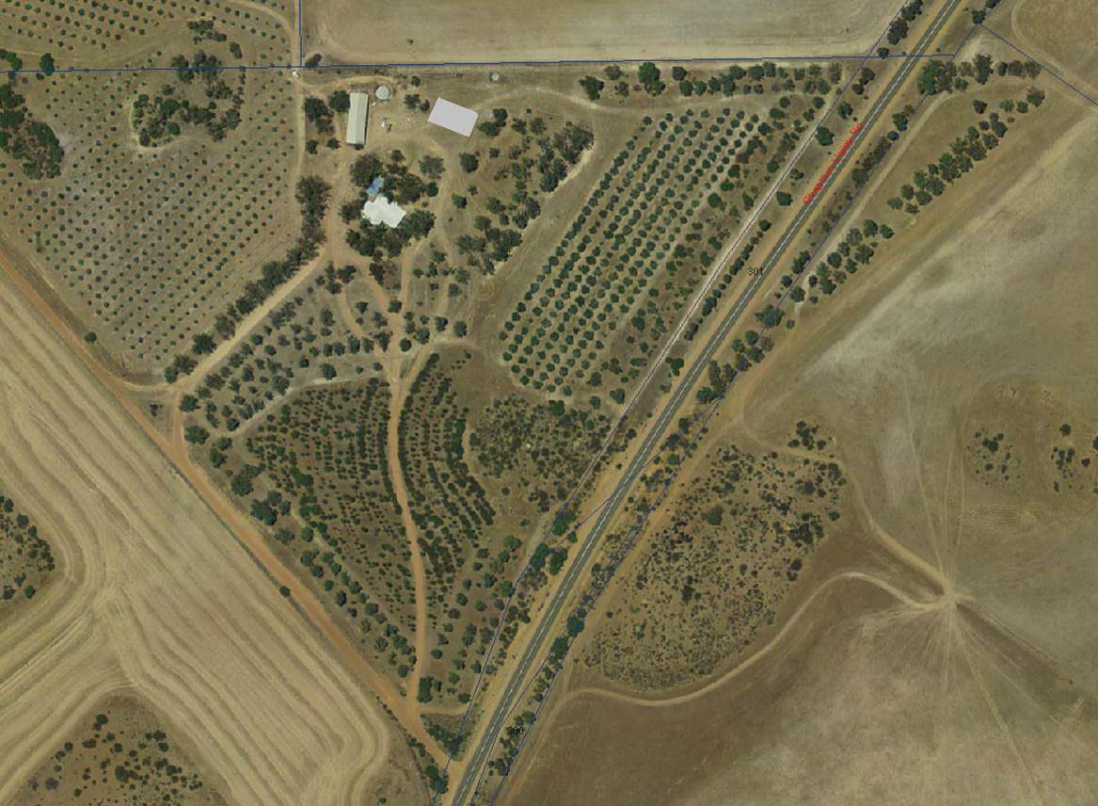

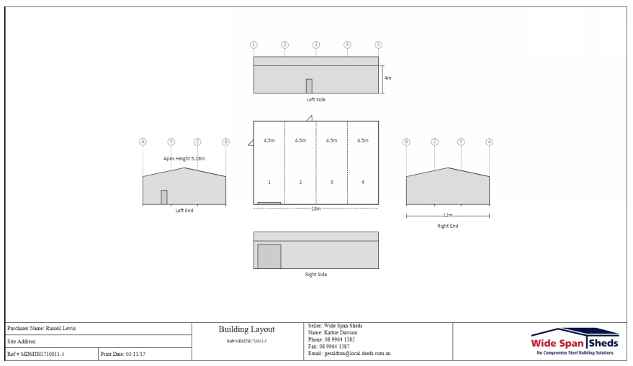

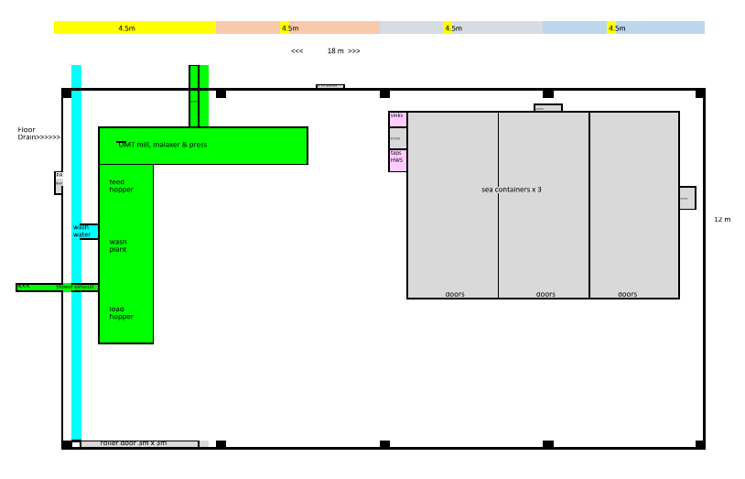

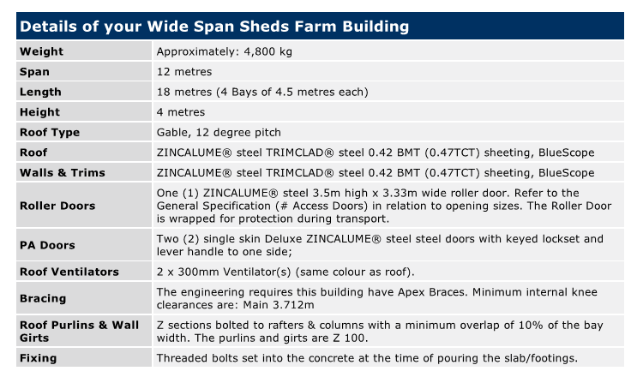
ATTACHMENT 1
AGENDA ITEM: | 10.1.3
SUBJECT: | DONGARA TO NORTHAMPTON CORRIDOR ALIGNMENT SELECTION STUDY
PROPONENT: | MAIN ROADS WA & MID WEST DEVELOPMENT COMMISSION
SITE: | MULTIPLE LOTS IN THE NARRA TARRA, WHITE PEAK, OAKAJEE, YETNA AND HOWATHARRA LOCALITIES
FILE REFERENCE: | 204.16.07
PREVIOUS REFERENCE: | 03/14-3 & 09/15-10
DATE: | 30 NOVEMBER 2017
AUTHOR: | SIMON LANCASTER

SUPPORTING DOCUMENT:

Ref | Title | Attached  to  Report | Under Separate Cover
10.1.3 | Dongara to Northampton Corridor Alignment Selection Study routes (as contained in the joint local government correspondence to the Minister for Transport, Planning and Lands) | √

DISCLOSURE OF INTEREST

Nil.

BACKGROUND

An update is provided in relation to the Dongara to Northampton Corridor Alignment Selection Study and this report recommends a number of actions for Council’s consideration.

COMMENT

In 2015 Main Roads WA released the draft Dongara to Northampton Corridor Alignment Selection Study that considered a range of alignment options to enable triple road-trains to travel south from their current termination point at Carnarvon to continue through to north of Perth. This will require several realignments to bypass Northampton, Geraldton and Dongara and the study is tasked with identifying the final corridor.

Three of the alignments under investigation are within the Shire of Chapman Valley (Options 4, 5 & 6) and Option 6 is the alignment of the Oakajee Narngulu Infrastructure Corridor (‘ONIC’).

Options 1, 2 & 3 are relevant to the section of the corridor between Dongara and Walkaway within the Shire of Irwin and the City of Greater Geraldton.

A map of the alignment options is provided as Attachment 10.1.3.

Council resolved at its 16 September 2015 meeting:

“That Council make submission to Main Roads WA regarding the Dongara to Northampton Alignment Selection Study as follows:

1 Council is supportive of Option 6 (i.e. the Oakajee-Narngulu Infrastructure Corridor ‘ONIC’ alignment between Morrell Road and the North West Costal Highway).

2 Council urges Main Roads WA and the Department of State Development to adopt the Option 6 section (i.e. the Oakajee-Narngulu Infrastructure Corridor alignment between Morrell Road and the North West Costal Highway) as Stage 1 for both land acquisition and construction as this will serve to immediately provide, in conjunction with Morrell Road, a short-term Geraldton Outer Bypass.

3 That the land acquisition phase of the corridor project commence upon finalisation of the alignment definition phase, and not be delayed by identifying future road reservations in local government planning schemes as this will unnecessarily prolong the project and pass the financial burden of addressing claims for compensation onto the local government.”

The Shire has also expressed the view that the Northampton Bypass was crucial, and should be an immediate priority.

The 4 relevant local governments (Shire of Chapman Valley, City of Greater Geraldton, Shire of Irwin and Shire of Northampton) jointly wrote to the Premier, the Minister of Transport, and all relevant state election candidates on 19 December 2016 to advise of their united position. The joint local governments again wrote to the new Premier, Minister for Transport, Planning and Lands, Minister for Regional Development and incoming Agricultural Region MLC on 21 March 2017. The Minister for Transport, Planning and Lands has written to advise the Shire that the Alignment Selection Study is progressing and is subject to further consultation and consideration and that a Working Group will be established.

The Shire of Chapman Valley has repeatedly expressed the view that whilst this is an alignment definition study, that whichever option was ultimately selected, the upshot of the study would be to draw a line on a map, and this would impact upon landowners who must not be left in limbo, and should be treated fairly and quickly through an immediately following land acquisition process.

The Shire of Chapman Valley expressed its disappointment that its specific request, prior to the advertising period being commenced, that the consultation maps be improved to colour the east-west portion of the ONIC to clearly indicate this was the Option 6 alignment had not been acted upon. The Shire expressed the view that the consultation maps made available to the public (with this vital section left black and white) gave the impression that Option 6 was the ‘do nothing’ option of leaving heavy traffic to run through Geraldton along the current alignment of the North West Coastal and Brand Highways, and the continuation of the current safety and intersection issues. The view was expressed that this potential for confusion needed to be recognised if community feedback was to be cited as a reason for Option 4 or 5 being promoted. The map provided as Attachment 10.1.3 has been modified by the Shire to avoid this misrepresentation.

The Shires of Chapman Valley, Irwin and Northampton and City of Greater Geraldton have jointly expressed their support for Option 6, the Northampton Bypass and the importance of a timely and fair land acquisition process in correspondence sent to the Minister for Transport, Planning and Lands.

It is understood that the Department of Jobs, Tourism, Science & Innovation (formerly Department of State Development), the Department for Planning and LandCorp have also raised concerns that Options 4 & 5 propose to bypass the Oakajee Industrial Estate.

Main Roads WA and the Mid West Development Commission support Option 4 which bypasses the Oakajee Industrial Estate.

As a summary, the Shire of Chapman Valley’s stance in relation to Option 6 has been reached based on the following:

• would impact on fewer landowners;
• impacts upon a lesser area of remnant vegetation (noting also that Options 4 & 5 run through 2 Conservation Nature Reserves);
• impacts upon fewer watercourses and tributaries;
• utilises existing road reserve where possible;
• less expensive to acquire;
• argument that Option 6 would be significantly more expensive to construct has not been provided, indeed the preliminary costings provided to the Shire indicate that Option 6 would be less expensive than Options 4 or 5, and costings relating to ‘freight efficiency’ in support of Options 4 or 5 have not been provided;
• Option 6 is not significantly longer (possibly 5km at most);
• the majority of the Option 6 alignment between the Wokatherra Gap and the North West Coastal Highway has already been acquired by the State Government for the purposes of the Oakajee Industrial Estate Buffer;
• in the event that widening for additional passing lanes or dual carriageway is required the land either side of the Option 6 alignment is already under State Government ownership for a 10km section of Option 6 (from White Peak Road to Coronation Beach Road);
• the acquisition and construction of either Option 4 or 5 would not preclude the need for Option 6 to still be acquired and constructed to provide linkage between the Oakajee Port and Industrial Estate to the Narngulu Industrial Estate, Geraldton Port, iron ore mines and the wider heavy vehicle and rail network;
• Option 6 can form part of a staged construction of the overall corridor which has more immediate cost and traffic flow advantages, Options 4 & 5 would not provide any linkage until constructed in their entirety as they are new alignments;
• Option 6 can resolve heavy vehicle traffic issues within Geraldton in a more timely manner than Options 4 & 5;
• Acquisition of Option 6 as part of this project has the accompanying benefit of providing greater certainty to potential investment and development in the Oakajee Industrial Estate which is currently isolated from rail, road and service corridors;
• Option 6 is along a general alignment that has been identified in planning documents since the 1970’s and landowners who have purchased in vicinity of the alignment since that time would be expected to have given regard for this, Options 4 & 5 have not been previously suggested;
• Option 6 provides an improved means for residents of the inland and coastal sections of the Chapman Valley community to interact, Options 4 & 5 do not serve this function;
• Option 6/ONIC represents the final major piece of state acquisition for the Oakajee Mid West Development Project, with the overall aim being to establish an integrated port and industrial estate at Oakajee; supporting rail and infrastructure corridors to facilitate the development of the resources sector in the Mid West; and ensure the long-term prosperity of the region. Ensuring that the Dongara to Northampton Corridor alignment replicates the ONIC alignment is essential for the Oakajee Mid West Development Project. Without certainty and security over access into the Oakajee Port and Industrial Estate then the previous land acquisitions of the Oakajee Industrial Estate and buffer area are isolated and unworkable, and private enterprise is unable to access the site which can lead to further incidents such as the socially divisive and unsuccessful application for Mining Tenement Miscellaneous Licence (for the purpose of transporting minerals) as previously lodged by Karara Mining Ltd, or provide an obstacle to potential project proponents (such as the current slurry pipeline proposal);
• Option 6 would also provide a strategic linkage for the Oakajee Port and Industrial Estate to the Narngulu Industrial Estate, Geraldton Port, iron ore mines to the south-east and north-east of Geraldton, and the wider heavy vehicle and rail network, and without it the Oakajee Industrial Estate is considered unlikely to develop to any significant level in the near future. Further to this, strategic industrial projects that do not require rail or port access could be encouraged to establish at the Oakajee site, rather than be lost to the Mid West region due to the Narngulu Industrial Estate being constrained by its cumulative emissions modelling. It might also be considered that logistics, transport, regional waste, energy and general industrial uses might consider the Oakajee Industrial Estate as a viable location were Option 6/ONIC to be in place and providing suitable road connection;
• the acquisition of Option 6/ONIC at the earliest possible stage will remove uncertainty for both landowners and private enterprise, as well as potential cost savings to the State Government. The acquisition of Option 6/ONIC will also remove statutory planning (in regards to development application assessment) and financial issues (in defending development decisions) for Local Government whereby landowners of private land may seek to lodge applications for development upon the alignment.

STATUTORY ENVIRONMENT

Options 4 and 5 are not identified within the Shire of Chapman Valley Local Planning Scheme No.2, this is also the case with Option 6 excepting the already operating section of the North West Coastal Highway that forms part of Option 6, which is zoned ‘Major Road’.

It is not recommended that Council initiate any amendments (‘rezonings’) to its Scheme to recognise whichever option is ultimately selected as a public purpose zoning, until, at a minimum, a formal commitment has been made by the State Government for the funding and acquisition of the alignment, and more preferably until the alignment has been acquired by the State Government and the zoning map can then correlate to the created cadastral boundaries. The reasoning behind this recommendation being that where privately owned land is zoned for an exclusively public purpose then the effected landowner can make a claim for compensation to the Local Government under Section 11.5.1 of the Scheme.

POLICY IMPLICATIONS

Shire of Chapman Valley Local Planning Policy 16.190 ‘Development adjacent to the proposed Oakajee to Tallering Peak and Oakajee to Narngulu Rail Corridors’ seeks to prevent incompatible development in vicinity to the ONIC/Option 6.

FINANCIAL IMPLICATIONS

The Main Roads WA correspondence relating to the Dongara to Northampton Coastal Route Corridor Alignment Selection Study dated 10 August 2015 stated that “No funding is currently available for any land acquisition or construction works”.

The State Budget that was announced in May 2015 included an allocation of $10.3 million to commence compulsory land acquisition for the ONIC, this amount was later withdrawn.

Concern is raised that the Dongara to Northampton Corridor Alignment Selection Study will result in further landowners being left in the position where a ‘line on a map’ is drawn over their property. It is considered that this is an unfair position for a landowner to be held in where there is no known timeframe as to when it will be bought by the state, no indication on what a purchase price might be, and no indication on which state government agency or which process might be responsible for the acquisition process.

- Long Term Financial Plan:

The Shire of Chapman Valley Long Term Financial Plan was endorsed by Council at its 19 July 2017 meeting, given Council is a commenting authority and not a decision making/delivery authority in relation to the Dongara this instance, it is not considered that this project would have impact upon the Shire’s Long Term Financial Plan.

STRATEGIC IMPLICATIONS

The ONIC (Option 6) is one component of the broader Oakajee Mid West Development Project which seeks to establish an integrated port and industrial estate at Oakajee; supporting rail and infrastructure corridors to facilitate the development of the resources sector in the Mid West; and ensure the long-term prosperity of the region.

A road and rail bypass east of the Moresby Range around Geraldton was identified in a number of planning studies including the 1976 and 1989 editions of the Department of Planning’s Geraldton Region Plan. A number of studies were undertaken in the 1990’s to identify and assess a suitable railway corridor from the Narngulu Industrial Estate to the proposed Oakajee Industrial Estate and to service the proposed An Feng Kingstream Steel Project.

The ONIC was further refined through the 1999 and 2011 editions of the Geraldton Region Plan (and its associated Greater Geraldton Structure Plan) and is also recognised in the following planning documents relevant to the Shire of Chapman Valley:

• Shire of Chapman Valley Local Planning Strategy (2008).
• Moresby Range Management Strategy (2009) prepared by the Department of Planning;
• Moresby Range Management Plan (2010) prepared jointly by the Shire of Chapman Valley and City of Greater Geraldton;
• Oakajee Industrial Estate Structure Plan (2011) prepared by LandCorp.

- Strategic Community Plan/Corporate Business Plan:

The Shire of Chapman Valley Strategic Community Plan was endorsed by Council at its 15 November 2017 meeting and the “need for wider and safer roads” was raised by the community as a key challenge. The Strategic Community Plan also identifies “Bypass through White Peak Road reserve (ONIC) for improved safety and beach access” as a specific priority and aspiration in which the Shire has a role to “act on opportunity” and “advocacy”.

CONSULTATION

The ONIC (Option 6) alignment has been identified in numerous public planning documents since 1976 and subject to repeated consultation with landowners with the most recent being in 2014 when the Department of Planning undertook the ONIC Alignment Definition Report. It is unclear as to the level of landowner awareness of Options 4 & 5 and Council may feel that it is appropriate that landowners along, and adjoining, these proposed alignments, be written to by the Shire to advise that these alternative inland alignments are subject to consideration.

Section 2.10 of the Local Government Act 1995 provides the following:

“2.10. Role of councillors

A councillor —

(a) represents the interests of electors, ratepayers and residents of the district; and
(b) provides leadership and guidance to the community in the district; and
(c) facilitates communication between the community and the council; and
(d) participates in the local government’s decision-making processes at council and committee meetings; and
(e) performs such other functions as are given to a councillor by this Act or any other written law.”

RISK ASSESMENT

Rating 1 (Insignificant) Measures of Consequence – Risk Assessment and Acceptance Criteria

VOTING REQUIREMENTS

Simple Majority required

Cr Warr and Cr Royce left Chambers at 9.14am

COUNCIL RESOLUTION / STAFF RECOMMENDATION

MOVED: CR FORRESTER SECONDED: CR FORTH

That Council undertake the following actions:

1 Write directly to all landowners within the Shire of Chapman Valley that are directly impacted by, or adjoining, the Dongara to Northampton Corridor Alignment Selection Study alignment favoured by Main Roads WA and the Mid West Development Commission advising them of the study’s current status and the Shire’s alignment preference.

2 Write to the City of Greater Geraldton, Shire of Irwin and Shire of Northampton to advise of the Shire of Chapman Valley’s actions in notifying impacted and adjoining landowners within its local government area, and inviting their consideration to do likewise.

3 Write to the Department of Biodiversity, Conservation and Attractions (formerly Parks & Wildlife) enquiring as to their awareness that the alignment favoured by Main Roads WA and the Mid West Development Commission runs through 2 nature reserves under its management.

4 Erect a sign on Nanson-Howatharra Road on the alignment favoured by Main Roads WA and the Mid West Development Commission advising of the study being undertaken and the lead agencies to contact for further information.

5 Write to the Mid West Development Commission and request that it reconsider its support for the Option 4 alignment, noting that the Commission’s core role as defined by its own objectives is as follows…

“• maximise job creation and improve career opportunities in the region;
• develop and broaden the economic base of the region;
• identify infrastructure services needed to promote economic and social development within the region;
• provide information and advice to promote business development within the region;
• seek to ensure that the general standard of government services and access to those services in the region is comparable to that which applies in the metropolitan area; and
• generally take steps to encourage, promote, facilitate and monitor the economic development in the region.

…and that these objectives are best served by supporting Option 6 which promotes economic and social development within the Mid West region, and that support for an inland option which is alleged to provide the most efficient means to travel from one end of the Mid West region to the other, and bypasses Oakajee, is contrary to these Commission objectives.

6 Write to the Minister for Transport, Planning and Lands in thanks for the consideration of the Shire’s concerns in relation to the Dongara to Northampton Corridor Alignment Selection Study and the establishment of a Working Group to consider this study further.

Voting 6/0
CARRIED
Minute Reference 12/17-4

Cr Warr and Cr Royce re-entered Chambers at 9.32am
ATTACHMENT 10.1.3

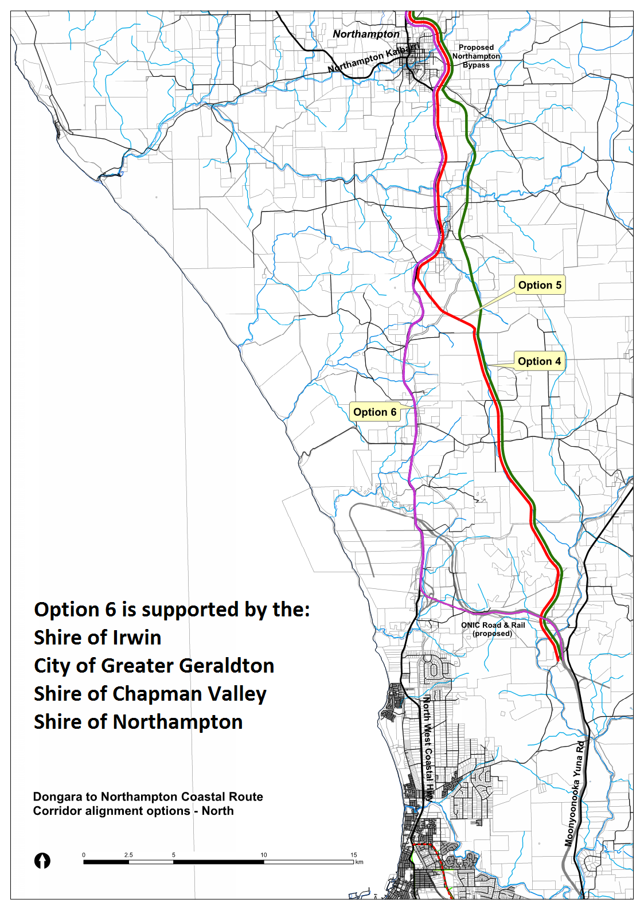

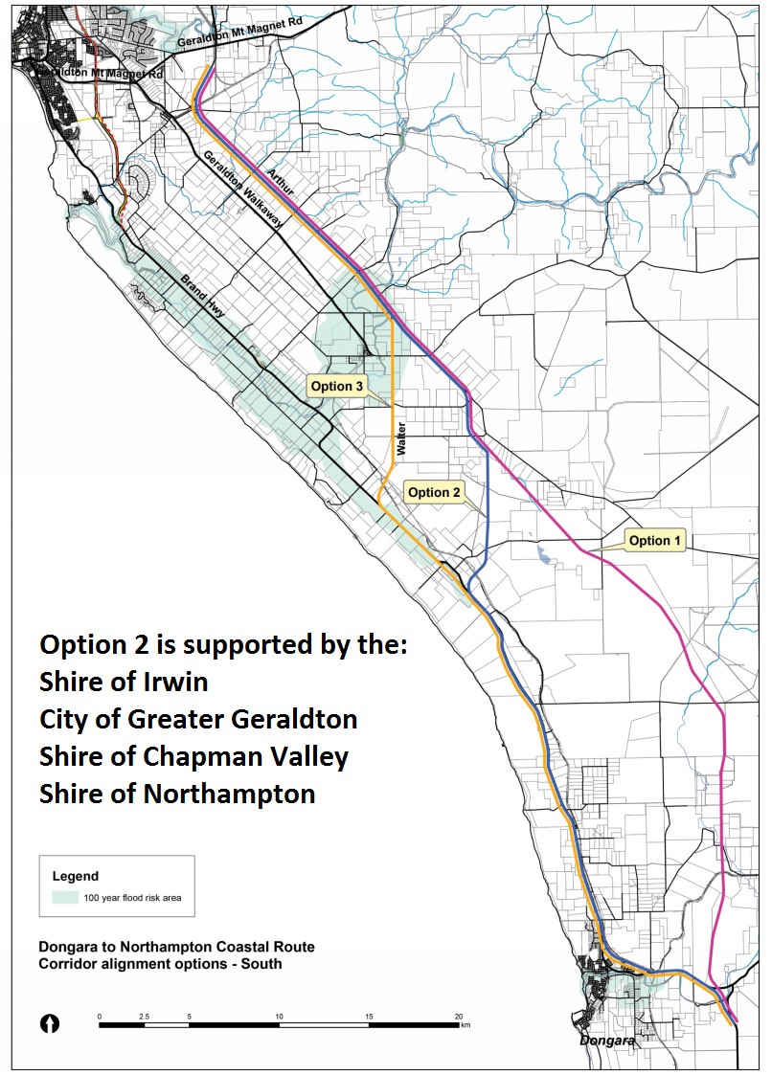

ATTACHMENT 1
AGENDA ITEM: | 10.1.4
SUBJECT: | BILL HEMSLEY PARK
PROPONENT: | SHIRE OF CHAPMAN VALLEY
SITE: | RESERVE 49641 ELIZA SHAW DRIVE, WHITE PEAK
FILE REFERENCE: | A2040
PREVIOUS REFERENCE: | 09/09-11, 08/10-3, 04/11-4, 05/11-29, 12/11-3, 04/13-5, 06/13-25, 10/13-3, 02/14-10-13, 06/14-6, 08/14-5 & 11/14-7, 12/14-19-21, 02/15-13, 03/15-4-5, 06/15-9, 09/15-2-8, 11/15-9, 04/16-10-11 & 05/16-9-12, 06/16-1, 06/16-3-10, 07/16-6-9, 08/16-3-5, 11/16-4-7, 12/16-6, 03/17-9-10, 04/17-10-11, 05/17-4-5 & 10/17-9-11
DATE: | 24 NOVEMBER 2017
AUTHOR: | SIMON LANCASTER

SUPPORTING DOCUMENT:

Ref | Title | Attached  to  Report | Under Separate Cover
10.1.4(a) | Bill Hemsley Park Management Committee Unconfirmed Minutes 22 November 2017 |  | √
10.1.4(b) | Draft Bill Hemsley Park Community Centre Management Licence |  | √

DISCLOSURE OF INTEREST

Nil.

BACKGROUND

The Bill Hemsley Park Management Committee met on 22 November 2017 and a copy of the minutes from this meeting have been provided as separate Attachment 10.1.4(a) for Council’s information.

COMMENT

The Bill Hemsley Park Management Committee discussed a number of issues relating to project management of the underway construction works, with a range of contractors engaged to undertake works e.g. community centre, lawn and reticulation, pathways, paving etc.

The Management Committee also discussed further external funding opportunities that will be pursued to deliver the works as shown upon the Bill Hemsley Park Concept Plan.

Given the Bill Hemsley Park Community Centre will be completed in early 2018 the Management Committee also discussed the drafting of a Management Licence that will address the operation of the building. A draft Management Licence that follows the model template for other Shire buildings that are used by community groups was prepared with the Management Committee recommending that this first draft should be provided to the Parkfalls Residents Association and Council for initial consideration and feedback.

The first draft of the Bill Hemsley Park Community Centre Management Licence is provided as separate Attachment 10.1.4(b) for Council’s consideration.

The Management Committee also discussed the issue of interim fees and charges for the use of the Bill Hemsley Park Community Centre as it is unlikely that a Management Licence will be finalised prior to the completion of the building. Therefore interim fees and charges need to be established to assist with requests for use of the building.
Figure 10.1.4(a) – View looking south-west across Bill Hemsley Park construction site
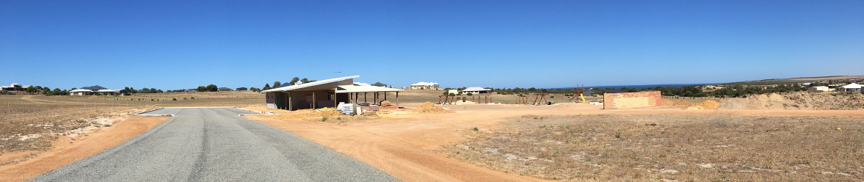

Figure 10.1.4(b) – View looking north-east across Bill Hemsley Park construction site
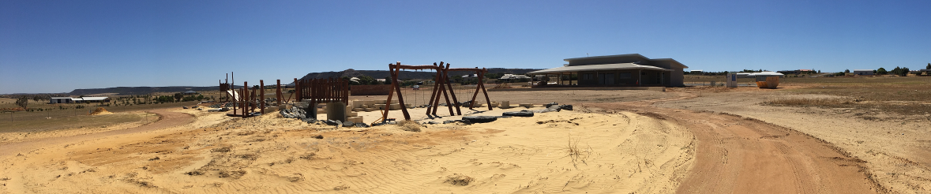

STATUTORY ENVIRONMENT

At the time of Council adopting its 2017/2018 Budget Fees & Charges the Bill Hemsley Park Community Centre was still in its early stage of construction and it was uncertain if a Management Licence for the use of the facility would be established with an affiliation of user groups (similar to the Management Licence arrangement for the Yuna Multipurpose Community Centre) or if the building would simple be hired out on an as-needs basis (similar to the Nabawa Community Centre). Irrespective of the possible establishment of a Management Licence for the Bill Hemsley Park Community Centre with an appropriate group(s) it has become necessary to establish venue hire fees and charges for individual use of the facility.

As the recommended introduction of fees and charges for the Bill Hemsley Park Community Centre is to be introduced after the adoption of the Annual Budget these fees and charges must be advertised separately as per Section 6.19(b) of the Local Government Act 1995.

“6.19 Local government to give notice of fees and charges

If a local government wishes to impose any fees or charges under this Subdivision after the annual budget has been adopted it must, before introducing the fees or charges, give local public notice of —

(a) its intention to do so; and

(b) the date from which it is proposed the fees or charges will be imposed.”

POLICY IMPLICATIONS

Council’s ‘Corporate Management Procedures CMP-010 - Building & Facility Hire Conditions’ clarifies the responsibilities of the various organisations and the Shire in regards to the use of Shire owned/controlled buildings and facilities as follows:

“1 All hire charges must be paid at the Shire Office before keys will be issued.
2 Keys issued under the Non-Cut Key System to Clubs or community organisations will require a bond to be paid prior to issue. Bond will be an amount equivalent to the cost to replace/adjust locks and cut new key(s) in the event of loss. If a key(s) is lost, the relevant lock(s) will have to be renewed and the actual cost of this replacement will be the responsibility of the hirer.
Keys issued to Clubs or community organisations must be returned to the Shire Office at the end of their season.
3 It is the responsibility of the hirer to ensure the conduct of the persons present at the time of their function is orderly.
4 It is illegal to consume liquor on any part of the building and grounds without the prior written approval of the Shire. An additional licence must be obtained from the appropriate authority (e.g. Police, Dept. Racing & Gaming) for the sale of liquor.
5 The cleaning of all facilities used is the responsibility of the hirer, however if the premises have been left in an untidy state and Shire is required to clean them, costs involved in such cleaning will be payable by the hirer.
If any items used (e.g.: barbecues, etc.) are left in an unsatisfactory condition, the Hirer will be requested to carry out the necessary cleaning or repairs to such items to the satisfaction of the Chief Executive Officer.
If in the event that any specific Hirer refuses to undertake the necessary cleaning and/or repairs required as specified, then Shire Staff will carry out this work and an appropriate charge specified by the Chief Executive Officer will be forwarded to the Hirer.
Any future use of such items by the specific Hirer will require a bond to be deposited with the Shire prior to use.
This bond will be set by Shire at the time fees and charges are set annually and will not be refunded until the items have been returned in a satisfactory condition.
Ensure all lights, including lights on the oval, are turned off after function. Penalty may be imposed if lights left on.
7 No spiked shoes or boots or the like to be worn in any part of the building except the two main change rooms and public toilets.
8 Crockery and Cutlery Hire
Breakages and losses - the cost of all replacements is the responsibility of the hirer.
9 Furniture
Tables or chairs are not to be removed from the building unless with the prior approval of the Shire CEO. All tables and chairs must be stacked in an orderly manner and not left out after the event.
Furniture must not be dragged across floors.
10 The building must be left locked up and with all lights switched off.
11 Exemption to hall hire charge
The Chapman Valley Parents and Citizens Association is exempt from paying hall hire charges at the Nabawa Community Centre for the following events: -
• Annual Christmas Tree
• Annual quiz night
• School Presentation night.
Footnote – Community Newspaper Group “Valley Vibes” are exempt from paying hire charges for the “clinic” room at the Community Centre.
12 When alcohol is to be consumed on the premises, a refundable bond, in accordance with that set annually by Council, is to be collected from hirers of this facility."

FINANCIAL IMPLICATIONS

The Shire’s 2017/2018 budget (Account: 2834, Job: CHEM) contains the following allocations relevant to the Bill Hemsley Park project:

Component | Full  Budget | Committed Expenditure YTD | Available  Budget | Contingency for Building
Full Budget | $852,230 | $781,129.72 | $71,100.28 | Contingency for Building
Drafting & Design | $17,490 | $17,525 | -$35.00
Building Component | $462,300 | $433,037.69 | $29,262.31 | $29,262.31
Playground Component | $140,000 | $140,127.03 | -$127.03
Associated Components | $190,440 | $192,424.32  Including:  $19,307.95  (car park & driveway)  $146,809.16  (Dirt Designs)  $23,718.18  (MW Turf Supplies) | -$1,984.32
Building Fit-out & BBQ/Gazebo  (MWDC grant) | $42,000 | $0 | $42,000

- Long Term Financial Plan:

The Shire of Chapman Valley Long Term Financial Plan was endorsed by Council at its 19 July 2017 meeting and identifies the Bill Hemsley Park development as a strategic new project.

STRATEGIC IMPLICATIONS

The Bill Hemsley Park project is contained within the Capital Building Works Program, as reviewed by the Building & Disability Services Committee and endorsed by Council at its 15 March 2017 meeting.

- Strategic Community Plan/Corporate Business Plan:

The Shire of Chapman Valley Strategic Community Plan was endorsed by Council at its 15 November 2017 meeting and lists developing, managing and maintaining built infrastructure as an objective for which the Shire is responsible to achieve the community’s vision.

CONSULTATION

Council resolved at its 18 October 2017 meeting to request that the Shire CEO approach the Parkfalls Residents Association to discuss the preparation of a Management Licence for the Bill Hemsley Park Community Centre.

The Parkfalls Residents Association advised the Shire on 14 November 2017 that:

"The PRA Committee recommend that the Bill Hemsley Park Management Committee pursue, on behalf of the PRA, the parameters and Terms and Conditions of the proposed issuing of a Management Licence prior to making any commitments."

The Management Committee have drafted a Management Licence for the Bill Hemsley Park Community Centre for the initial consideration of Council and the Parkfalls Residents Association, that can be further modified upon receipt of feedback.

RISK ASSESMENT

Rating 1 (Insignificant) Measures of Consequence – Risk Assessment and Acceptance Criteria

VOTING REQUIREMENTS

Simple Majority required

COUNCIL RESOLUTION / STAFF RECOMMENDATION

MOVED: CR FORRESTER SECONDED: CR MALUISH

That Council:

1 Provide comment to the Shire CEO on the draft Bill Hemsley Park Community Centre Management Licence, and this feedback (along with any comment that is received from the Parkfalls Residents Association) be provided to the Management Committee for further consideration.

2 Adopt and advertise the following fees and charges for the hire of the Bill Hemsley Park Community Centre.

Whole facility $88.00 per use
Local Community member $46.50 per use
Annual booking fee $586.00
Adopt existing Venue Bonds

3 The adopted Fees and Charges (and curfew times of 9pm Sunday-Thursday, and 11pm Friday, Saturday & Public Holidays) will be imposed until the Management Licence has been finalised and endorsed by Council with the understanding that Council reserves the right to review these Fees and Charges annually when all Fees and Charges are reviewed.

4 Delegate to the Shire CEO, in consultation as necessary with the Management Committee, the organisation of an Opening Event for the Bill Hemsley Park, with Council’s preference being for it be held at 4:00pm on 21 March 2018 (although the delegation provided to the Shire CEO extends to the changing of this time/date as may be required).

COUNCIL RESOLUTION

MOVED: CR WARR SECONDED: CR HUMPHREY

That Standing Orders 8.5, 8.7, 8.8 & 8.9 be suspended.
Voting 8/0
CARRIED
Minute Reference: 12/17-5

Cr Forrester left Chambers at 9.54am

Cr Forrester re-entered Chambers at 9.57am

COUNCIL RESOLUTION

MOVED: CR WARR SECONDED: CR FORTH

That Standing Orders 8.5, 8.7, 8.8 & 8.9 be re-instated.
Voting 8/0
CARRIED
Minute Reference: 12/17-6

AMENDMENT

MOVED: CR HUMPHREY SECONDED:

3 The adopted Fees and Charges (and curfew times of 9pm all days) will be imposed until the Management Licence has been finalised and endorsed by Council with the understanding that Council reserves the right to review these Fees and Charges annually when all Fees and Charges are reviewed.

The Amendment lapsed due to no seconder

AMENDMENT

MOVED: CR WARR SECONDED: CR HUMPHREY

- The adopted Fees and Charges (and curfew times of 10pm all days unless otherwise determined by the CEO) will be imposed until the Management Licence has been finalised and endorsed by Council with the understanding that Council reserves the right to review these Fees and Charges annually when all Fees and Charges are reviewed.
Voting 8/0
CARRIED
Minute Reference: 12/17-7

The Amendment became the Substantive Motion i.e.

That Council:

1 Provide comment to the Shire CEO on the draft Bill Hemsley Park Community Centre Management Licence, and this feedback (along with any comment that is received from the Parkfalls Residents Association) be provided to the Management Committee for further consideration.

2 Adopt and advertise the following fees and charges for the hire of the Bill Hemsley Park Community Centre.

Whole facility $88.00 per use
Local Community member $46.50 per use
Annual booking fee $586.00
Adopt existing Venue Bonds

3. The adopted Fees and Charges (and curfew times of 10pm all days unless otherwise determined by the CEO) will be imposed until the Management Licence has been finalised and endorsed by Council with the understanding that Council reserves the right to review these Fees and Charges annually when all Fees and Charges are reviewed.

- Delegate to the Shire CEO, in consultation as necessary with the Management Committee, the organisation of an Opening Event for the Bill Hemsley Park, with Council’s preference being for it be held at 4:00pm on 21 March 2018 (although the delegation provided to the Shire CEO extends to the changing of this time/date as may be required).

Voting 8/0
CARRIED
Minute Reference: 12/17-8

Reason for deviation from Staff Recommendation - Council considered curfew time of 10pm on all days more appropriate

AGENDA ITEM: | 10.1.5
SUBJECT: | PROPOSED REZONING
PROPONENT: | LANDWEST FOR FRANK TOMASI NOMINEES PTY LTD
SITE: | LOT 1455 CHAPMAN VALLEY ROAD, WAGGRAKINE
FILE REFERENCE: | 204.04.05 & A108
PREVIOUS REFERENCE: | 12/02-13, 03/05-13 & 08/06-5
DATE: | 4 DECEMBER 2017
AUTHOR: | SIMON LANCASTER

SUPPORTING DOCUMENT:

Ref | Title | Attached  to  Report | Under Separate Cover
10.1.5(a) | Scheme Amendment No.5 document & Shire of Chapman Valley Heritage Inventory extract (Place Number 1 - Coffee Pot & Waggrakine Well) |  | √
10.1.5(b) | Lot 1455 indicative subdivision layout (1983) | √
10.1.5(c) | Lot 1455 indicative subdivision layout (2009) | √
10.1.5(d) | Lot 1455 indicative subdivision layout (2017) | √

DISCLOSURE OF INTEREST

Nil.

BACKGROUND
Council is in receipt of an application seeking to amend the Shire of Chapman Valley Local Planning Scheme No.2 (‘the Scheme) text provisions relating to Lot 1455 Chapman Valley Road, Waggrakine. The amendment would allow for the preparation of a Structure Plan (for Council’s later consideration) with improved consideration for drainage and the subdivisional road network, and the Coffee Pot cottage ruin and Waggrakine Well to be potentially subdivided into a conservation lot. This report recommends initiation of the rezoning application as Scheme Amendment No.5.

COMMENT
Lot 1455 is a 40.33ha rectangular property, located immediately east of the Coffee Pot Drive subdivision, that is largely cleared excepting some remnant vegetation along the Ego Creek tributary lines that run through the property, and the steeper sections of the Moresby Range.

The property straddles the Chapman Valley Road, and the rezoning application relates to the 37.14ha portion on the northern side of Chapman Valley Road.

Lot 1455 was the site of an experimental coffee plantation established in 1870 that had failed by 1873 due to strong winds and lack of rainfall. The property still contains the Coffee Pot cottage ruin and Waggrakine Well towards the northern end of the lot, setback approximately 720m from Chapman Valley Road, which is listed in the Shire of Chapman Valley Heritage Inventory.

A copy of the submitted Scheme Amendment documentation and the relevant entry from the Shire’s Heritage Inventory have been provided to Councillors as separate Attachment 10.1.5(a). The Scheme Amendment documentation contains site analysis, a Conservation Plan for the historic buildings upon Lot 1455 and an indicative subdivision guide plan.

The development history for Lot 1455 is as follows:

21 April 1985 Minister approves Scheme Amendment No.1 to Town Planning Scheme No.1 that rezones Lot 1455 (and adjoining Lot 2649 to the west) from ‘General Farming’ to ‘Special Rural’.
17 December 2002 Council supports the entry of the Coffee Pot and Waggrakine Well onto the State Register of Heritage Places.
20 July 2004 Gazettal notice for permanent entry of the Coffee Pot and Waggrakine Well onto the State Register of Heritage Places.
28 January 2009 Minister approves Scheme Amendment No.40 to Town Planning Scheme No.1 that reduces minimum lot size to 2ha and amends text provisions.
25 August 2009 WAPC approves 13 lot subdivision application of Lot 1455 (not proceeded with) and the approved subdivision plan is provided as Attachment 10.1.5(c).

Figure 10.1.5(a) – Location Plan for Lot 1455 Chapman Valley Road, Waggrakine
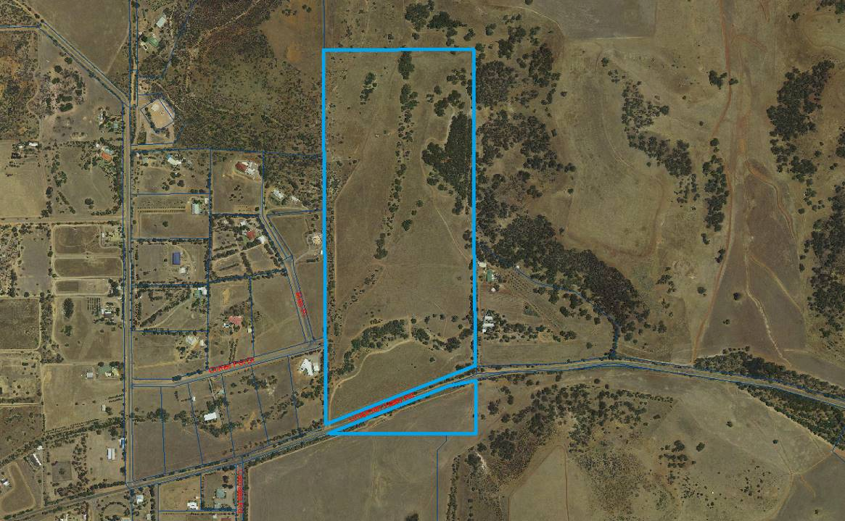

Figure 10.1.5(b) – View looking north across Lot 1455 Chapman Valley Road
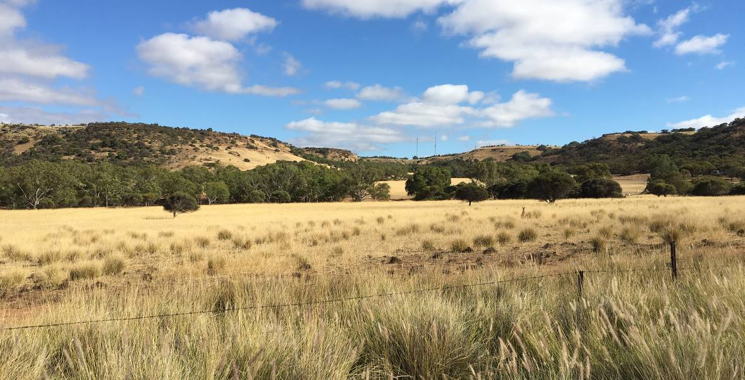

It is considered that the current scheme provisions that relate to Lot 1455 are unduly restrictive and should be modified to enable exploration of an improved subdivision layout for the next stage of the Coffee Pot subdivision.

A summary of the proposed modifications to the Scheme text are as follows:

Delete Schedule 12 RR2 Condition 16 “At the time of subdivision the site that includes the historic Coffee Pot and Waggrakine Well as shown of the Subdivision Guide Plan shall be set aside as the Public Open Space to be transferred to the local authority.”

The current Scheme text requires that at time of subdivision of Lot 1455 that the Coffee Pot and Waggrakine Well be created in an area of public open space under the management of the Shire.

The Shire has no identified purpose for the Coffee Pot site and the building’s limited floor area and proximity to the existing Waggrakine Hall are not conducive to a future community use. Further to this the site’s location at the end of a quiet cul-de-sac road, is not suited for activities that might generate significant traffic associated with a commercial or community use.

It is suggested that public ownership of the building is not the ideal means to ensure that the historic site is maintained, as an infrequently visited and underutilised building can be subject to neglect, whereas if the building is privately owned and regularly made use of, it is more likely to be maintained.

Council would still have the ability to ensure the heritage aspects of the site are conserved and enhanced through the private ownership model. There is the option for the Coffee Pot building to be subdivided onto a lot that has attached legal requirements, including conservation/restoration works to be undertaken as a condition of subdivision and ongoing protections through means of notifications upon title/restrictive covenants. The ongoing protections can also establish requirements for development elsewhere upon the lot, for example, setting conditions relating to setback distances, building materials/style, etc. and guide the appropriate use of the site. It is considered that a private ownership model provides greater potential for activation, with possible uses (that can be undertaken in association with a sensitively sited and designed main residence) including bed and breakfast, art studio, coffee themed business, appointment business, home office etc.

Delete Schedule 12 RR2 Condition 17 “The subdivider is to contribute to the upgrade and maintenance of the historic Coffee Pot and Waggrakine Well at the time of subdivision.”

The above Scheme text provision was based on the assumption that the site would be transferred to the ownership of the Shire. It is now considered that the future management of the Coffee Pot and Waggrakine Well become an issue that Council and the developer should have the ability to discuss rather than pursue the previously entertained prescriptive model of placing the site in a park and transferring it to the Shire. There are other examples of buildings being restored by subdividers and then transferred to the local government and then due to their location and/or limited floor area, and the reactive, legislated nature of the public ownership model, becoming underutilised and the deletion of conditions 16 & 17 provides the flexibility for Council and the developer to consider alternative models that might better protect and promote the site.

Figure 10.1.5(c) – Coffee Pot cottage ruin upon Lot 1455 Chapman Valley Road
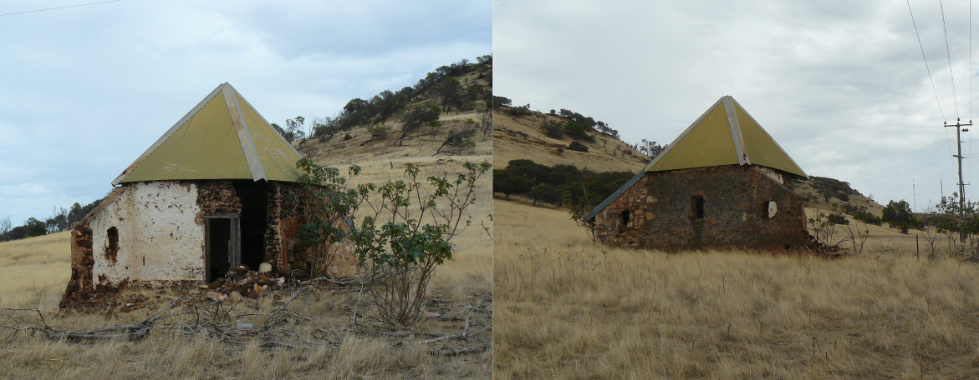

It should be emphasised that the initiation of this rezoning application does not remove Council’s ability to give this matter further consideration, as the rezoning application must be returned to Council again following the consultation period. Council would also at a later date be required to give consideration to a structure plan for Lot 1455. The Shire would also be requested to comment and provide suggested conditions to be applied to the future subdivision application over the land, and provide clearance of those conditions prior to release of the subdivided lots.

Delete Schedule 12 RR2 Condition 18 “The creation of lots adjoining Chapman Valley Road will not be permitted without a trafficable alternative access being provided to the subject land, and direct access onto Chapman Valley Road will not be permitted” and replace with the following “Any new subdivisional or service road intersection(s) with Chapman Valley Road subject to the approval of the Local Government. Direct vehicular access from lots onto Chapman Valley Road shall not be permitted.”

Lot 1455 fronts an approximately 430m long section of Chapman Valley Road and the subdivision planning for this property dates back to a period in the early 1980’s when the road was being considered for upgrade for harvest haulage to the Geraldton Port. On this basis the original subdivision layout, provided as Attachment 10.1.5(b), was designed to access Chapman Valley Road exclusively via Hackett Road.

Subsequent planning has re-directed harvest traffic via Morrell Road, and Chapman Valley Road west of Morrell Road is now under the management of the Shire and is approved only for vehicles to a maximum length of 20m.

Council may wish to provide itself with greater flexibility in its consideration of a future subdivision layout, that could provide some lots with access to Chapman Valley Road via an alternative to Coffee Pot Drive/Hackett Road, for example a one-way slip road similar to that developed further west on Chapman Valley Road (near Sutcliffe Road), or a subdivisional road intersection in a safe location may be two solutions for consideration.

Figure 10.1.5(d) – view along Lot 1455 Chapman Valley Road frontage looking east/west
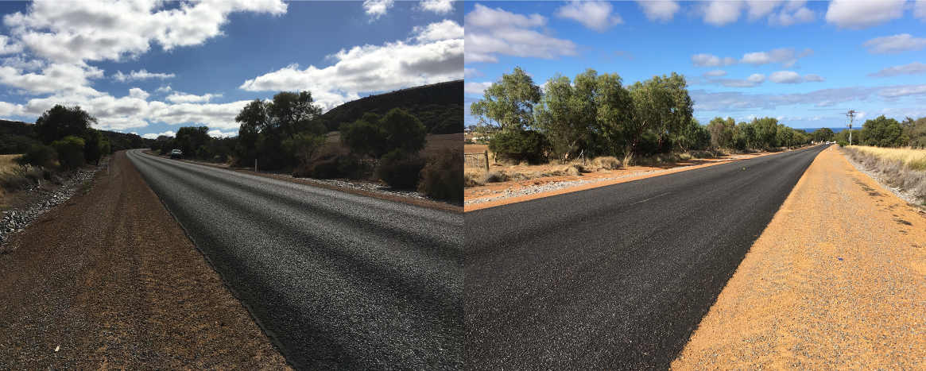

Lot 1455 also contains a number of watercourses and greater flexibility in the subdivision design would provide the means to better address drainage and remnant vegetation protection.

The Scheme Amendment documentation includes an indicative subdivision layout, provided as Attachment 10.1.5(d), that illustrates how the subdivision could be improved upon to achieve a more effective environmental outcome. However, it is emphasised that this is a concept plan only and Council would be provided with a number of opportunities to consider a more detailed subdivision plan at a later stage as part of the structure plan process, and this would include more detailed regard for engineering, environmental and heritage aspects of the plan.

STATUTORY ENVIRONMENT
Lot 1455 Chapman Valley Road, Waggrakine is zoned ‘Rural Residential 2’ under the Scheme, and also lies within the ‘Special Control Area 2-Moresby Range Landscape Protection’ zone. The Scheme Amendment proposes no alteration to this zoning.

Section 4.2.4 of the Scheme lists the objectives of the ‘Rural Residential’ zone as being:

“(a) Provide for residential development within a low-density environment;
(b) Provide for other land-uses compatible with a high level of residential amenity;
(c) Prevent the establishment of land-uses more appropriately undertaken in commercial and/or industrial areas; and
(d) Protect the environmental and landscape values of the land.”

Part 4 of Schedule 11 of the Scheme notes the following for the ‘Rural Residential 2’ zone:

“1 Subdivision and land use shall be generally in accordance with a Structure Plan adopted by the Local Government and endorsed by the Western Australian Planning Commission.

2 All dwellings shall be sited in accordance with the setback requirements specified in the Scheme for the Rural Residential Zone, except where for specific lots, building envelopes are shown on the Structure Plan. Where building envelopes are shown then all dwellings, associated structures and effluent disposal systems must be located within that envelope.

3 All buildings constructed on the land shall be sympathetic to existing landscape elements, namely landform, vegetation and amenity, in terms of their design, height, location, materials and cladding colours.

4 All stormwater and runoff from buildings and other impervious surfaces shall be disposed of within each lot so as to avoid scouring and erosion.

5 With the objective of maintaining sustainable land use practices, and preventing land degradation through wind and water erosion, the keeping of animals is permitted in accordance with the following or such density as approved by the local government following consultation with the Department of Agriculture and Food, with conditions if appropriate:

5 sheep / 1ha of agistment area
1 horse / 2ha of agistment area
1.6 pony / 2ha of agistment area
1 milking cow / 2ha of agistment area
1.6 heifer / 2ha of agistment area
5 goats / 1ha of agistment area

Only one stock option as specified above will be permitted or a combination equivalent of one option.

6 Notwithstanding the above, the Local Government may reduce or vary the limit on stocking or place any other conditions in light of prevailing seasonal conditions to prevent overstocking, erosion, or other practices detrimental to the environment or amenity of the neighbouring properties from those rates described in Clause (5) above.

7 No remnant vegetation or tree shall be destroyed or removed except where the landowner obtains the prior consent in writing of the Local Government, or where such vegetation is dead or diseased, or where the clearing is required for the purpose of firebreak, development within a building envelope and access to the envelope, for an outbuilding or fence or for development of a water source.

8 Prior to the commencement of any development on any new lot, the Local Government will require each lot owner to prepare a tree planting and maintenance program with the intention of screening building structures and rehabilitating and revegetating the land without restricting approved activities/operations.

9 Construction of a dam or soak or land use activity that may impede in any way the natural flow along any water course shall be subject to formal planning consent being granted by the local government, following consultation with the Department of Water.

10 No dwelling shall be constructed or approved for construction unless an approved method of on-site effluent disposal suitable for long-term usage has been incorporated into the approved plans, and is in a location, to the satisfaction of the local government in consultation with the Health Department of WA.

11 At the time of subdivision the preparation of a fire protection plan may need to be established in consultation with and to the satisfaction of the Local Government and FESA.

12 The Local Government shall recommend to the Western Australian Planning Commission that as part of any approval to subdivide the land that an Urban Water Management Plan and Watercourse Management Plan shall be prepared and implemented to the satisfaction of the Local Government and the Department of Water by the subdivider at the subdivider’s cost.

13 At subdivision, the development setback from either side of any creek line is to be confirmed in conjunction with the Department of Water.

14 No building shall be erected above the 140metre A.H.D. contour.

15 a) At the time of subdivision suitable arrangements are to be made with the Water Corporation for the adequate provision of a reticulated water supply to service lots above the RL 112 AD line. This shall include the transfer of freehold land (free of cost) and any infrastructure works (at the subdividers expense) as indicated on the Structure Plan.
b) In regards to the proposed water tank site, an overhead tank erected on a stand is not permitted.
c) The infrastructure (tank and associated buildings/infrastructure) shall be of a colour complementary to the existing landform and landscape elements, to the satisfaction of the local government. Zincalume or a galvanised corrugated iron finish or similar is not permitted;
d) The Water Corporation or Developer will be required at the time of installing a water storage tank to submit a landscaping plan for screening purposes to be endorsed by the local government, with this plan to be implemented within 12 months from the date of approval unless otherwise approved by the Local Government.

16 At the time of subdivision the site that includes the historic Coffee Pot and Waggrakine Well as shown on the Structure Plan shall be set aside as the Public Open Space to be transferred to the local authority.

17 The subdivider is to contribute to the upgrade and maintenance of the historic Coffee Pot and Waggrakine Well at the time of subdivision.

18 The creation of lots adjoining Chapman Valley Road will not be permitted without a trafficable alternative access being provided to the subject land, and direct access onto Chapman Valley Road will not be permitted.”

The applicant is seeking the deletion of conditions 16 & 17 and the requested revision of condition 18 to instead state that “Any new subdivisional or service road intersection(s) with Chapman Valley Road subject to the approval of the Local Government. Direct vehicular access from lots onto Chapman Valley Road shall not be permitted.”

Part 5 of the Planning & Development Act 2005 provides for the amendment of a Scheme.

The Heritage of Western Australia Act 1990 enabled the creation of the State Register that lists places of state heritage significance, and the Coffee Pot is included on the State Register. Listing requires that planning, building, demolition and other applications affecting a place on the State Register are referred by the relevant decision making authority (usually a local government) to the Heritage Council for advice.

The Heritage Council of WA would be written to directly by the Shire seeking comment should Council initiate this rezoning application. The Shire would also seek the advice of the Heritage Council in the preparation of a Heritage Agreement, which is a legally binding contract with the subdivider/ongoing landowner that sets out a framework for the long-term conservation and maintenance of a place, in the event that the Coffee Pot cottage ruin was to be created upon a private lot through subdivision.

POLICY IMPLICATIONS
Lot 1455 Chapman Valley Road, Waggrakine is located within Precinct No.7 – South-West of the Shire of Chapman Valley Local Planning Strategy (2008) the vision for which is:

“The planned expansion of the south west area of the Shire, whilst taking into consideration the plans and policies of other local and regional government authorities.”

Figure 11 of the Local Planning Strategy identifies Lot 1455 as ‘Existing Rural Residential’ and the rezoning application therefore accords with the strategic direction of the Shire’s Local Planning Strategy.

The rezoning application is seeking to provide greater flexibility to Council in its future discussions with the developer of the Coffee Pot Estate to better meet the following community objective for Precinct 7 of the Local Planning Strategy:

“7.1.4 Encourage the protection and restoration of places and buildings of heritage/historical significance.”

It is suggested that past models of requiring subdividers to restore a building and it then sit as an unused shell for decades on public land is not always the best means to maintain or promote a building, and that there should be the ability for Council to consider other alternatives. This could include the creation of a lot with legal provisions that protect the place’s heritage significance whilst also enabling the more responsive and innovative exploration of opportunities that the private sector can provide.

The rezoning application would provide an improved means to meet with the following economic objectives for Precinct 7 of the Local Planning Strategy:

“7.2.1 Accommodate urban growth sympathetic to rural lifestyle based on appropriate structure planning.
7.2.2 Promote tourist related uses/development and encourage agricultural diversification in appropriate areas where there will be no detrimental impact to the surrounding land and existing uses.”

The rezoning application has the potential to better meet the following environmental objectives for Precinct 7 of the Local Planning Strategy through conditions attached to the subsequent subdivision of Lot 1455 that would follow the rezoning:

“7.3.1 Encourage re-vegetation and retention of existing vegetation in order to minimise soil erosion and to stabilise existing landforms along the coast and the western portion of the Moresby Ranges.
7.3.2 Protect and enhance the visual amenity in areas of visual prominence.
7.3.3 Ensure that land use and development adjacent to and in proximity to coastal and river areas incorporate appropriate environmental protection based on natural resource management measures.
7.3.4 Ensure that land use conflicts (i.e. noise, dust, odour, spray drift, vermin etc) are avoided through appropriate environmental controls.
7.3.5 Ensure fire prevention measures are implemented and maintained in accordance with statutory requirements as a minimum.”

The rezoning application can be considered to accord with the following infrastructure objectives for Precinct 7 of the Local Planning Strategy:

“7.4.2 Ensure adequate levels of servicing and infrastructure, as determined by Council, exist or will be provided when supporting proposals for a change in land use, development or subdivision, to avoid burden (financial or otherwise) on the Council’s resources.
7.4.3 Identify, support and facilitate the efficient and coordinated use of existing road linkages.”

FINANCIAL IMPLICATIONS
The applicant has been charged the $4,023 (GST inclusive) fee for a request to Council for the initiation of a (minor) Scheme Amendment under the Shire of Chapman Valley 2017/2018 Planning Service Fees. In the event that Council did not initiate and advertise the Scheme Amendment, 50% of the fee would be refunded to the applicant as per the Fee Schedule.

- Long Term Financial Plan:

In addition to the issue of whether the Coffee Pot might be better served by being under (controlled) private rather than public ownership in terms of site activation and ongoing maintenance, Council also needs to consider, as it would with any asset, what is the purpose of Council holding the asset and what is the financial model for the maintenance of the asset.

The Shire of Chapman Valley Long Term Financial Plan was endorsed by Council at its 19 July 2017 meeting and Section 5.1 ‘Long Tern Financial Sustainability’ notes the following:

“A financially sustainable council is described as one with the ability to fund ongoing service delivery, and the renewal and replacement of assets without imposing excessive debt or rate increases on future generations. This definition has been translated into four key financial sustainability principles:
• Council should aspire to achieve a fully funded operating position reflecting the collection enough revenue from rate revenue, “as of right” FAGs and normal, continuing operations, to fund all operational expenditure.
• Council should aspire to maintain sufficient cash reserves to ensure it can meet its short-term working capital requirements.
• Council should aspire to have a fully funded capital program, where the source of funding is identified and secured for both capital renewal and new capital works.
• Council should aspire to maintain its asset base, by renewing ageing infrastructure, which are identified or envisaged.

It is important to note while these principles represent financial sustainability, in the current environment, most councils will find it difficult to obtain this level of sustainability as:
• Funding the life cycle of assets is a major issue for all levels of Government.
• The backlog in asset renewal is a direct result of councils in WA not being able to cash fund the Fair Value replacement cost of assets (represented by the annual depreciation charge). Current asset renewal funding is based on the actual renewals program and this is often modified to fit within budgetary restraints. This means as assets are consumed funds are generally not being put aside to replace the asset at the end of its useful life. This is not a result of poor management; councils simply cannot afford to fund asset renewal without compromising existing levels of service.”

STRATEGIC IMPLICATIONS
The Geraldton Region Plan was released in 1999 by the WAPC to provide a framework for the future management, protection and coordination of regional planning. The Region Plan incorporates the 2011 Structure Plan for the Greater Geraldton area which identifies Lot 1455 as ‘Rural Living’.

The Moresby Range Management Plan (2010) was prepared jointly by the Shire of Chapman Valley and City of Greater Geraldton to address the section of the Moresby Range immediately south of White Peak Road and east of Geraldton. It is this section that is under the most immediate pressure from a range of demands including urban and rural-residential development from the west, infrastructure corridor alignments to the east and north, recreational demands from the community, economic interest from renewable venture proponents and tourism possibilities.

The preparation of the Plan was strongly informed by extensive community consultation that asked the people of the Mid West ‘what future did they want to see for the Range and how did they want to engage with the Range into the future?’ The major finding was that the community wanted the Range to be turned into a unique and iconic park that would become an asset and a resource for the regional, Western Australian and international communities. The Plan has recognised this concept but also that the majority of the land in the Range is privately owned at present and that the realisation of this vision must be done in partnership with landowners and will be a long term project with a nominal 20 year time frame for its creation, although the Plan also recognises that this process may take longer and that the final outcome may differ from what is proposed.

The Plan defines a ‘Range Precinct’ as the area that includes the flat tops and major slopes of a section of the Moresby Range but excludes the flatter areas of land that surrounds the Range. The Plan has the vision for a community park that would ultimately turn the Range Precinct into an iconic regional resource. The Plan identifies the community park not as a formal planning description, rather a statement of aspiration and intent, ideally, when a park eventuates it will be formally recognised under an appropriate planning framework.

The boundary of the Range Precinct was selected according to a number of criteria including topography, cadastral boundaries, biogeographical and biodiversity features, and existing developments. The Plan makes recommendations for land uses around the Range Precinct, particularly on the western side of the Range that is under the most immediate pressure. Here the objective is to allow limited urban development to occur in the foothills, subject to development conditions, that will create smooth and gradual visual transitions from the obviously urban centre of the City to the vegetated and green appearance of the Range.

The ‘Range Precinct’ boundary as it relates to Lot 1455 follows the subdivision layout as previously approved by the WAPC. The opportunity to review the structure plan/subdivision layout for Lot 1455, that this rezoning application will facilitate, will enable further consideration to be given to realigning the ‘Range Precinct’ boundary with contours and the visual landscape as viewed from Chapman Valley Road, rather than an arbitrary rectangular cadastral line.

Figure 10.1.5(e) – Moresby Range Management Plan extract relating to Lot 1455
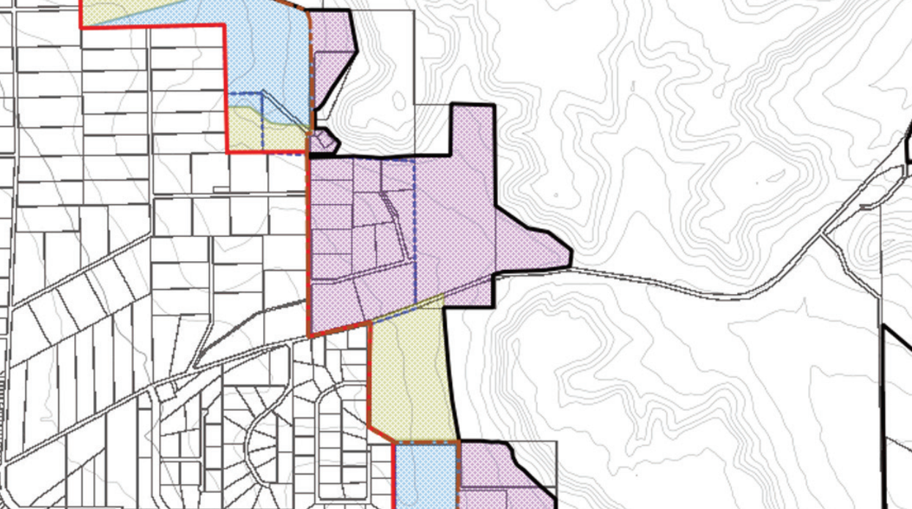

- Strategic Community Plan:

The Shire of Chapman Valley Strategic Community Plan was endorsed by Council at its 15 November 2017 meeting. It may be considered that support for this rezoning application, and the subsequent further consideration of a structure plan and subdivision application by Council that this would allow, would assist in addressing the following as outlined by the Shire’s Strategic Community Plan.

“Our Aim
To maintain and build population while ensuring financial and asset management is robust to allow for effective service delivery as an independent shire participating in the growth of the region.

Our Shire and Community will:
• Value our past and embrace our future
• Experience a safe and peaceful place to work, live or visit
- Enhance the Valley lifestyle with an area specific approach to community development
• Ensure ongoing sustainability through affordable development and informed decision making
• Welcome local tourism activities and encourage participation in regional tourism strategies”

CONSULTATION

Should Council support this rezoning application then it is required to forward a copy of the Scheme Amendment documentation to the EPA for its assessment as per Section 81 of the Planning & Development Act 2005. Should the EPA advise that the proposed rezoning does not warrant assessment under Part IV Division 3 of the Environmental Protection Act 1986 then the Shire would forward a copy of the Scheme Amendment documentation to the Western Australian Planning Commission (‘WAPC’) advising of its intent to advertise the rezoning application as a standard scheme amendment.

Were Council to initiate the Scheme Amendment then the Shire would undertake the following actions of consultation, inviting comments and responses within a 42 day advertising period:

• erect a public notification sign upon the site;
• place a notice within a locally circulating newspaper;
• place a copy of the Scheme Amendment documentation on the Shire website;
• place a copy of the Scheme Amendment documentation in the Shire office/library for public viewing;
• write directly to all surrounding landowners; &
• write directly to all relevant government agencies and service authorities (the Shire would particularly target the comments of the Heritage Council of WA given that Lot 1455 contains a site listed upon the State Register of Heritage Places).

At the completion of the advertising period all received submissions would be presented for Council’s consideration, and should the Scheme Amendment be given final approval at this point by Council then the rezoning documents would be forwarded to the WAPC seeking final assessment and approval.

RISK ASSESMENT

Rating 1 (Insignificant) Measures of Consequence – Risk Assessment and Acceptance Criteria

VOTING REQUIREMENTS
Simple majority of Council.

COUNCIL RESOLUTION / STAFF RECOMMENDATION

MOVED: CR WARR SECONDED: CR BATTEN

That Council pursuant to Part 5 of the Planning and Development Act 2005 amend Shire of Chapman Valley Local Planning Scheme No.2 by modifying the conditions column for the ‘Rural Residential 2’ (RR2) zone in Schedule 11 by:

1 Deleting Conditions 16, 17 and 18.

2 Inserting the following new Condition 16:

“Any new subdivisional or service road intersection(s) with Chapman Valley Road subject to the approval of the Local Government. Direct vehicular access from lots onto Chapman Valley Road shall not be permitted.”

Voting 7/1
CARRIED
Minute Reference:12/17-2
(Item moved en-bloc)
ATTACHMENT 10.1.5(b)

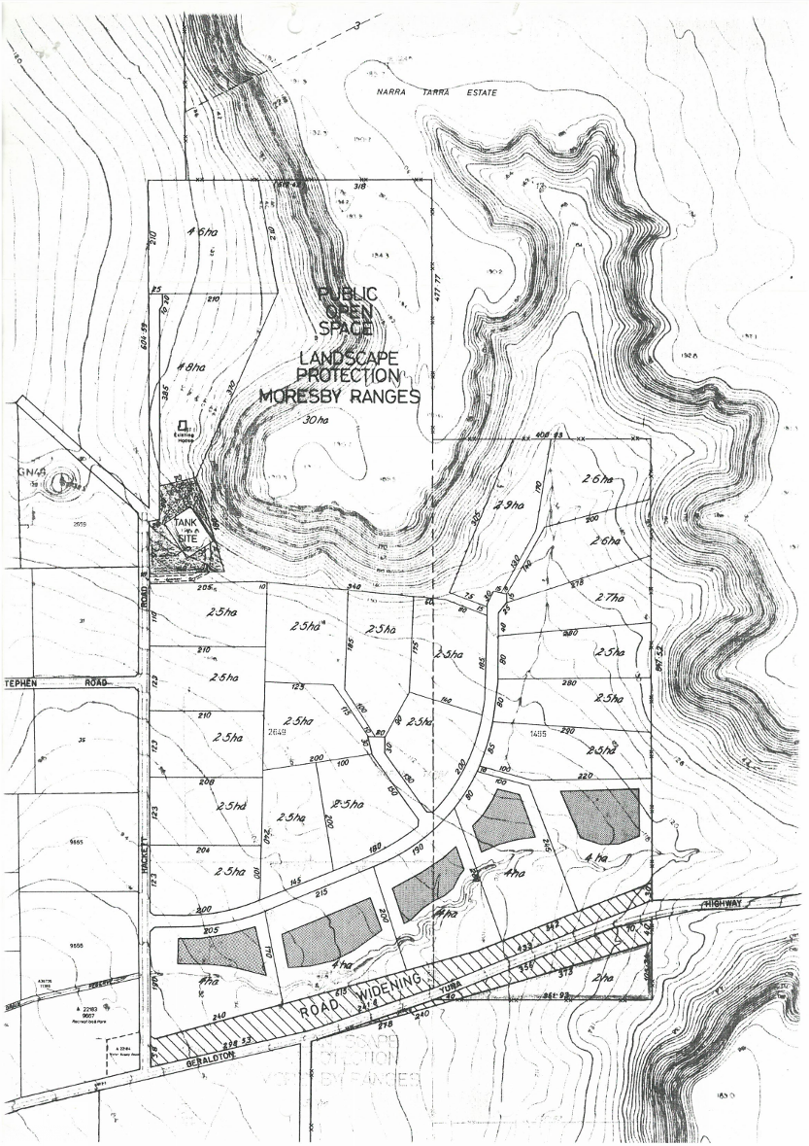

ATTACHMENT 10.1.5(c)

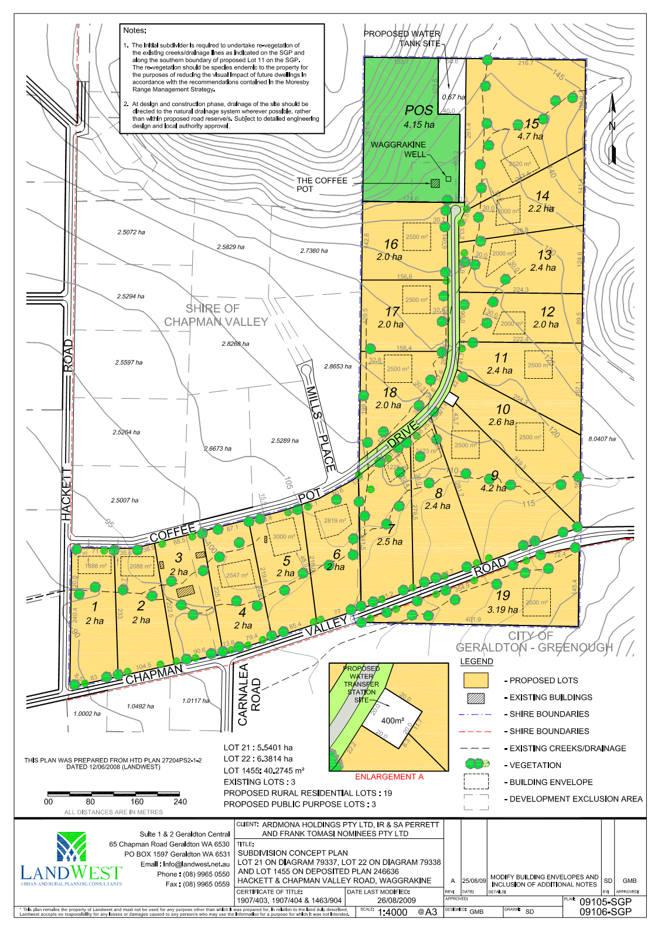

ATTACHMENT 10.1.5(d)

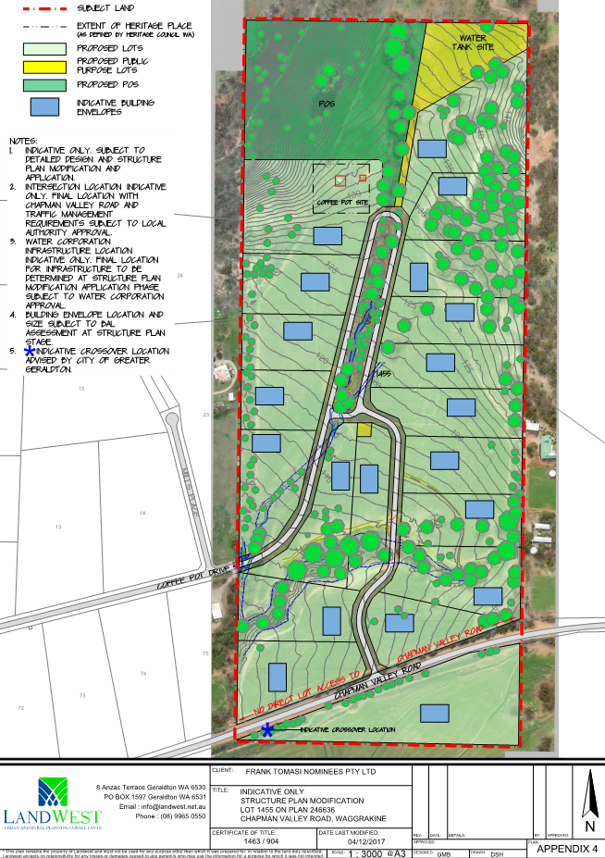

AGENDA ITEM: | 10.1.6
SUBJECT: | PROPOSED REZONING
PROPONENT: | LANDWEST FOR E. WHYATT
SITE: | 337 (LOT 7550) HICKETY ROAD, HOWATHARRA
FILE REFERENCE: | 204.04.02 & A455
PREVIOUS REFERENCE: | N/A
DATE: | 5 DECEMBER 2017
AUTHOR: | SIMON LANCASTER

SUPPORTING DOCUMENT:

Ref | Title | Attached  to  Report | Under Separate Cover
10.1.6(a) | Scheme Amendment No.2 document |  | √
10.1.6(b) | Lot 7550 indicative subdivision layout | √

DISCLOSURE OF INTEREST

Nil.

BACKGROUND
Council is in receipt of an application seeking to rezone Lot 7550 Hickety Road, Howatharra from the ‘General Farming’ zone to the ‘Rural Smallholding’ zone. This report recommends initiation of the rezoning application as Scheme Amendment No.2 to Shire of Chapman Valley Local Planning Scheme No.2 (‘the Scheme).

COMMENT
Lot 7550 is a 265.2ha property, with its eastern boundary fronting the unsealed Hickety Road. The property is approximately 7km east of the Howatharra townsite, 7km north-west of the Nanson townsite and 8km south-west of the Nabawa townsite.

Figure 10.1.6(a) – Location Plan for Lot 7550 Hickety Road, Howatharra
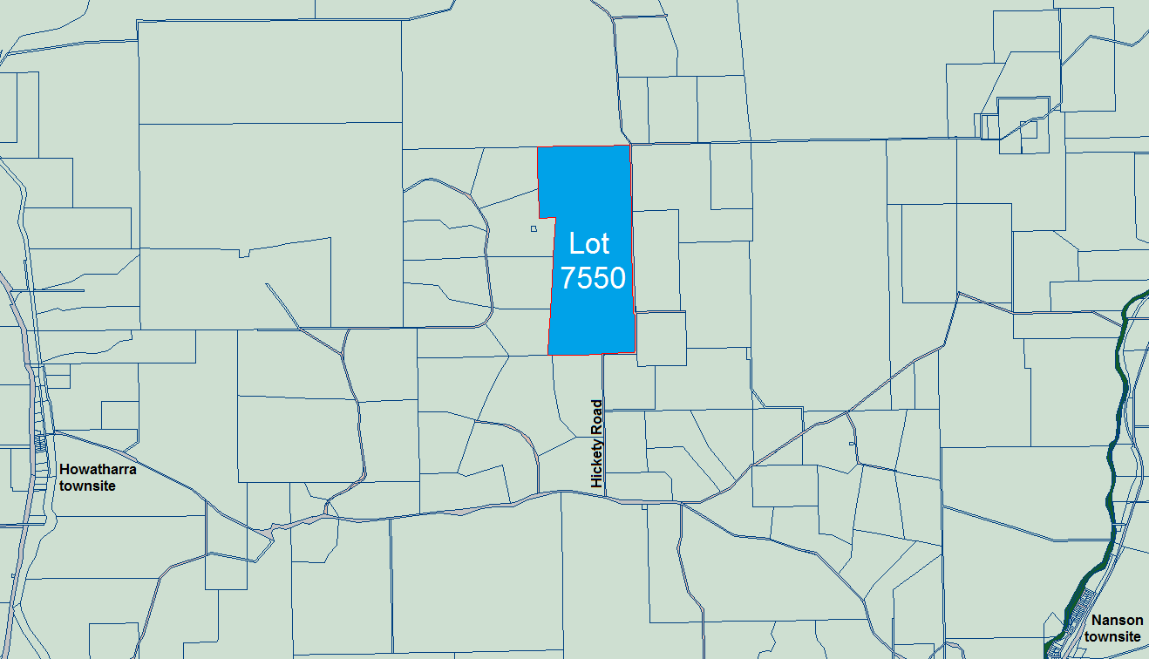

Lot 7550 is largely cleared and used for farming and horticultural (market gardening) purposes, there is some remnant vegetation along the western boundary of the property where the property rises.

Figure 10.1.6(b) – Aerial Photograph of Lot 7550 Hickety Road, Howatharra
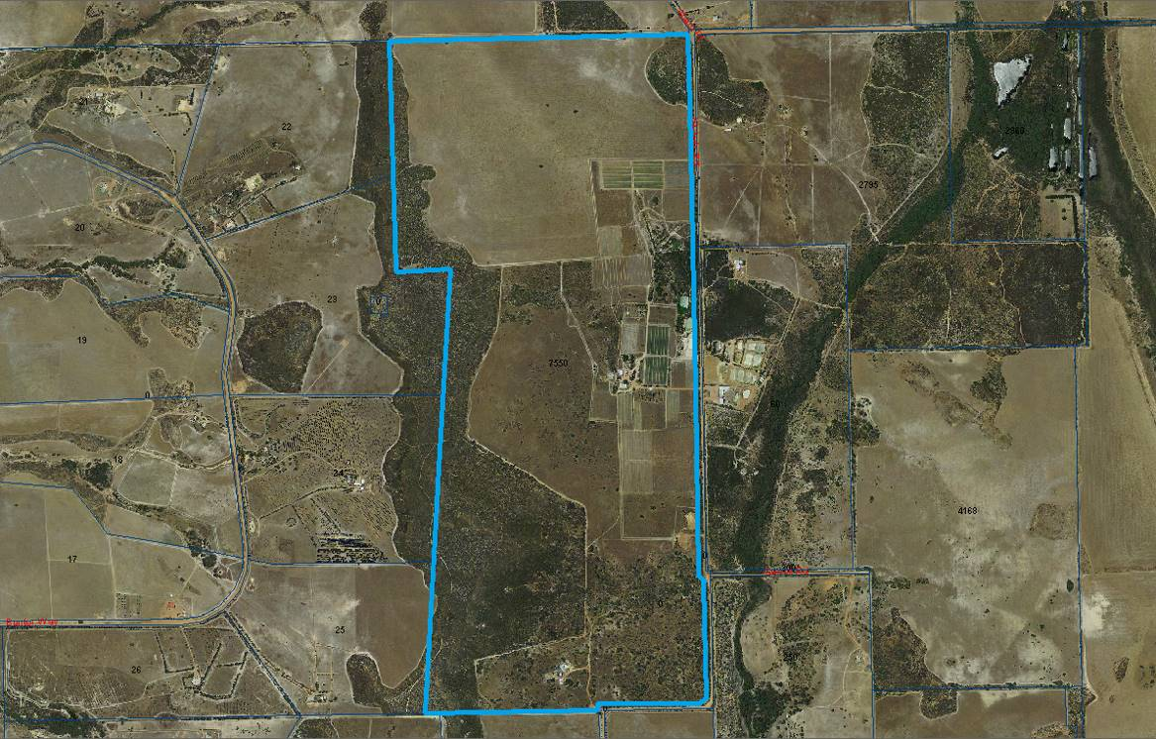

A copy of the submitted Scheme Amendment documentation has been provided to Councillors as separate Attachment 10.1.6(a). The Scheme Amendment documentation contains site analysis, justification and an indicative subdivision guide plan. The indicative subdivision guide plan proposes that Lot 7550 be subdivided into 3 lots and a copy is also provided as Attachment 10.1.6(b).

Figure 10.1.6(c) – View across Lot 7550 looking south-west from Hickety Road
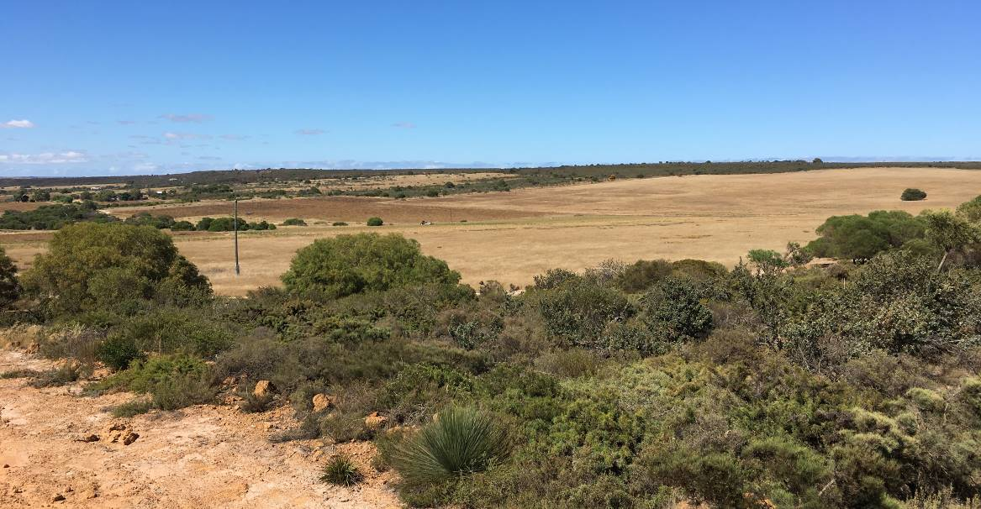

In assessing this application it is recommended that it be supported based upon the following:

• The rezoning of the subject property presents no environmental constraints.
• The rezoning of the subject property presents no heritage constraints.
• The rezoning of the subject property, and subsequent subdivision with application of building envelopes, and adherence to standard bushfire requirements at time of future development presents no bushfire hazard constraints.
• The rezoning of the property will allow for the subdivision/creation of lots that are consistent with those already existing in the surrounding area.
• The 3km road frontage provides opportunity for additional vehicle access points to be located with good visibility and sight lines.
• The rezoning and subdivision would not prevent the current horticultural land use from continuing.
• The property contains two residences and the rezoning would enable the subsequent subdivision of Lot 7550 to create them upon separate lots.
• The rezoning process will give formal opportunity to the Environmental Protection Authority (‘EPA’), the Department of Fire & Emergency Services, the Department of Primary Industries and Regional Development, the Department of Water and Environmental Regulation, service authorities and neighbouring landowners (amongst others) to make comment upon the proposed Scheme Amendment and the accompanying indicative subdivision guide plan;
• The application is consistent with the objectives of the Western Australian Planning Commission’s (‘WAPC’) State Planning Policy 2.5 Land Use Planning in Rural Areas.
• The rezoning application accords with Council’s strategic planning direction as laid out in the WAPC endorsed Shire of Chapman Valley Local Planning Strategy.

STATUTORY ENVIRONMENT
Lot 7550 Hickety Road, Howatharra is zoned ‘Rural’ under the Scheme and is set amidst land already zoned ‘Rural Smallholding’ including the immediately adjoining Bunter Way subdivision to the west, the Ahern Place subdivision to the north, and the Nanson-Howatharra subdivision to the south.

Figure 10.1.6(d) – Scheme Zoning Map extract for land surrounding Lot 7550
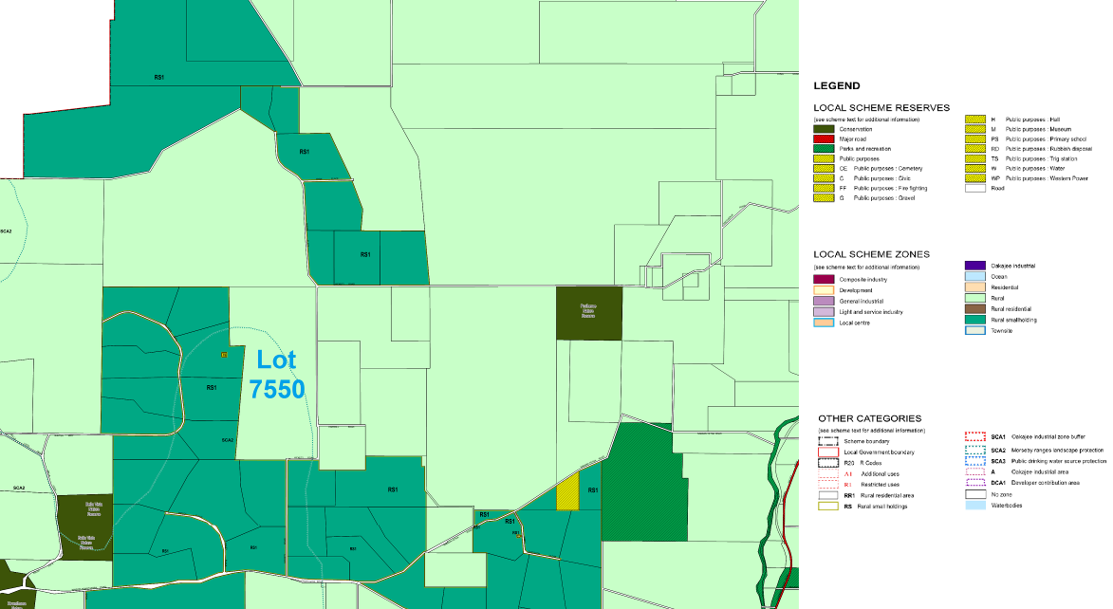

Section 4.2.5 of the Scheme lists the objectives for the ‘Rural Smallholding’ zone as being:

“(a) Provide for residential development within a low density environment and integrated with a variety of agricultural/rural activities, including agricultural/rural activities undertaken on a commercial basis;
(b) Provide for other land-uses compatible with the predominant use of the land;
(c) Prevent the establishment of land-uses more appropriately undertaken in commercial and/or industrial areas; and
(d) Protect the environmental and landscape values of the land.”

Schedule 12 of the Scheme lists the following conditions relevant to the ‘Rural Smallholding 1’ zone:

“1 Subdivision
Subdivision and land use shall generally be in accordance with the Structure Plan adopted by the Local Government and endorsed by the Western Australian Planning Commission.

2 Building
All dwellings shall be sited in accordance with the setback requirements specified in the Scheme for the Rural Smallholding Zone, except where for specific lots, building envelopes are shown on the Structure Plan. Where building envelopes are shown then all dwellings, associated structures and effluent disposal systems must be located within that envelope.

3 Applications for Planning Consent
In addition to the requirements of Part 9 of the Scheme all applications for planning consent are required to be accompanied by relevant plans and information that:
(a) propose appropriate land management techniques to the satisfaction of the responsible authority to make good areas of degradation identified as such;
(b) delineate areas of significant remnant vegetation, surface water and other water bodies and significant topographical features;
(c) delineate areas of stock grazing and proposed stock numbers;
(d) delineate the proposed location of building envelopes;
(e) delineate the location of existing and proposed effluent disposal systems;
(f) delineate location of existing tracks and fences and proposed location of fences and driveways; and
(g) describe materials and colour of external cladding of all proposed buildings.

4 Land use
(a) When considering applications for development approval (planning consent), the local authority may refer the application to the Department of Environment and Conservation, the Department of Agriculture and Food, the Department of Water and any other responsible authority and relevant Government agency for comment and approval where appropriate;
(b) Piggeries, feedlots, poultry farms and extractive industry are prohibited; and
(c) The subdividing owner of the land shall make arrangements satisfactory to the local authority to ensure that prospective purchasers are advised that preliminary advice should be sought from the Department of Agriculture and Food regarding the establishment within the subject land any proposed use that falls under the use class ‘intensive agriculture’ as defined in Schedule 1.

5 Stocking Rates
(a) With the objective of maintaining sustainable landuse practices, and preventing land degradation through wind and water erosion, the keeping of animals is permitted in accordance with the following or such density as approved by the Local Government following consultation with the Department of Agriculture and Food, with conditions if appropriate:
2.5 dry sheep equivalent / 1 hectare
1 horse / 2 hectares
1 pony / 1.6 hectares
1 milking cow / 4 hectares
1 heifer / 1.6 hectares
1 dairy goat / 0.5 hectares
5 cashmere goats / 1 hectare
1 deer / 0.3 hectares
Only one stock option will be permitted or a combination equivalent to one option is permitted.
(b) Notwithstanding the above, the Local Government may reduce or vary the limit on stocking or place any other conditions in light of prevailing seasonal conditions to prevent overstocking, erosion, or other practices detrimental to the environment or amenity of the neighbouring properties from those rates described in Clause 5(a) above.

6 Water Resources
(a) Where scheme water supply is unavailable a minimum 92,000L rainwater storage facility for each residence or evidence from the proponent which is satisfactory to the local authority than an adequate on-site potable water source exists shall be provided;
(b) A licence from the Department of Water is required to draw groundwater from a well, bore, dam or any naturally occurring surface water body or watercourse;
(c) Where the area has not been surveyed for hydrological resources, the prior advice of the Department of Water should be sought regarding the provision of a water supply for any proposed ‘intensive agriculture’ use and development;
(d) All storm water from structures or paved surfaces is to be contained within each lot;
(e) No development or land use activity shall impede in any way the natural water flow along any creek line or water course;

7 Clearing of Land
No removal of any remnant native vegetation (including any tree) is permitted without the prior approval of the local authority outside the building envelope;

8 Location, siting and appearance of buildings
(a) All residential and ancillary buildings shall be located and constructed within an approved building envelope for each proposed lot;
(b) Notwithstanding (a) above, where by reason of the nature of material to be stored in a building it is considered that it would be undesirable that the buildings be clustered, the buildings may be separated by such distance as determined by the local authority;
(c) No building shall be constructed in such a manner or of such materials that it would in the opinion of the local authority, have a detrimental impact on the local amenity.

9 Effluent Disposal
(a) No dwelling shall be constructed or approved for construction unless an approved method of on-site effluent disposal suitable for long-term usage has been incorporated into the approved plans, and is in a location, to the satisfaction of the local government in consultation with the Health Department of WA.
(b) In considering applications for planning consent the Local Government shall ensure that the development proposed will not result in any net export of nutrients from the land to any wetland, watercourse or underground aquifer.

10 Fencing
Prior to any stocking of land, all areas of remnant native vegetation, including vegetation along streamlines, shall be fenced with stock proof fencing to the specification and satisfaction of the local authority. All fences are to be maintained in a stock proof condition by the landowner to the satisfaction of the local authority.

11 Landscaping
(a) All buildings and structures within any lot shall be suitably screened to the satisfaction of the local authority;
(b) Prior to the commencement of any development on any lot, the local authority will require the preparation of a tree planting and maintenance program with the intent of rehabilitating and revegetating any areas of degraded land so identified but without restricting the operation of approved rural activities.

12 Fire Management
At the time of subdivision the following fire management controls will be imposed:
(a) A strategic fire break for each lot will be installed in a manner acceptable to the local authority in consultation with FESA.
(b) Provision of a suitable permanent water supply for fire-fighting purposes to be established in consultation with the local authority and FESA.

13 Advice to purchasers of lots
As a condition of any subdivision approval granted, the subdividing owner of the land is to advise, to the specifications and requirements of the Local Government, prospective purchasers of any lot created within this location of all of the provisions contained herein.”

The south-west portion of Lot 7550 is also located within the overlying ‘Special Control Area 2 - Moresby Range Landscape Protection’ zone. Section 6.3 of the Scheme notes the following for the ‘Moresby Range Landscape Protection’ zone:

“6.3.2 The purpose of Special Control Area 2 is the protection of the Moresby Ranges and associated valleys from development and/or subdivision that will detrimentally affect the landscape values of the area, including preventing development that may lead to problems of erosion. In determining any application for planning approval on land within Special Control Area 2, the Local Government shall give consideration to the purpose of the Special Control Area.

6.3.3 Within Special Control Area 2 no clearing or destruction of any remnant native vegetation or re-vegetation shall be permitted except for:
(a) Clearing to comply with the requirements of the Bush Fires Act 1954 (as amended), the Local Government’s Bush Fire Notice and/or any fire management plan endorsed by the Local Government;
(b) Clearing as may reasonably be required to accommodate an approved building and curtilage, or vehicular access to an approved building or other land use approved by the Local Government; and/or
(c) Clearing as may be allowed under the Department of Environment and Conservation Land Clearing Regulations;
(d) Trees that are diseased or dangerous.

6.3.4 In the determination of any application for planning approval within Special Control Area 2 the Local Government may, having regard to the purpose of the Special Control Area set out in Clause 6.3.2 and the assessment criteria detailed in the Moresby Ranges Management Strategy, require modification of development proposals, or impose conditions of approval regarding:
(a) The siting of the proposed development;
(b) The design and layout of the proposed development;
(c) The materials and finishes to be used in the proposed development;
(d) The protection of remnant native vegetation or re-vegetation located on the site;
(e) The installation and maintenance of vegetation to provide for the visual screening of proposed development; and/or
(f) The installation and maintenance of vegetation, retaining walls or other works to prevent erosion.”

Part 5 of the Planning & Development Act 2005 provides for the amendment of a Scheme.

Should Council support this rezoning application then it is required to forward a copy of the Scheme Amendment documentation to the EPA for its assessment as per Section 81 of the Planning & Development Act 2005. Should the EPA advise that the proposed rezoning does not warrant assessment under Part IV Division 3 of the Environmental Protection Act 1986 then the Shire would forward a copy of the Scheme Amendment documentation to the WAPC advising of its intent to advertise the rezoning application.

POLICY IMPLICATIONS
Lot 7550 Hickety Road, Howatharra is located within Precinct No.3 – Chapman Valley of the Shire of Chapman Valley Local Planning Strategy (2008) the vision for which is:

“a diverse range of rural pursuits and incidental tourist developments that complement the sustainable use of agricultural resources.”

Figure 7 of the Local Planning Strategy identifies Lot 7550 as ‘Proposed Rural Smallholdings (20-40ha)’ and the rezoning application therefore accords with Council’s strategic planning direction for this area.

Figure 10.1.6(e) – extract from Local Planning Strategy Precinct No.3 Map
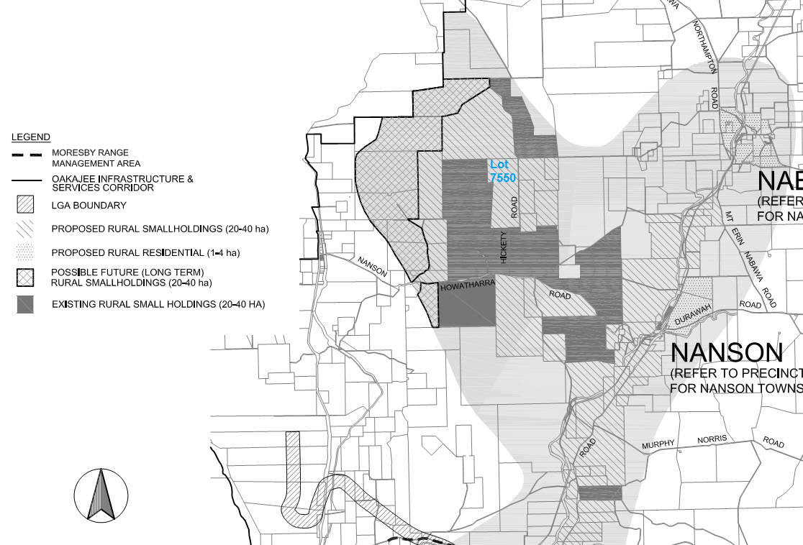

The rezoning application is consistent with the following community objectives for Precinct 3 of the Local Planning Strategy:

“3.1.1 Ensure that the rezoning and subdivision of rural land into Rural Smallholdings maximises and reflects the agricultural potential of the land, and can accommodate a range of agricultural pursuits coupled with lifestyle opportunity.”

“3.1.3 Encourage the rezoning and subdivision of land into Rural Smallholdings and Rural Residential lots in accordance with Section 3.5 and Figure 3.”

FINANCIAL IMPLICATIONS
The applicant has been charged the $4,023 (GST inclusive) fee for a request to Council for the initiation of a (minor) Scheme Amendment under the Shire of Chapman Valley 2017/2018 Planning Service Fees. In the event that Council did not initiate and advertise the Scheme Amendment, 50% of the fee would be refunded to the applicant as per the Fee Schedule.

- Long Term Financial Plan:

The Shire of Chapman Valley Long Term Financial Plan was endorsed by Council at its 19 July 2017 meeting. It is not considered that the determination of this application by Council would have impact in relation to the Long Term Financial Plan.

STRATEGIC IMPLICATIONS
The Geraldton Region Plan was released in 1999 by the WAPC to provide a framework for the future management, protection and coordination of regional planning. The Region Plan incorporates the Greater Geraldton Structure Plan that was updated in 2011 by the WAPC to account for a number of strategic planning directions. Lot 7550 is located north of the structure plan area and Section 3.2.2 of the 2011 report notes that rural land to the north of the study area has been identified for rural living purposes in the endorsed Shire of Chapman Valley Local Planning Strategy, and are beyond the scope of the Greater Geraldton Structure Plan and are to be considered through wider regional planning.

Lot 7550 is located within the study area for the WAPC’s Moresby Range Management Strategy (2009). The Strategy identifies that the south-west corner of Lot 7550 forms part of the Moresby Range sideslopes and the southern portion forms part of the footslope, but does not identify the lot as being within a visually sensitive area. It is considered that the existing Scheme provisions are capable of implementing the recommendations of the Moresby Range Management Strategy relevant to Lot 7550.

- Strategic Community Plan:

The Shire of Chapman Valley Strategic Community Plan was endorsed by Council at its 15 November 2017 meeting, and the rezoning application is in accordance with its objectives.

CONSULTATION

Were Council to initiate the Scheme Amendment then the Shire would undertake the following actions of consultation, inviting comments and responses within a 42 day advertising period:

• erect a public notification sign upon the site;
• place a notice within a locally circulating newspaper;
• place a copy of the Scheme Amendment documentation on the Shire website;
• place a copy of the Scheme Amendment documentation in the Shire office/library for public viewing;
• write directly to all surrounding landowners; &
• write directly to all relevant government agencies and service authorities.

At the completion of the advertising period all received submissions would be presented for Council’s consideration, and should the Scheme Amendment be given final approval at this point by Council then the rezoning documents would be forwarded to the WAPC seeking final assessment and approval.

RISK ASSESMENT

Rating 1 (Insignificant) Measures of Consequence – Risk Assessment and Acceptance Criteria

VOTING REQUIREMENTS
Simple majority of Council.

COUNCIL RESOLUTION / STAFF RECOMMENDATION

MOVED: CR WARR SECONDED: CR BATTEN

That Council pursuant to Part 5 of the Planning and Development Act 2005 amend the Shire of Chapman Valley Local Planning Scheme No.2 by rezoning Lot 7550 Hickety Road, Howatharra from ‘Rural’ to ‘Rural Smallholding’ (RS1) and modifying the Scheme Map accordingly.
Voting 7/1
CARRIED
Minute Reference:12/17-2
(Item moved en-bloc)

ATTACHMENT 10.1.6(b)

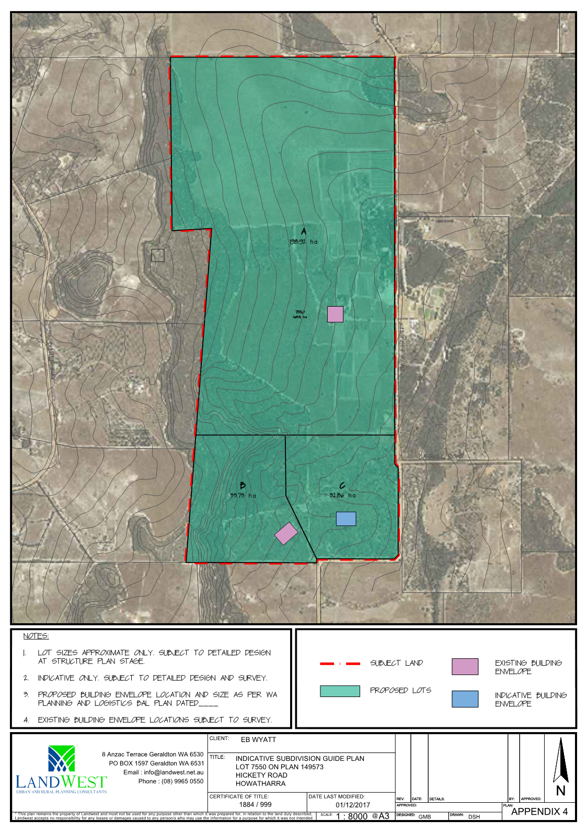

10.2
Finance
December 2017

Contents

10.2 AGENDA ITEMS

10.2.1 Financial Reports for November 2017

10.2.2 Write Off Outstanding Debt – A1398

AGENDA ITEM: | 10.2.1
SUBJECT: | FINANCIAL REPORTS FOR NOVEMBER 2017
PROPONENT: | SHIRE OF CHAPMAN VALLEY
SITE: | SHIRE OF CHAPMAN VALLEY
FILE REFERENCE: | 307.04
PREVIOUS REFERENCE: | N/A
DATE: | 13 DECEMBER 2017
AUTHOR: | DIANNE RAYMOND, MANAGER FINANCE & CORPORATE SERVICES

SUPPORTING DOCUMENTS:

Ref | Title | Attached  to  Report | Under Separate Cover
10.2.1 | Merged Financial Reports |  | √

DISCLOSURE OF INTEREST
Nil

BACKGROUND
Financial Regulations require a monthly statement of financial activity report to be presented to Council.

COMMENT
The monthly financial statements for November 2017 have been provided as a separate attachment for Council’s review.

STATUTORY ENVIRONMENT
Local Government Act 1995 Section 6.4
Local Government (Financial Management) Regulations 1996 Section 34

POLICY IMPLICATIONS
There are no policy implications

FINANCIAL IMPLICATIONS
As presented in November 2017 financial statements.

- Long Term Financial Plan (LTFP):

No significant effect on the LTFP

STRATEGIC IMPLICATIONS
Nil

- Strategic Community Plan/Corporate Business Plan:

Nil

CONSULTATION
Not applicable

RISK ASSESSMENT

The associated risk would be the failure to comply with Local Government Financial Regulations requiring monthly reporting of financial activity. The Risk Rating is Level 1 Insignificant.

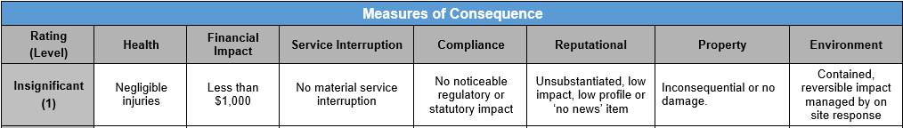

VOTING REQUIREMENTS
Simple Majority

COUNCIL RESOLUTION / STAFF RECOMMENDATION

MOVED: CR WARR SECONDED: CR BATTEN

That Council receives the financial report supplied under separate attachment for the month of November 2017 comprising the following:

- Statement of Financial Activities with notes
- Note 1 – Significant Accounting Policies
- Note 2 – Explanation of Material Variances
- Note 3 – Net Current Funding Position
- Note 4 – Cash & Investments
- Note 5 – Budget Amendments
- Note 6 – Receivables
- Note 7 – Cash Backed Reserves
- Note 8 – Capital Disposals
- Note 9 – Rating Information
- Note 10 – Information on Borrowings
- Note 11 – Grants & Contributions
- Note 12 – Trust
- Note 13 – Capital Acquisitions
- Appendix A – Budget by Program
- Summary of Payments
- Bank Reconciliation
- Credit Card Statement

Voting 8/0
CARRIED
Minute Reference: 12/17-9

AGENDA ITEM: | 10.2.2
SUBJECT: | WRITE OFF OUTSTANDING DEBT
PROPONENT: | NOT APPLICABLE
SITE: | SHIRE OF CHAPMAN VALLEY
FILE REFERENCE: | A1398
PREVIOUS REFERENCE: | NIL
DATE: | 13th DECEMBER 2017
AUTHOR: | DIANNE RAYMOND

SUPPORTING DOCUMENTS:

Ref | Title | Attached  to  Report | Under Separate Cover
Nil

DISCLOSURE OF INTEREST
Nil

BACKGROUND
The sundry debtor (DM45 invoice number 7333) was raised for a Private Works request (Job No. WP381) being for the construction of firebreaks to meet legislative requirements on vacant land situated at 22 Green Drive, Nabawa.

COMMENT
The applicant and property owner, at the time, was infringed for noncompliance of firebreaks and made agreement with the Shire to construct a firebreak on the vacant land situated at 22 Green Drive, Nabawa to meet legislative requirements. Subsequently the property owner became incapacitated; was admitted to care and has since passed away in South Australia. There was considerable delay in finalising the affairs with the deceased estate by the Public Trustee. The property has now been sold by the Commonwealth Bank as Mortgagee in possession without the Public Trustee being informed prior to settlement. The sale proceeds received by the bank were not enough to meet the outstanding mortgage debt; the estate has no further funds and is insolvent. The debt incurred of $151.80 is an internal cost recovery of employee time and does not include any material expenses.

STATUTORY ENVIRONMENT

6.12. Power to defer, grant discounts, waive or write off debts
(1) Subject to subsection (2) and any other written law, a local government may —
(a) when adopting the annual budget, grant* a discount or other incentive for the early payment of any amount of money;
(b) waive or grant concessions in relation to any amount of money; or
(c) write off any amount of money,
which is owed to the local government.
* Absolute majority required.
(2) Subsection (1)(a) and (b) do not apply to an amount of money owing in respect of rates and service charges.
(3) The grant of a concession under subsection (1)(b) may be subject to any conditions determined by the local government.
(4) Regulations may prescribe circumstances in which a local government is not to exercise a power under subsection (1) or regulate the exercise of that power.

POLICY/PROCEDURE IMPLICATIONS

No Policy affected.

FINANCIAL IMPLICATIONS
A minor loss of revenue for the small debt write off totaling $151.80

- Long Term Financial Plan (LTFP):

Nil

STRATEGIC IMPLICATIONS
Nil

- Strategic Community Plan/Corporate Business Plan:

Nil

CONSULTATION
There have been ongoing discussions between staff and the Public Trustee office in South Australia, prior to this the ratepayer was not in a state of mind to negotiate the recovery of the outstanding debt.

RISK ASSESSMENT

As set out in the Risk Management Governance Framework Procedures there are appropriate processes and internal controls for the management of this type of operational risk. The actual impact on total revenue is insignificant.

Measures of Consequence
Rating  (Level) | Health | Financial Impact | Service Interruption | Compliance | Reputational | Property | Environment
Insignificant  (1) | Negligible injuries | Less than $1,000 | No material service interruption | No noticeable regulatory or statutory impact | Unsubstantiated, low impact, low profile or ‘no news’ item | Inconsequential or no damage. | Contained, reversible impact managed by on site response

VOTING REQUIREMENTS
Absolute majority required

COUNCIL RESOLUTION / STAFF RECOMMENDATION

MOVED: CR WARR SECONDED: CR BATTEN

That Council authorise the write off for the sundry debt totaling $151.80 for Debtor DM45, which forms part of the outstanding Sundry Debtors Ledger, in accordance with section 6.12(1)(c) of the Local Government Act 1995.
Voting 7/1
CARRIED
Minute Reference:12/17-2
(Item moved en-bloc)
.
10.3
Chief Executive Officer
December 2017

Contents

10.3 AGENDA ITEMS

10.3.1 2016/2017 Annual Report

10.3.2 M Ramshaw – Waiver of Fees/Charges

10.3.3 Tourism & Events Working Group – Australia Day Awards

10.3.4 Budget Variation

AGENDA ITEM: | 10.3.1
SUBJECT: | 2016/2017 ANNUAL REPORT AND ANNUAL GENERAL MEETING OF ELECTORS
PROPONENT: | CHIEF EXECUTIVE OFFICER
SITE: | WHOLE OF SHIRE
FILE REFERENCE: | 413.01
PREVIOUS REFERENCE: | NA
DATE: | 13th DECEMBER 2017
AUTHOR: | MAURICE BATTILANA

SUPPORTING DOCUMENTS:

Ref | Title | Attached  to  Report | Under Separate Cover
10.3.1(a) | 2016/2017 Annual Report |  | √

DISCLOSURE OF INTEREST

Nil

BACKGROUND

The purpose of this item is to accept the Shire of Chapman Valley 2016/2017 Annual Report, receive the Auditors Report and Management Letter and set a date/time for the Annual General Meeting of Electors (Note: The Annual Report is provided under separate cover).

When considering setting a date for the Annual General Meeting of Electors it is a requirement of s5.27 ‘Electors General Meeting’ of the Local Government Act 1995 this meeting can be no later than 56 days after accepting the Annual Report (i.e. 14th February 2018).

The Shire of Chapman Valley last held the Annual General Meeting of Electors for 2015/2016 financial year on the 2nd February 2017 at the Council Chambers, Nabawa. This meeting commenced at 6.00pm.

COMMENT

The Staff Recommendation below is suggesting the date, time and location to hold the Annual General Meeting of Electors as being:

- Thursday 1st February 2018
- Commencing at 6.00pm
- Council Chambers, Nabawa

Bearing in mind the Act stipulates the Annual General Meeting of Electors must be held not more than 56 days after the local government accepts the annual report for the previous financial year. Therefore the latest date the meeting could be held is the 14th February 2018.

It is important to maximise attendances at the Annual General Meeting of Electors by constituents, hence the Staff Recommendation has suggested a date and time, which is after the harvest and school holiday periods.

STATUTORY ENVIRONMENT
Local Government Act 1995

The Local Government Act 1995 states the following;

“5.27. Electors’ general meetings
(1) A general meeting of the electors of a district is to be held once every financial year.
(2) A general meeting is to be held on a day selected by the local government but not more than 56 days after the local government accepts the annual report for the previous financial year.
(3) The matters to be discussed at general electors’ meetings are to be those prescribed.”

5.29. Convening electors’ meetings
(1) The CEO is to convene an electors’ meeting by giving —
(a) at least 14 days’ local public notice; and
(b) each council member at least 14 days’ notice, of the date, time, place and purpose of the meeting.
(2) The local public notice referred to in subsection (1)(a) is to be treated as having commenced at the time of publication of the notice under section 1.7(1)(a) and is to continue by way of exhibition under section 1.7(1)(b) and (c) until the meeting has been held.

5.32. Minutes of electors’ meetings
The CEO is to —
(a) cause minutes of the proceedings at an electors’ meeting to be kept and preserved; and
(b) ensure that copies of the minutes are made available for inspection by members of the public before the council meeting at which decisions made at the electors’ meeting are first considered.

5.33. Decisions made at electors’ meetings
(1) All decisions made at an electors’ meeting are to be considered at the next ordinary council meeting or, if that is not practicable —
(a) at the first ordinary council meeting after that meeting; or
(b) at a special meeting called for that purpose, whichever happens first.
(2) If at a meeting of the council a local government makes a decision in response to a decision made at an electors’ meeting, the reasons for the decision are to be recorded in the minutes of the council meeting.

5.54. Acceptance of annual reports
(1) Subject to subsection (2), the annual report for a financial year is to be accepted* by the local government no later than 31 December after that financial year.
* Absolute majority required.

5.55. Notice of annual reports
The CEO is to give local public notice of the availability of the annual report as soon as practicable after the report has been accepted by the local government.

POLICY IMPLICATIONS
No existing Policy/procedure relevant.

FINANCIAL IMPLICATIONS

Nil affect

- Long Term Financial Plan (LTFP):

Nil affect

STRATEGIC IMPLICATIONS

It is considered appropriate to conduct the Annual General Meeting of Electors to retain open and accountable governance and communication with the Shire’s constituents

- Strategic Community Plan/Corporate Business Plan:

Nil affect

CONSULTATION

The previous Shire President, relevant staff and the Shire’s Auditors have been consulted and had input into the development of the 2017/2018 Annual Report.

RISK ASSESSMENT

- Insignificant risk of non-compliance with legislation to complete this activity in accordance with the Local Government Act and associated Regulations.

- Insignificant risk of not conducting the Annual General Meeting of Electors at an appropriate time/date to provide constituents to opportunity to attend.

Measures of Consequence
Rating  (Level) | Health | Financial Impact | Service Interruption | Compliance | Reputational | Property | Environment
Insignificant  (1) | Negligible injuries | Less than $1,000 | No material service interruption | No noticeable regulatory or statutory impact | Unsubstantiated, low impact, low profile or ‘no news’ item | Inconsequential or no damage. | Contained, reversible impact managed by on site response

VOTING REQUIREMENTS

Staff Recommendation 1 - Absolute Majority
Staff Recommendation 2 – Simple Majority

COUNCIL RESOLUTION / STAFF RECOMMENDATION 1 (Absolute Majority Vote Required)

MOVED: CR FORTH SECONDED: CR MALUISH

Council:
- Accepts the Annual Report for the 2016/2017 Financial Year as required by s5.54 of the Local Government Act 1995.
Voting 8/0
CARRIED
Minute Reference: 12/17-10

COUNCIL RESOLUTION / STAFF RECOMMENDATION 2 (Simple Majority Vote Required)

MOVED: CR ROYCE SECONDED: CR MALUISH

Council:
1 Receives and accepts the Auditors Report for 2016/2017;
2 Receives and accepts the Auditors Management Letter 2016/2017;
3 Sets the date for the Annual General Meeting of Electors for Thursday 1st February 2018 commencing 6.00pm at the Nabawa Council Chamber and advertise this meeting.
4 Request the CEO give local public notice of the availability of the Annual Report as required by s5.55 of the Act;
5 Provides a copy of the Shire of Chapman Valley 2016/2017 Annual Report to the Director General of the Department of Local Government.
Voting 8/0
CARRIED
Minute Reference: 12/17-11

AGENDA ITEM: | 10.3.2
SUBJECT: | NABAWA STADIUM – REQUEST FOR WAIVER OF FEES
PROPONENT: | MARK RAMSHAW
SITE: | INDOOR BASKETBALL COURT – NABAWA STADIUM
FILE REFERENCE: | A1327
PREVIOUS REFERENCE: | NIL
DATE: | 13th DECEMBER 2017
AUTHOR: | MAURICE BATTILANA, CHIEF EXECUTIVE OFFICER

SUPPORTING DOCUMENTS:

Ref | Title | Attached  to  Report | Under Separate Cover
10.3.2(a) | M Ramshaw - Correspondence | √
10.3.2(b) | CMP-066 Waiver of Fees & Charges | √

DISCLOSURE OF INTEREST

Nil

BACKGROUND

Contact has been made by Mr. Mark Ramshaw seeking permission to use the Nabawa Indoor Basketball Court for children to play basketball after school hours without having to pay the Shire’s hire fees and charges for such use.

Correspondence between Mr. Ramshaw and the CEO is provided at Attachment 10.3.2(a), which explains the reasons for the request.

COMMENT

I have indicated to Mr. Ramshaw his request and purpose does have merit as the indoor courts are basically not used at all and has been rendered a wasted asset since the Geraldton Amateur Basketball Association decided to no longer hold games at Nabawa. However; it was also clearly indicated I did not have authority to waiver Shire fees and charges as he has requested.

I sent Mr. Ramshaw a copy the Shire Management Procedure (CMP-066) regarding his requests for the waiver of fees and charges for the use of Shire owned/controlled facilities (see Attachment 10.3.2(b)).

The Management Procedure states a waiver will not be given to individuals i.e.

Fee Waivers will not be considered for or provided to:
• Individual persons*;
• State or Federal Government bodies;
• Commercial Organisations or Businesses;
• Fees and Charges levied and collected by the Shire under any written law;
• Support for organisational or general operating costs;
• Activities that will financially benefit the Community Organisation (i.e. entry charge);
• Activities that are already covered by an existing service agreement with the Shire of Chapman Valley;
• Community Organisations that receive funding from the Shire of Chapman Valley by way of Donation, Community Development Grant or Council Contribution in the current financial year.

*Individual persons may seek the assistance of an Advocacy Agent to submit an application on their behalf. Note: Applications submitted by an Advocacy Agent will not impact the agent’s ability to apply for financial assistance within that financial year.

Based on the Management Procedure conditions I then referred Mr. Ramshaw to some possible Advocacy Agents i.e.

- CV Basketball Club
- Nabawa Men’s Shed
- CV P & C Association

It appears Mr. Ramshaw has approached the Chapman Valley Primary School and the Chapman Valley Basketball Club; however, nothing has eventuated, perhaps due to the insurance and possible liability issues these organisations may have with such activities. Enquiries were made with the Local Government Insurance Scheme (LGIS) with response being Council’s existing Policies does not cover the use being requested by Mr. Ramshaw i.e.

From: Claire.Choo@lgiswa.com.au [mailto:Claire.Choo@lgiswa.com.au]
Sent: Monday, 4 December 2017 12:14 PM
To: Dianne Raymond <finance1@chapmanvalley.wa.gov.au>
Subject: Basketball session

Hi Di
As discussed over the phone, as the person in question would be hiring the basketball courts on more than 12 times a year unfortunately this is not covered under Shire’s Casual Hirers’ Liability policy and the individual would need to seek their own insurance cover for the activity.
In regards to the Shire’s public liability cover, please note this does not cover individuals for accidental injury as members of the public decide to take part in activities at their own risk.
Hope this helps, should you have any further queries please let me know
Many thanks,

Claire Choo | Account Broker, Member Services
Level 3, 170 Railway Parade West Leederville WA 6007
Tel: +61 (8) 9483 8819
claire.choo@lgiswa.com.au | www.lgiswa.com.au



Mr. Ramshaw has now requested again if he could seek permission as an individual to use the Nabawa Indoor Basketball court and be given an exemption form fees and charges as an individual, this time as a trial period. I suggested perhaps over the Christmas School holiday period.

There are some concerns I have with the request i.e.

- Council’s Casual Hirer Insurance Policy does not cover the use being proposed by Mr. Ramshaw; therefore, rendering Mr. Ramshaw uninsured and liable for any injury or damage;

- A key would need to be given to Mr. Ramshaw on permanent basis, rather than this needing to be collected and returned after each day’s use;

One key, which will give access to the PA door on the west side of the court, currently provides access to the court area, yet denies access to the remainder of the facility if the internal barrier gate is locked, so there is no issue with access being obtained to areas were permission is not granted.

If a key is provided then a Key Bond ($50) should be insisted upon.

- Ability to restrict access to the time request (i.e. one hour from 4:00pm);

- Children being unsupervised as stated in Mr. Ramshaw’s correspondence i.e.

“…I’m thinking that if I have a key to provide access, I would go over and open the court up at 4.00pm and allow the kids to play for an hour or so.”

If approval is given, then perhaps it is condition upon adult supervision being in place at all times.

- I believe all other bookings for the whole or part of the Stadium (or perhaps Stadium and Community Centre) should result in the requested access to the Indoor Court granted to Mr. Ramshaw being denied. If this is not the case then I envisage a situation of complaints being made about noise, etc. during booked events at these venues.

- Court area and facilities being left in an untidy condition if the commitment to keeping the area clean and cared for is not forthcoming.

I do; however, believe if the children develop a sense of ownership and pride in the facilities they will keep it clean and care for it much more than if they were denied access. This can obviously be monitored.

There is a Mini Basketball Court outside the Stadium, near the Playground, so I suppose it could be argued there is already a facility available for children to play basketball at this location, rather than use to indoor court. The outdoor court is obviously open to the elements, whereas the indoor courts will not be. However; is something Council may wish to take into consideration when determining Mr. Ramshaw’s request.

If Council is prepared to consider Mr. Ramshaw’s request to use the Indoor Basketball Court conditions on any such use could include (yet not necessary limited to):

- Ramshaw acknowledge the use requested is not covered under any of Council’s insurance policy and it is incumbent upon him to cover all claims for possible damage, injury, etc.;
- Courts are to be swept down (with court broom provided) before and after each use;
- There must be adult supervision at the Courts at all times;
- Area used is to have all rubbish, etc. removed and placed in bins;
- Remove spider webs from reachable areas (i.e. from the ground not on ladder, etc.) in basketball area and around the building monthly;
- Lights are not to be turned on (i.e. facility only to be used in daylight hours);
- Maximum period of use is one (1) hours from Monday to Friday;
- Access is denied at times the Stadium and/or Community Centre are booked for use at the same time (i.e. for function and or any event preparation lead times);
- Stadium Toilets are not to be used. The Public Toilets located at the Nabawa Community Centre are available for use;
- Hire application form for the use of the facility must still be completed
- The use may be discontinued at any time and for any reason consider necessary by the Chief Executive Officer. This will be totally at the Chief Executive Officer’s discretion and will be imposed without dispute.

I believe items (a) and (b) above creates a situation where the children are doing something to earn the use of the facility without payment, assist Council in keeping the facility clean and hopefully instil a sense of ownership of the facility by the children.

STATUTORY ENVIRONMENT

Council has legal process to follow regarding wavering fees and charges i.e.

Local Government Act, 1995 – Section 6.12 – Power to Defer, Grant Discount, Waive or Write off Debts
(1) Subject to subsection (2) and any other written law, a local government may —
(a) when adopting the annual budget, grant* a discount or other incentive for the early payment of any amount of money; or
(b) waive or grant concessions in relation to any amount of money; or
(c) write off any amount of money,
which is owed to the local government.
* Absolute majority required.
(2) Subsection (1)(a) and (b) do not apply to an amount of money owing in respect of rates and service charges.
(3) The grant of a concession under subsection (1)(b) may be subject to any conditions determined by the local government.
(4) Regulations may prescribe circumstances in which a local government is not to exercise a power under subsection (1) or regulate the exercise of that power.

POLICY/PROCEDURE IMPLICATIONS

Management Procedure CMP-066 stipulates conditions and guidelines for any request to waiver fees and charges (see Attachment 10.3.2(b)).

FINANCIAL IMPLICATIONS
The adopted Fees & Charges for the 2017/2018 Budget sets the amount of $50 per use (GST Inclusive) for the Basketball Courts (only).

The other option is the Annual Booking Fee of $586, which allows for 2 uses per week only. There has been an allowance made at other venues to annualise the 2 uses per week to provide some flexibility (e.g. Yuna Primary School use of Yuna Memorial Hall.

The Fees & Charges also have Bonds applicable for the requested use i.e.

- All Venues Bond – Events without Liquor License $530
- All Venues Bond – Long Term Key Bond $ 50

It is understood the abovementioned fees could be out of range of the applicant adopted Fees & Charges relevant to the requested use

There will also be utility costs associated with the requested use (i.e. power for running lights) unless a condition is stipulated the lights cannot be used, which creates a situation of how to police/control such a condition.

- Long Term Financial Plan (LTFP):

No effect on LTFP.

STRATEGIC IMPLICATIONS
- Strategic Community Plan/Corporate Business Plan:

1.1 | Nurture the sense of community | Determine a whole of Shire community integration approach | Advocate a sense of community when opportunity arises.

CONSULTATION
Emails and telephone dialogue has occurred between Mr. Ramshaw and the CEO.

The CEO has also discussed the logistics of access restrictions with the Building Surveyor/Projects Officer

RISK ASSESSMENT

Measures of Consequence
Rating  (Level) | Health | Financial Impact | Service Interruption | Compliance | Reputational | Property | Environment

VOTING REQUIREMENTS

Absolute Majority

COUNCIL RESOLUTION / STAFF RECOMMENDATION (Absolute Majority Required)

MOVED: CR FORRESTER SECONDED: CR HUMPHREY

Council:

- Council agree to trialling the use Nabawa Indoor Basketball Court as requested by Mr. Ramshaw at no cost for the period between the December 2017 and February 2018 Ordinary Council Meetings under the following initial conditions:

- Mr. Ramshaw acknowledge the use requested is not covered under any of Council’s insurance policy and it is incumbent upon him to cover all claims for possible damage, injury, litigation, etc.;
- All Bonds relating to the use of the facility (e.g. venue, key) are to be paid and will be held in Trust by Council until use discontinues;
- Courts are to be swept down (with court broom provided) before and after each use;
- There must be adult supervision at the Courts at all times;
- Area used is to have all rubbish, etc. removed and placed in bins;
- Remove spider webs from reachable areas (i.e. from the ground not on ladder, etc.) in basketball area and around the building monthly;
- Lights are not to be turned on (i.e. facility only to be used in daylight hours);
- Maximum period of use is one (1) hours from Monday to Friday;
- Access is denied at times the Stadium and/or Community Centre are booked for use at the same time (i.e. for function and or any event preparation lead times);
- Stadium Toilets are not to be used. The Public Toilets located at the Nabawa Community Centre are available for use;
- Hire application form for the use of the facility must still be completed.
- The use may be discontinued at any time and for any reason consider necessary by the Chief Executive Officer. This will be totally at the Chief Executive Officer’s discretion and will be imposed without dispute.

- Subject to a satisfactory trial period mentioned in Item 1 above the use may be continued under the following conditions:

- The Annual Booking Fee be reduced from $586pa to $150pa for the use of the Nabawa Indoor Basketball Court area only;
- The Chief Executive Officer can vary (e.g. add, delete, amend) any of the conditions applied during the trial period as considered necessary for any ongoing use;

Voting 8/0
CARRIED
Minute Reference: 12/17-12
Attachment 10.3.2(a)

Email Received 28/11/2017

Hi Maurice

Thanks for making time yesterday to discuss the use of the basketball stadium with me.

Because the Council meeting is imminent, below is a copy of the original email I sent to you regarding using the stadium. I think it adequately outlines what I’m trying to do.

As you have suggested maybe the Council could allow this on a trial basis and just see how it goes ! As I’ve stated I’m very happy to take full responsibility for the day to day care and operation of the stadium.

Hopefully we can get this approved, it would be SO good to put this facility to use.

I’d appreciate it if you could let me know the outcome after the Council meeting

Kind regards

Mark Ramshaw

0429 342 999

Dear Mr Battilana
I am writing to you to seek permission from the Shire to use the Basketball Stadium. I recently met with Anthony Abbott and he is supportive of this proposal. Simply put, I would like to be able to have access to the stadium. The reason for this is that there are a number of children ( 6-10), including my son Jack, who live here in Nabawa, who have a keen interest in Basketball. At present, when weather permits, they are going and using the schools outdoor court. What I would like to do is be able to offer them the use of the board court on a daily basis under my direction.
I’m thinking that if I have a key to provide access, I would go over and open the court up at 4.00pm and allow the kids to play for an hour or so.
I feel that if I can do this it would provide a great opportunity for these kids to come and do physical activity and direct their energy in an appropriate way. Of course part of them using the facility would include THEM keeping it clean and cared for. If they are made to feel that it’s their responsibility to keep it in good order, I think this is a good thing.
I understand from discussion with Anthony that the stadium is basically unused at the moment, and has been for 2 years or so since the Chapman Valley Basketball Club stopped using it.
I would like to be able to use the stadium free of charge, but if the Shire felt that it was important I would be prepared to personally pay a reduced bond to help ensure the maintenance of the stadium. I think this proposal does present a great opportunity to provide a facility for some of the young kids around the area to come and associate and play in a supervised environment.
My wife, Cassandra, and I are about to provide foster care for some children in need of care, because we have the desire to help where we can. I can see the use of the stadium as an added activity and responsibility, that the Shire would assist in providing to these children, who come from varied backgrounds of disadvantage, and often trauma. The use of the Stadium would continue to help any local young people, and any we may have in our care, to get together and feel part of this great little community.
I understand that this proposal may need Council’s approval.
I look forward to hearing from you.
Kind regards
Mark Ramshaw
0429 342 999
Emails received & Sent from 11/08/2017 & 14/08/2017

Hi Mark

Some ideas:

- CV Basketball Club
- Nabawa Men’s Shed
- CV P & C Association

You can search the Shire website under the Community Tab for contact details of the above organisations (and others).

Cheers

Maurice Battilana | CHIEF EXECUTIVE OFFICER

Address 3270 Chapman Valley Road | Nabawa | WA | 6532
Mailing Address PO Box 1 | Chapman Valley Road | Nabawa | WA | 6532
www.chapmanvalley.wa.gov.au | email ceo@chapmanvalley.wa.gov.au
phone (08) 9920 5011 | fax (08) 9920 5155 | mobile 0429 205011

Disclaimer by the Shire of Chapman Valley: -
This email is private and confidential. If you are not the intended recipient, please advise us by return email immediately, and delete the email and any attachments without using or disclosing the contents in any way. The views expressed in this email are those of the author, and do not represent those of the Shire of Chapman Valley unless this is clearly indicated.

 please consider the environment before printing this email.

From: mramshaw1958@gmail.com [mailto:mramshaw1958@gmail.com]
Sent: Friday, 11 August 2017 9:02 AM
To: Maurice Battilana <ceo@chapmanvalley.wa.gov.au>
Subject: Re: Basketball Stadium

Hi Maurice

I'm really pleased that you do see merit in this and that I have your support. I've read through the documentation and understand it. Given that the Advocacy Agent has to be incorporated and operating in the Shire, I'm struggling to think who could make this application for me.

As you are familiar with the various organizations in the Shire, I'm just wondering if you might be able to suggest who might be able to help me with this application ?

Kind regards Mark
Sent from my iPhone

On Aug 11, 2017, at 7:56 AM, Maurice Battilana <ceo@chapmanvalley.wa.gov.au> wrote:
Hi Mark

Council has a Management Procedure in regards to requests for the waiver of fees and charges for the use of Shire owned/controlled facilities (see attached).

You will note in the Management Procedure state a waiver will not be given to individuals i.e.

Fee Waivers will not be considered for or provided to:
• Individual persons*;
• State or Federal Government bodies;
• Commercial Organisations or Businesses;
• Fees and Charges levied and collected by the Shire under any written law;
• Support for organisational or general operating costs;
• Activities that will financially benefit the Community Organisation (i.e. entry charge);
• Activities that are already covered by an existing service agreement with the Shire of Chapman Valley;
• Community Organisations that receive funding from the Shire of Chapman Valley by way of Donation, Community Development Grant or Council Contribution in the current financial year.

*Individual persons may seek the assistance of an Advocacy Agent to submit an application on their behalf. Note: Applications submitted by an Advocacy Agent will not impact the agent’s ability to apply for financial assistance within that financial year.

As stated above, if you seek the assistance of an Advocacy Agency to use as an applicant then this may be considered.

I personally see merit in what you are advocating so would encourage you to investigate this further before submitting an application for waiver (application form also attached).

Regards

Maurice Battilana | CHIEF EXECUTIVE OFFICER

Address 3270 Chapman Valley Road | Nabawa | WA | 6532
Mailing Address PO Box 1 | Chapman Valley Road | Nabawa | WA | 6532
www.chapmanvalley.wa.gov.au | email ceo@chapmanvalley.wa.gov.au
phone (08) 9920 5011 | fax (08) 9920 5155 | mobile 0429 205011

Disclaimer by the Shire of Chapman Valley: -
This email is private and confidential. If you are not the intended recipient, please advise us by return email immediately, and delete the email and any attachments without using or disclosing the contents in any way. The views expressed in this email are those of the author, and do not represent those of the Shire of Chapman Valley unless this is clearly indicated.

 please consider the environment before printing this email.

-----Original Message-----
From: Mark Ramshaw [mailto:mramshaw1958@gmail.com]
Sent: Thursday, 10 August 2017 12:22 PM
To: Maurice Battilana <ceo@chapmanvalley.wa.gov.au>; Simon Lancaster <dceo@chapmanvalley.wa.gov.au>
Subject: Basketball Stadium

Dear Mr Battilana

I am writing to you to seek permission from the Shire to use the Basketball Stadium. I recently met with Anthony Abbott and he is supportive of this proposal. Simply put, I would like to be able to have access to the stadium. The reason for this is that there are a number of children ( 6-10), including my son Jack, who live here in Nabawa, who have a keen interest in Basketball. At present, when weather permits, they are going and using the schools outdoor court. What I would like to do is be able to offer them the use of the board court on a daily basis under my direction.

I’m thinking that if I have a key to provide access, I would go over and open the court up at 4.00pm and allow the kids to play for an hour or so.

I feel that if I can do this it would provide a great opportunity for these kids to come and do physical activity and direct their energy in an appropriate way. Of course part of them using the facility would include THEM keeping it clean and cared for. If they are made to feel that it’s their responsibility to keep it in good order, I think this is a good thing.

I understand from discussion with Anthony that the stadium is basically unused at the moment, and has been for 2 years or so since the Chapman Valley Basketball Club stopped using it.

I would like to be able to use the stadium free of charge, but if the Shire felt that it was important I would be prepared to personally pay a reduced bond to help ensure the maintenance of the stadium. I think this proposal does present a great opportunity to provide a facility for some of the young kids around the area to come and associate and play in a supervised environment.

My wife, Cassandra, and I are about to provide foster care for some children in need of care, because we have the desire to help where we can. I can see the use of the stadium as an added activity and responsibility, that the Shire would assist in providing to these children, who come from varied backgrounds of disadvantage, and often trauma. The use of the Stadium would continue to help any local young people, and any we may have in our care, to get together and feel part of this great little community.

I understand that this proposal may need Council’s approval.

I look forward to hearing from you.

Kind regards

Mark Ramshaw
0429 342 999

Attachment 10.3.2(b)

MANAGEMENT PROCEDURE No. | CMP-066
MANAGEMENT PROCEDURE | WAIVER OF FEES & CHARGES
RESPONSIBLE OFFICER | CHIEF EXECUTIVE OFFICER
PREVIOUS POLICY No. | NA
SECTOR | ADMINISTRATION
RELEVANT DELEGATIONS

OBJECTIVES:

These procedures provide prospective applicants with information about financial assistance from the Shire of Chapman Valley by way of a Waiver of Fees and Charges.

Please read these procedures carefully before submitting an application. You may refer to the Completing your Application section for Shire Officer contact information.

MANAGEMENT PROCEDURE STATEMENT/S:

Restrictions on Funding

All fees and charges must be paid upfront and if a “Waiver of Fees and Charges” is granted, a reimbursement for the approved amount will be forwarded to the successful applicant.

The approval of a Waiver for a Fee and Charge is governed by Delegation, and specifically Delegation 3008

Write Off Debts.
The exercise of powers and the discharge of duties under section 6.12 of the Local Government Act 1995 to waive or grant concessions (excluding rate concessions) and to write off debts not exceeding $1,000. In cases where the request for Fee Waivers exceed $1,000 a report needs to be submitted to an Ordinary Council Meeting for Council’s consideration and approval.

Where a Fee and/or Charge is due to the Shire under another Act, regulatory body or Australian Law in respect of a service, then the Shire will not consider any application to waive that Fee and/or Charge.

A maximum of 50% of the Fee and Charge will be considered for waiver as listed in the annual Schedule of Fees and Charges adopted by Council.

The Shire may at its own discretion determine an individual application on its merits and give consideration to natural disasters.

The activity, event, competition, project or celebration must be offered within the Shire of Chapman Valley local government boundaries.

The Community Organisation is not to have already received funding from the Shire by way of a Sponsorship, Donation, Community Development Grant or Council Contribution or received financial assistance from the Shire under any existing written agreement during the current financial year.

Where an activity, event, competition, project or celebration occurs on a regular basis within a financial year July to June, then application for financial assistance shall be based on the full financial year.

One application per financial year (July to June) may be submitted at any time during the year for Financial Assistance.

Reimbursement for utility charges such as water and electricity will not be considered for waivers.

Recurrent annual or seasonal fees for sporting groups such as the Sporting Club Levy, court hire and line marking will not be considered for waivers.

Applications are to be lodged on the Shire’s official application form and retrospective applications will not be considered where they are submitted after the activity, event, competition, project or celebration.

Once the Delegated Shire Officer has determined that the application for financial assistance be approved, a request for payment for the approved percentage of the fee waiver will be submitted to the Creditors Officer for payment.

If circumstances surrounding a successful applicant change during the financial year the Shire reserves the right to review and cancel any or all of the approved financial assistance.

Eligibility - Who can apply?

To be eligible for a Waiver of Fees and Charges the applicant must meet all of the following criteria:
- Operate in the Shire of Chapman Valley;
- Community Organisation which is an Incorporated body;
- Not-for-profit organisation;
- Educational Institution.

Waiver of Fees and Charges

Fee Waivers will be considered for:
- Shire Fees and Charges that are not due to the Shire as an Australian Tax under Australian law in respect of a service;
- Events that occur as a result of natural disasters;

Fee Waivers will not be considered for or provided to:
- Individual persons*;
- State or Federal Government bodies;
- Commercial Organisations or Businesses;
- Fees and Charges levied and collected by the Shire under any written law;
- Support for organisational or general operating costs;
- Activities that will financially benefit the Community Organisation (i.e. entry charge);
- Activities that are already covered by an existing service agreement with the Shire of Chapman Valley;
- Community Organisations that receive funding from the Shire of Chapman Valley by way of Donation, Community Development Grant or Council Contribution in the current financial year.

*Individual persons may seek the assistance of an Advocacy Agent to submit an application on their behalf. Note: Applications submitted by an Advocacy Agent will not impact the agent’s ability to apply for financial assistance within that financial year.

Application Timeframes

Community Organisations may make application for a Fee Waiver from the Shire of Chapman Valley at any time during the year.

Completing and Lodging your application
Once you have completed all sections of the form and signed the declaration, please take a copy for your records. The Shire requires the original signed Application Form be submitted by either of the following methods:

By Post: Chief Executive Officer
Shire of Chapman Valley
PO Box 1
Nabawa WA 6532
In Person: Shire of Chapman Valley Administration Centre
Lot 7 Chapman Valley Rd, Nabawa, WA 6532
Office Hours: 9.00am – 4.00pm

What happens when your application is received?
- Your application will be reviewed by the Shire and we will notify you in writing of the outcome of our assessment.

Acknowledging the Shire’s support
Successful applicants will be required to liaise with the Shire’s Community Development Officer and provide for marketing and media opportunities during the Project or Event.

ADDITIONAL EXPLANATORY NOTES:

APPLICANT DETAILS
Name of Organisation:
Contact Person:
Postal Address for organisation/correspondence:
Phone Number:
Email address:
Website address:
ABN Number:
Is your organisation registered for GST? | ◻ Yes ◻ No
Type of Organisation: | ◻ Community Organisation  ◻ Charitable Body  ◻ Not-for-profit  ◻ Educational Institution
ACTIVITY / EVENT DETAILS
Type of Activity or Event:
Name of Activity or Event:
Location and Venue:
Date of Activity or Event:
Will income be generated as a result of the Activity or Event? | ◻ Yes $ ◻ No  Expected Amount
Are all workers associated with the Activity or Event working in a voluntary capacity? | ◻ Yes  ◻ No % of volunteers:
What is the Shire Fee and Charge that is requested to be waived in line with Policy
Reason for request:
BANK DETAILS
Account Name: | BSB Number:
Bank & Branch: | Account Number:
Account Holders Signature:
DECLARATION
I, __________________________________________ confirm that all of the information contained within the request form is true and correct and submit it to the Shire of Chapman Valley for consideration.
Signed: _____________________________________ |  | Name: ________________________
Position: ____________________________________ |  | Date: __________________________

SHIRE OFFICE USE ONLY
Total of the Fees and Charges:
Receipt Number:
Authorised Officer from the Instrument of Delegation No 3008
Do I require the application to be reviewed by the Management?
◻ Yes* complete below ◻ No
Is 50% of the Fee and Charge paid over $1,000? | ◻ Yes - Council approval required  ◻ No
Ordinary Council Meeting Date:
Outcome of the Council Recommendation:
◻ Approved ◻ Declined Reason:

Amount of Tax Invoice $ | Income Budget COA/Job:

__________________________ ____________________________ __________
Stamp of Authorised Officer Signature Date

* Management to complete if required
On review of the application I provide reasons for the determination as below:
◻ Approved | ◻ Declined
____________________________ ____________________________________ ____________ Authorise Officer Signature Date

AGENDA ITEM: | 10.3.3
SUBJECT: | TOURISM & EVENTS WORKING GROUP – AUSTRALIA DAY AWARDS
PROPONENT: | TOURISM & EVENTS WORKING GROUP
SITE: | SHIRE OF CHAPMAN VALLEY
FILE REFERENCE: | 403.04
PREVIOUS REFERENCE: | NIL
DATE: | 13th DECEMBER 2017
AUTHOR: | MAURICE BATTILANA, CHIEF EXECUTIVE OFFICER

SUPPORTING DOCUMENTS:

Ref | Title | Attached  to  Report | Under Separate Cover
10.3.3(a) | Confidential – T&EWG Minutes |  | √

DISCLOSURE OF INTEREST

Nil

BACKGROUND

The Tourism & Events Working Group (TEWG) met on the 29th November 2017. Minutes from this meeting have been provided under separate cover due to the need to keep the Australia Day Award nominations and recommended recipients confidential until they are announced at the Australia Day Event to be held on the 26th January 2016.

Councillors and Staff are therefore requested to treat the TEWG Minutes as CONFIDENTIAL.

COMMENT

The TEWG met to discuss:

- 2018 Australia Day Awards;
- 2018 Australia Day Event;

Due to the need for confidentiality this Report and the Staff Recommendation will not mention the recommended Australia Day Award recipients.

STATUTORY ENVIRONMENT

Not applicable.

POLICY IMPLICATIONS

MANAGEMENT PROCEDURE No. | CMP-033
MANAGEMENT PROCEDURE | HONOUR AWARDS
RESPONSIBLE DIRECTORATE | ADMINISTRATION
RESPONSIBLE OFFICER | CHIEF EXECUTIVE OFFICER
PREVIOUS POLICY No. | 9.120
RELEVANT DELEGATIONS

OBJECTIVES:

Set conditions, guidelines and processes for bestowing awards upon recipients.

MANAGEMENT PROCEDURE STATEMENT/S:

The Chief Executive Officer is to present an Agenda item at the appropriate time each year requesting Council consideration for awards to be presented in accordance with this Operational Procedure.

Citizenship Ceremonies

Citizenship ceremony be conducted at an event as considered appropriate by the Chief Executive Officer (in consultation with the President) and a native plant be given to the recipients.

Shire of Chapman Valley – Freeman of the Shire

A member of our Community may be honoured by the Shire with the title "Honorary Freeman of the Shire".

An Honorary Freeman of the Shire must have served the community of the Shire of Chapman Valley in an outstanding and meritorious manner that stands above the contributions of most other persons, and whose activities have contributed significantly to the wellbeing of the Shire's residents.

The Shire of Chapman Valley Freeman of the Shire Award recognises the outstanding achievements and dedicated service to the community by a person. The Freeman of the Shire Award is the highest honour the Shire of Chapman Valley can give to a community member.

Council may also consider conferring of the title of ‘Posthumous Freeman of the Municipality’. In this case, the eligibility criteria would still apply.

Eligibility Criteria
To be eligible for nomination, a person does not have to currently reside within the Shire or have served on Council.

Nominees will be assessed on their record of service to the local and broader community against the following criteria:

1. Length of service in a field (or fields) of activity;
2. Level of commitment to the field (or fields) of activity;
3. Personal leadership qualities;
4. Benefits to the community of the Shire of Chapman Valley and/or to the State of Western Australia and/or to the nation resulting from the nominee’s work; and
5. Special achievements of the nominee.

Exclusions

- A current Council Elected Member with the Shire of Chapman Valley cannot be nominated for the award.

Nomination Procedure

- Nominations for the Award may be made by Elected Members, individuals or organisations and are to be sponsored by an Elected Member of the Shire of Chapman Valley;
- They are to be submitted to the Chief Executive Officer in written format addressing the Eligibility Criteria;
- Nominations are to be made in the strictest confidence without the knowledge of the nominee;
- On receipt of a nomination the Chief Executive Officer is to present the nomination to Council as a Confidential Agenda Item for consideration;
- Council is to consider the item behind closed doors;
- Once a nomination has been accepted by Council, the nominee and any person(s) or organisation(s) involved in the nomination are to be informed of the decision and nominee is to be contact to confirm their acceptance of the honour;
- Should the nomination be supported by Council and accepted by the nominee the awrd shall be presented to the nominee at a function considered appropriate by the President.

Number of Freeman within the Shire

There is no limit on the number of persons upon which the title of Freeman of the Shire of Chapman Valley may be conveyed.

Entitlements

Any person upon whom the title ‘Honorary Freeman of Shire’ has been conferred may designate him/herself ‘Honorary Freeman of the Shire of Chapman Valley’.

The recipient shall be presented with a special badge, which identifies them as ‘Honorary Freeman of the Shire’ along with a certificate to commemorate receiving the award.

Any Honorary Freeman of the Shire shall be invited to all subsequent formal Civic functions conducted by the Shire.

Revocation of Title of Freeman or Honorary Freeman

Council, by resolution, shall also have the ability to revoke the title bestowed upon a person, if;

- A criminal matter, for which the Freeman in question was found guilty of, or for any other matter, was considered by Council to have caused embarrassment to the municipality or that the ongoing recognition of such a title on this person by the Shire was inappropriate.

- The removal of the name from Honour Boards and other places and any other such items will be at the discretion of Council and conducted through liaison with the Chief Executive Officer.

WALGA Honour Awards

As detailed by the WALGA Awards Guidelines

Elected Members eligible due to length of service are to be automatically nominated by the Chief Executive Office.

All other award types are to be determined by Council.

Shire of Chapman Valley - Certificate of Appreciation

For personal commitment, eminent service and contribution to the Shire of Chapman Valley as an Elected Members, Community Members or Staff Member

Automatically given to Elected Members who have retired from Council or are the recipient of a Department of Local Government Certificate of Recognition.
All others as determined by Council.
Annual Agenda Item to discuss suitable nominations.

Elected Members
Presented at Annual Council Dinner/Function

Community Members
Certificate of Appreciation issued at an Annual Council Dinner/Function.
Recipient & partner invited to attend.

Shire of Chapman Valley Australia Day Awards and Function

For personal commitment, service and contribution to the community of the Shire of Chapman Valley

Nominations called in October and close in November (or as determined by the Australia Day Council).

The Council appointed Working Group shall:

- Evaluate annual Australia Day Award Nominations and submitting these to Council in readiness for presenting the awards at the Shire's annual Australia Day Function;
- Assist with coordinating the annual Australia Day function(s);
- Discuss all other item(s) referred to them by Council in the areas of tourism and events.

Dept. Local Government & Community Services Awards

As detailed by the Department’s Awards Guidelines
Elected Members eligible due to length of service are to be automatically nominated by the Chief Executive Office.

All other award types are to be determined by Council.

(Note: All other Awards such as Australia Day Citizen of Year, Bushfire Brigade Service, etc., will only be dealt with by Council if nomination is initiated from within the community or by a Council resolution).

FINANCIAL IMPLICATIONS
No financial implications are envisaged at this stage as the costs for Australia Day Awards/Event has been budgeted for as per previous years and it not expected to exceed this amount.

- Long Term Financial Plan (LTFP):

No adverse affect of the LTFP envisaged.

STRATEGIC IMPLICATIONS
It is important to both recognize the achievement of constituents and Australia Day.

- Strategic Community Plan/Corporate Business Plan:

1.1 | Nurture the sense of community | Determine a whole of Shire community integration approach | Advocate a sense of community when opportunity arises.

CONSULTATION

The TEWG met with staff to determine a recommendation to Council for award recipient(s).

RISK ASSESSMENT

Measures of Consequence
Rating  (Level) | Health | Financial Impact | Service Interruption | Compliance | Reputational | Property | Environment
Insignificant  (1) | Negligible injuries | Less than $1,000 | No material service interruption | No noticeable regulatory or statutory impact | Unsubstantiated, low impact, low profile or ‘no news’ item | Inconsequential or no damage. | Contained, reversible impact managed by on site response

VOTING REQUIREMENTS

Simple majority

COUNCIL RESOLUTION / WORKING GROUP RECOMMENDATIONS

MOVED: CR WARR SECONDED: CR BATTEN

Council endorses the following Working Group recommendation:

- Recipient(s) of the 2018 Australia Day Awards;

- The Australia Day 2018 event be held at Chapman Valley Historical Society, gazebo area, Nanson, subject to consultation with the Historical Society, with Coronation Beach venue being the alternative location.

Voting 7/1
CARRIED
Minute Reference:12/17-2
(Item moved en-bloc)

AGENDA ITEM: | 10.3.4
SUBJECT: | BUDGET VARIATION
PROPONENT: | CHIEF EXECUTIVE OFFICER
SITE: | YUNA MEMORIAL HALL
FILE REFERENCE: | A1796
PREVIOUS REFERENCE: | N/A
DATE: | 13th DECEMBER 2017
AUTHOR: | MAURICE BATTILANA, CHIEF EXECUTIVE OFFICER

SUPPORTING DOCUMENTS:

Ref | Title | Attached  to  Report | Under Separate Cover
 | NIL

DISCLOSURE OF INTEREST
Nil

BACKGROUND

It has been brought to my attention the glass door refrigerator located at the Yuna Memorial Hall is no longer operating satisfactorily.

A refrigeration mechanic has looked at the refrigerator with the outcome being it is not repairable and should be replaced.

COMMENT

The question was initially asked as to who owns the refrigerator as this item does not show up on Councils Asset Register or Inventory. The thought was it is owned by a Yuna based Club or organisation and not the Shire. However; ownership cannot be determined.

Irrespective of the ownership uncertainty it is considered appropriate for Council to provide this type of equipment at the Yuna Memorial Hall, as it does at other community buildings (e.g. Yuna Multipurpose Community Centre, Bill Hemsley Park Community Centre, Nabawa Community Centre/Stadium, etc.).

The other matter which needs to be taken in to account is determining venues where similar refrigerators are used more often than others. For example, the Office refrigerator would be used more than the Yuna Hall or Nabawa Community Centre refrigerators. Hence the recommendation for a new glass door (2 door) refrigerator be purchased for the Shire office and the other refrigerators be moved around to locations of most use for this equipment (i.e. it would not be considered appropriate to purchase a new refrigerator for the Yuna Memorial Hall due to this being the least used of all Council facility with similar refrigerators.

STATUTORY ENVIRONMENT

In accordance with legislative requirements of the Local Government Act, 1995, Section 6.8(1)(b) Council is required to resolve by Absolute Majority to incur expenditure from its municipal fund for an additional purpose that is not identified in the Adopted Budget i.e.

Local Government Act (1995) – Section 6.8. - Expenditure from municipal fund not included in annual budget

(1) A local government is not to incur expenditure from its municipal fund for an additional purpose except where the expenditure:

(a) is incurred in a financial year before the adoption of the annual budget by the local government; or

(b) is authorised in advance by resolution*; or

(c) is authorised in advance by the mayor or president in an emergency.

* Absolute majority required.

(1a) In subsection (1):

additional purpose means a purpose for which no expenditure estimate is included in the local government’s annual budget.

(2) Where expenditure has been incurred by a local government —

(a) pursuant to subsection (1)(a), it is to be included in the annual budget for that financial year; and

(b) pursuant to subsection (1)(c), it is to be reported to the next ordinary meeting of the council.

POLICY IMPLICATIONS
Nil

FINANCIAL IMPLICATIONS

Cost estimates to purchase a new two door upright glass door refrigerator is $2,500 (GST Exclusive) delivered. A similar refrigerator has recently been purchased for the Bill Hemsley Park Community Centre.

The Staff Recommendation is requesting the reallocation of funds, yet with no increase in total expenditure across the 2017/2018 budget. Below is a summary of Budget Variations being requested:

- Increase COA 0473 - $2,500 – Purchase New Refrigerator
- Reduce COA2722/Job No LSHG - $2,500 – Savings recognised for Septic System Upgrades at Nanson Showgrounds

- Long Term Financial Plan (LTFP):

No significant effect on the LTFP

STRATEGIC IMPLICATIONS

- Strategic Community Plan/Corporate Business Plan:

5.2 | Be accountable and transparent in managing resources | Asset Management | Review Asset Management Plan regularly and maintain integration with other Strategic Plans within the Shire

CONSULTATION
I have conferred with Anthony Abbott (Building Surveyor/Project Officer) and it is agreed the concept of placing the new refrigerator in an area where it will be used more often and shuffle existing refrigerators around venues to place the oldest item at the venue where it will be least used is the best approach.

RISK ASSESSMENT

As the overall effect to the current budget is nil there is no significance financial risk.

Measures of Consequence
Rating  (Level) | Health | Financial Impact | Service Interruption | Compliance | Reputational | Property | Environment
Insignificant  (1) | Negligible injuries | Less than $1,000 | No material service interruption | No noticeable regulatory or statutory impact | Unsubstantiated, low impact, low profile or ‘no news’ item | Inconsequential or no damage. | Contained, reversible impact managed by on site response

VOTING REQUIREMENTS
Absolute Majority

COUNCIL RESOLUTION / STAFF RECOMMENDATION

MOVED: CR WARR SECONDED: CR BATTEN

Council endorses the following variations to the 2017/2018 Budget:

- Increase COA 0473 - $2,500 – Purchase New Refrigerator for Admin Building;
- Reduce COA2722/Job No LSHG - $2,500 – Savings recognised for Septic System Upgrades at Nanson Showgrounds;

Voting 7/1
CARRIED
Minute Reference:12/17-2
(Item moved en-bloc)
11.0 ELECTED MEMBERS MOTIONS OF WHICH PREVIOUS NOTICE HAS BEEN GIVEN

Nil

12.0 NEW BUSINESS OF AN URGENT NATURE INTRODUCED BY DECISION OF THE MEETING

Nil

13.0 DELEGATES REPORTS

Cr Warr represented the Shire at the Yuna Primary School Presentation night.

Cr Farrell attended the Chapman Valley Primary School Presentation night.

Cr Forrester attended the Menshed Shinema Thank a Volunteer event.

Cr Forth and Cr Maluish attended the Local Government Review

Cr Batten left Chambers at 10.43am

Cr Batten re-entered Chambers at 10.44am

14.0 ANNOUNCEMENTS BY PRESIDING MEMBER WITHOUT DISCUSSION

Nil

15.0 MATTERS FOR WHICH MEETING TO BE CLOSED TO MEMBERS OF THE PUBLIC

Nil

16.0 CLOSURE
ATTACHMENT 10.1.6(b)
ATTACHMENT 10.1.6(b)
ATTACHMENT 10.1.6(b)
ATTACHMENT 10.1.6(b)
The Chairman thanked the Elected Members and Staff for their attendance and closed the meeting at 10.46am.

